# Week1 Asking The "Right Questions"

## 1.1 Introduction

### Tips for Becoming a Data Analyst

1, Ask Questions, Nourish Curiosity, and Embrace the Unknown

to stay competitive, your skill set will need to be dynamic

2, Start Thinking about Everything You See as a Dependent or Independent Variable.

the dependent variable, because it is the phenomenon I am measuring and I'm most interested in

3, explore the advantages and disadvantages of continuous versus discrete variables

Bar graph vs. line graph

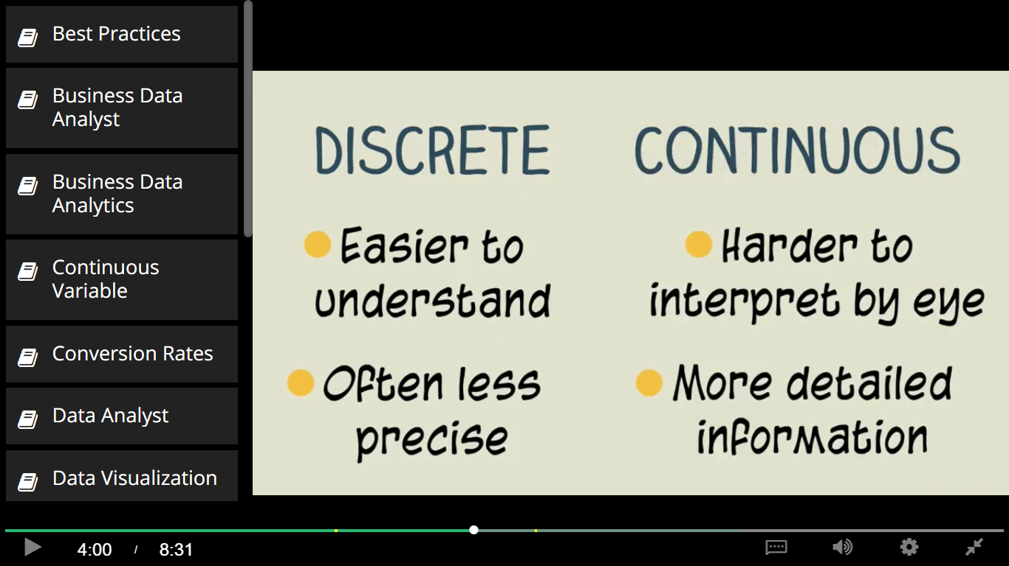

4, make sure you always listen, and contribute

5. Train your skepticism muscles

whenever somebody tells you something with extreme confidence, temper your expectations

 6, that's why you need to seek details

 7, Cherish Precision

8, which is the best practices in data analytics are not necessarily the most common practices in data analytics

9. the expectations of your teammates and stakeholders matter

10. the ability to put yourself in other people's shoes

## 1.2 Asking the Right Questions

### S.M.A.R.T. Objectives

Figure out where all your stakeholders’ true motivations and financial interests lie. Remember, unfortunately, they may not always know where their motivations and financial interest lie. Even, if they think they know.

What problem is this business having that you are hoping to solve by developing this project?

Can you tell me more about how this problem is affecting the business?

What is your ideal outcome for this project?

Specific

Measurable

Attainable

Relevant

Time-bound

>> People aren't returning back to our site after they log in for the first time. I need you to tell us how to convert first time visitors to returning visitors.

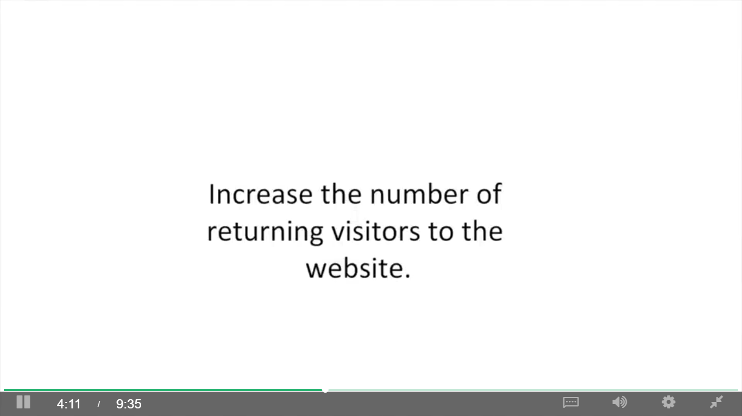

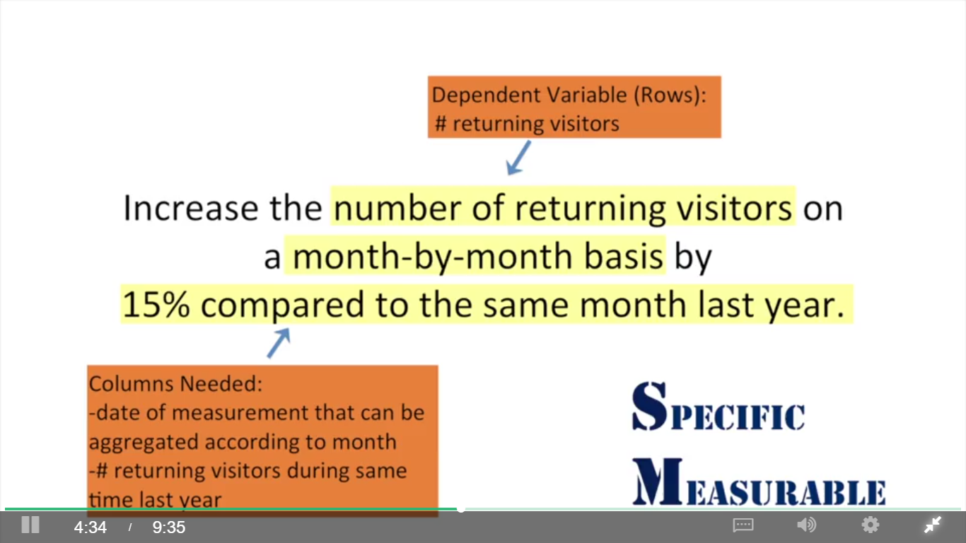

She was just making the assumption based on things she read. But the reasons profits were down was because customers weren't returning to the website. That's a good hypothesis, but in reality we have no idea whether the number of returning customers will be relevant to the drop in revenue. And if it turns out that the number of returning customers is not relevant to the drop in revenue, and your analysis is solely dedicated to the changing of the number of returning customers, your project manager and the rest of your stakeholders are not gonna be very happy.

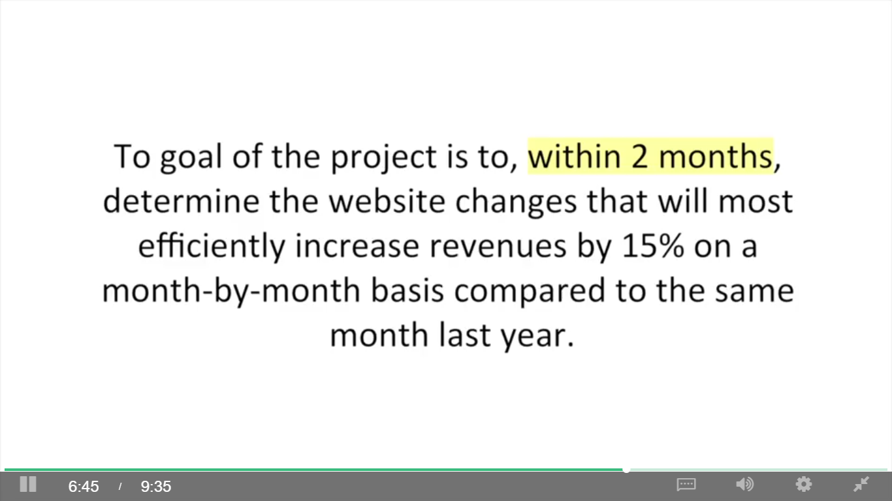

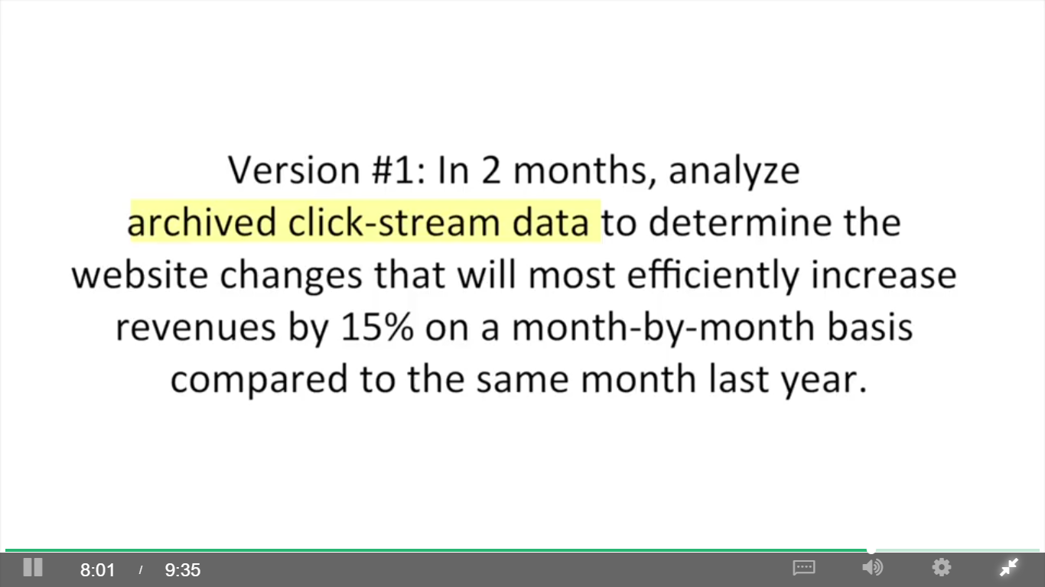

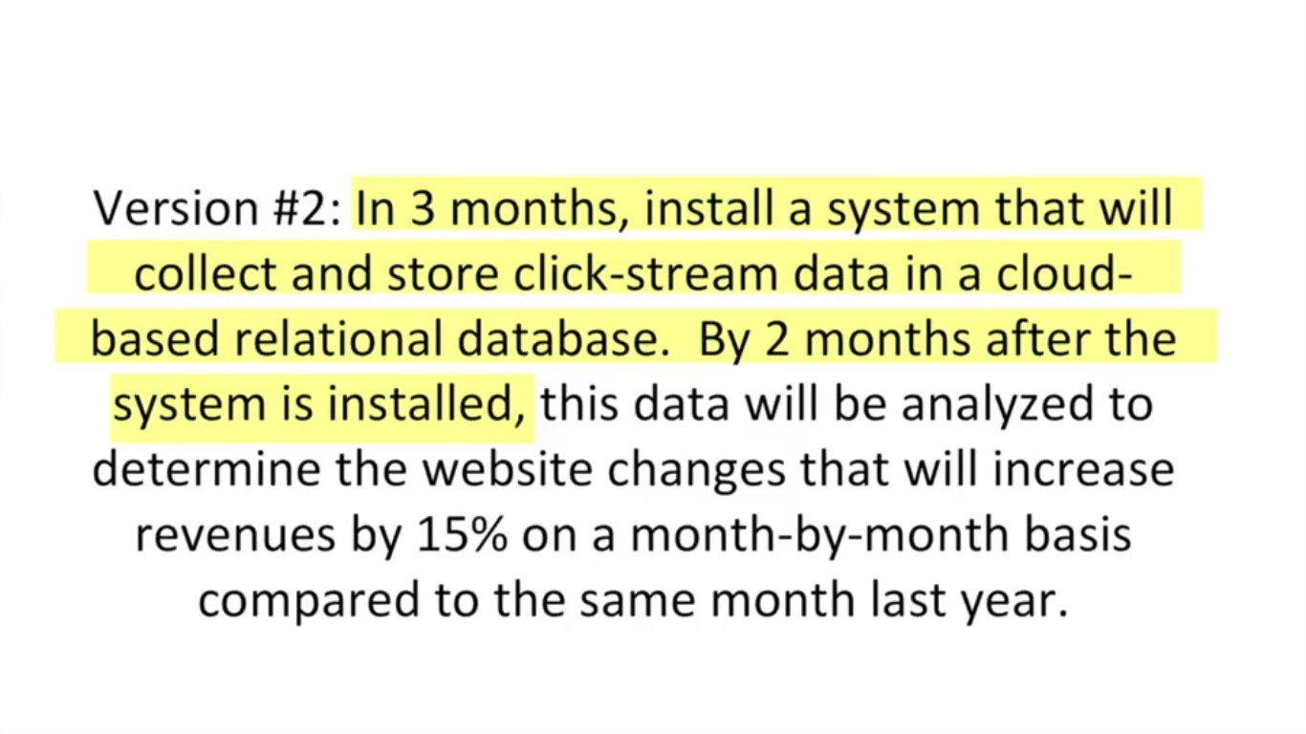

## 1.3 Your Stakeholders

### Listening to Stakeholders During Elicitation

Methods: in person meetings, focus groups, and emails

Goal

1. Identify your key stakeholders

2. Identify independent variables to test

what has been tried before and how did it turn out? What do you think might improve this business problem?

3. determine whether stakeholders agree about problem to be solved

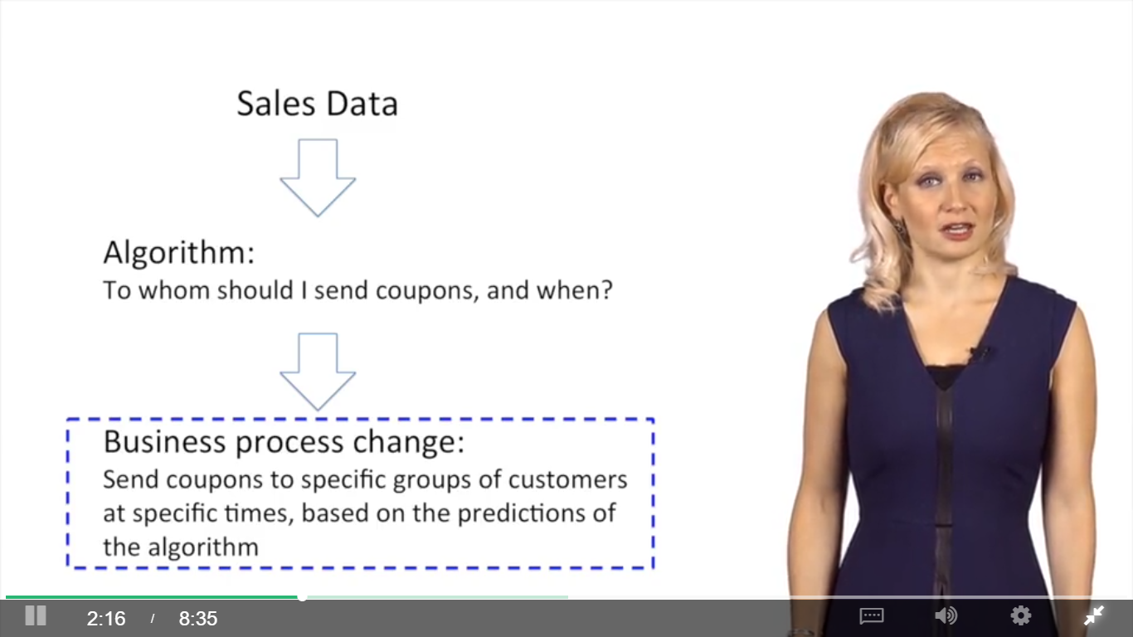

### Stakeholder Expectations Matter

Gartner:

Analytics continuum:

Descriptive: what happened or is happening

Diagnostic: why things are happening ( fraud detection)

Predictive: what is going to happen (forecasting)

Prescriptive: giving recommendations

Understand the cause of stakeholders’ reluctance

## 1.4 Structure Pyramid Analysis Plans

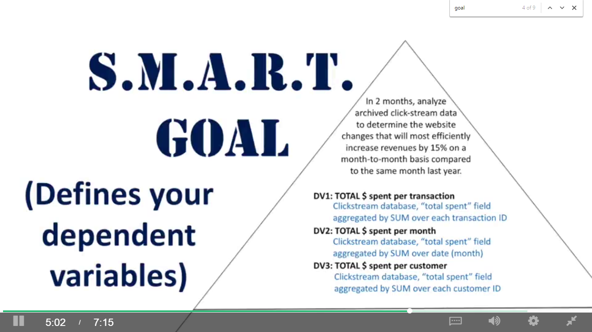

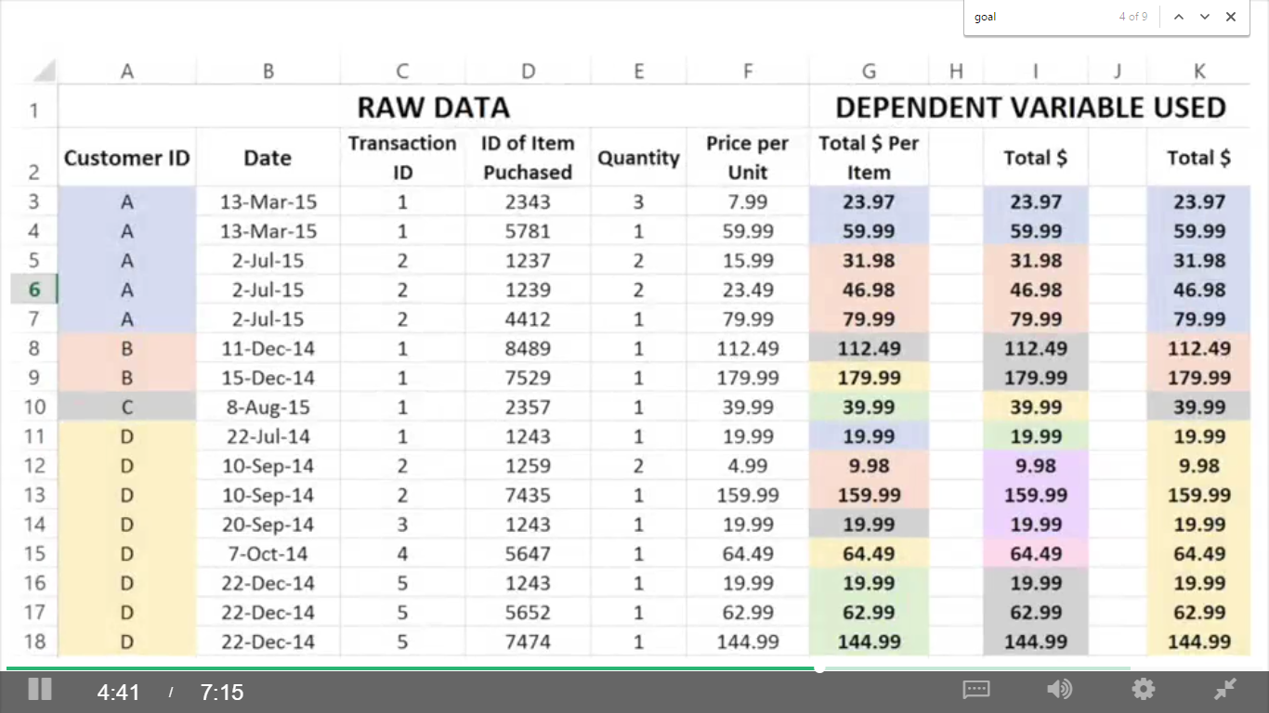

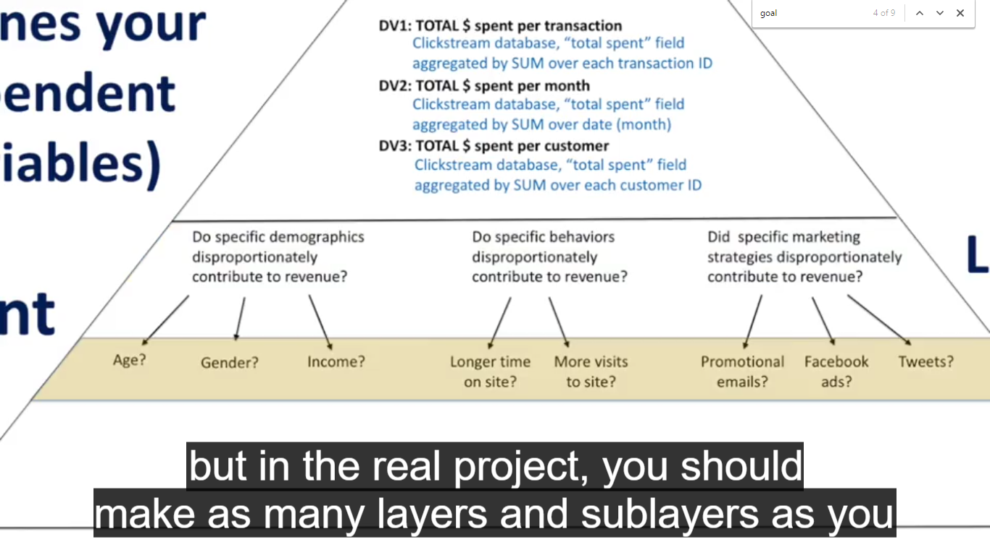

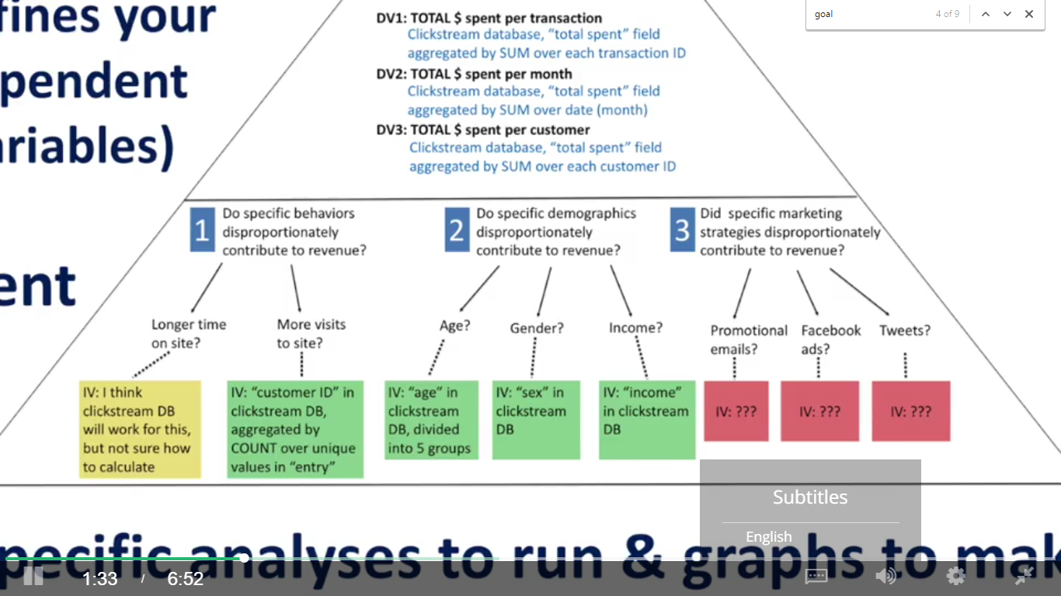

assign each category or subcategory a priority based on who suggested them, how much impact you suspect they could have, and how feasible you suspect they will be to assess.

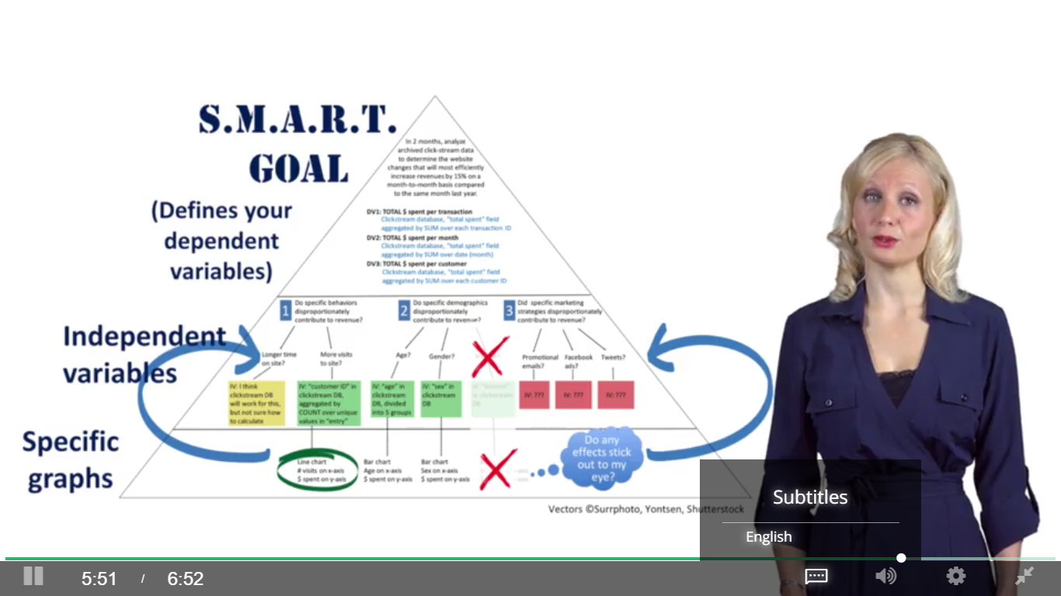

# Week2 Data Visualization with Tableau

## 2.1 Introduction

Why Tableau?

Connect databases and import data of big sizes

Easy to draw interactive dashboards

It will help you clean your data, find patterns in your data, test your hypothesis, and tell stories with your data

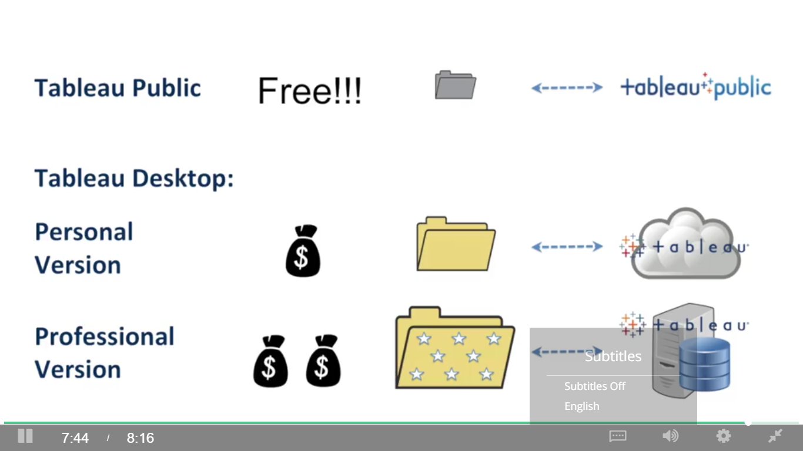

## 2.2 Using Tableau to Determine How Much You Can Make as a Data Analyst

## 2.3 Let’s Get Started!

### 2.3.1 Your First Graph

Measures: continuous variables (green)

Dimensions: discreet or categorical variables (blue)

Cards and shelves

Dependent variable = paid wage per year (rows)

Independent variable = job title subgroup (columns)

Change measure from sum to median

### 2.3.2 Formatting and Exporting

Columns and rows(double click), quick sort, swap(switch from vertical to horizontal bar chart)

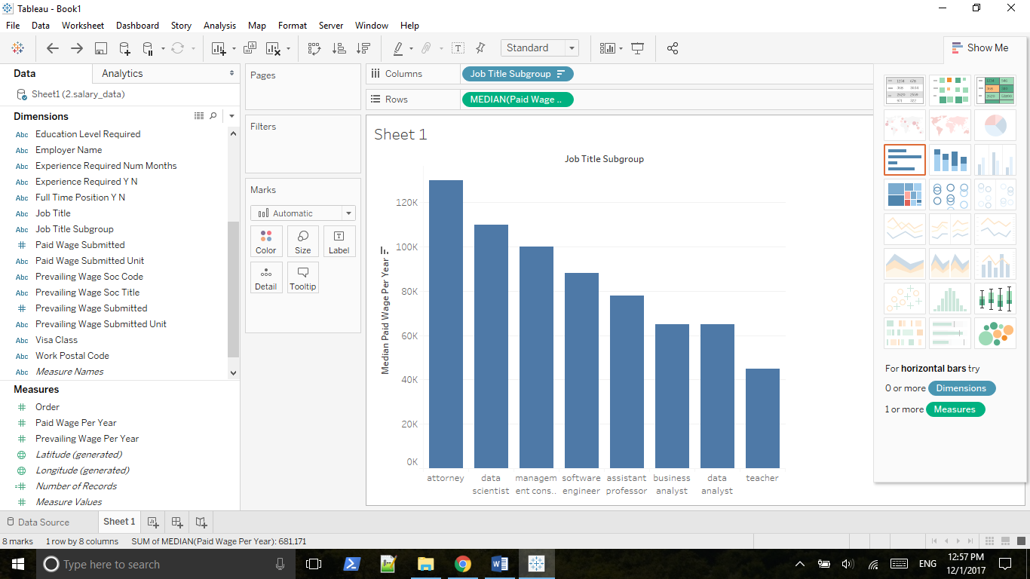

Save:

Worksheet => Export => Image

File => Print to PDF

File => Save as twb

### 2.3.3 Digging Deeper Using the Rows and Columns Shelves

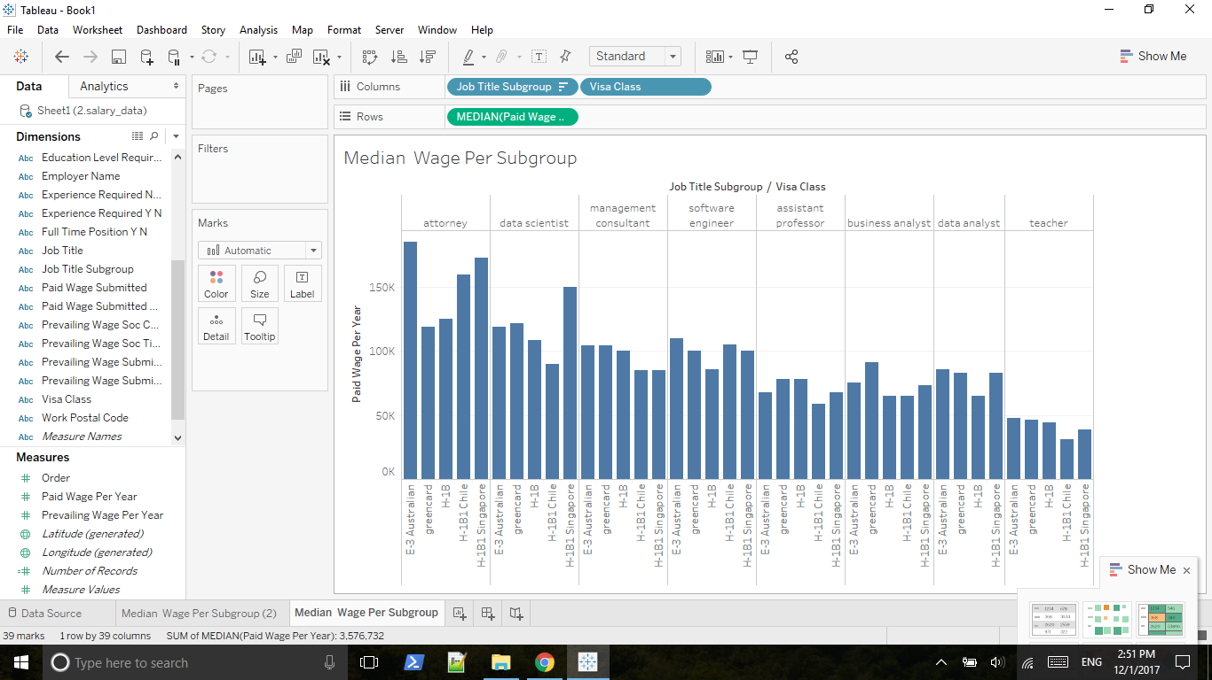

Change default aggregation to median

Right click bar and view data

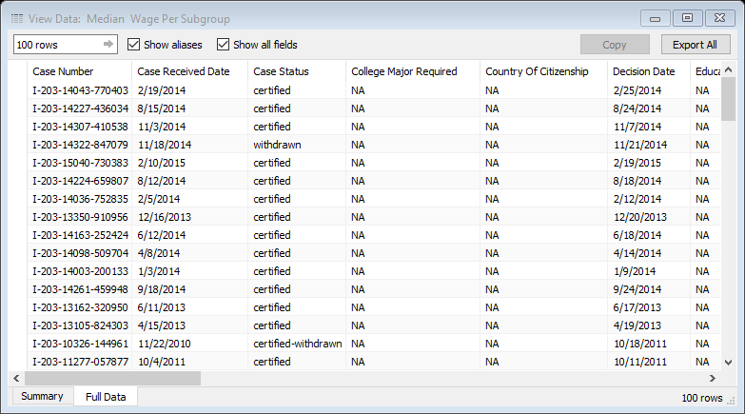

put number of rows behind paid wage

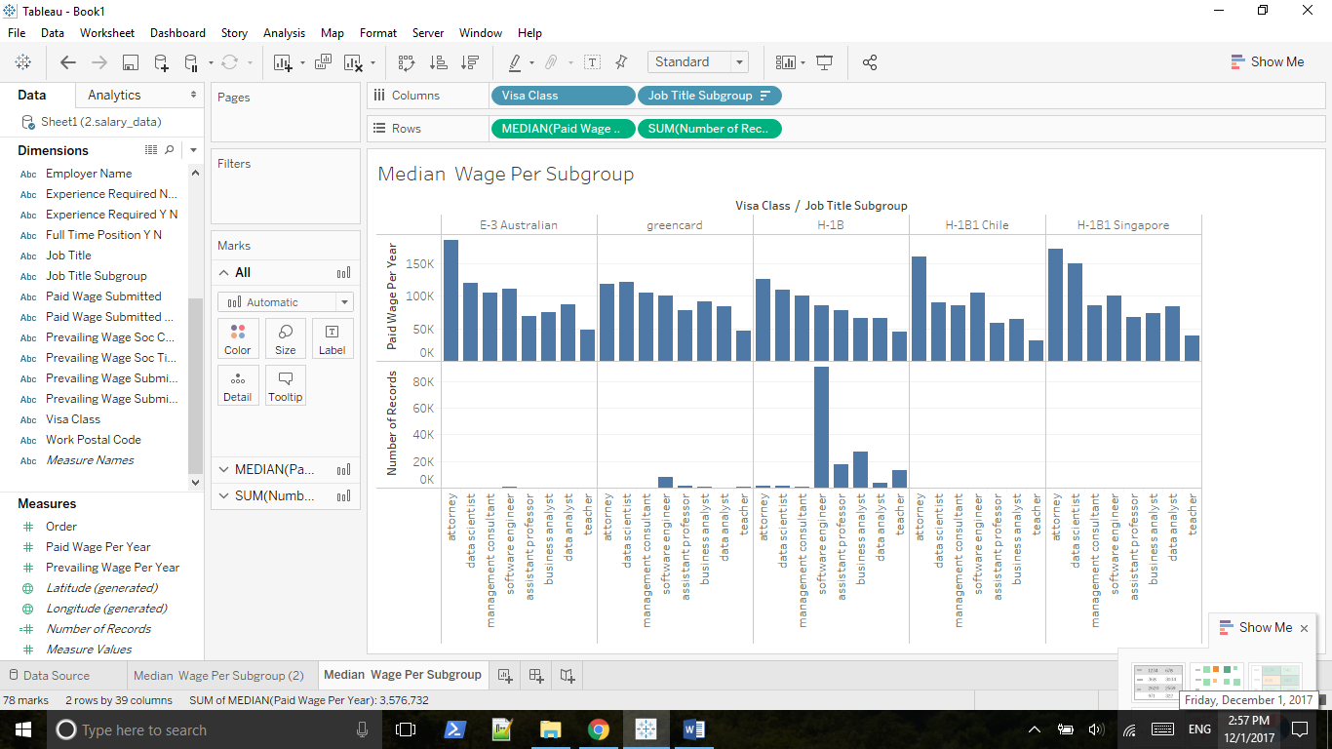

Number of records now showing on the tooltip

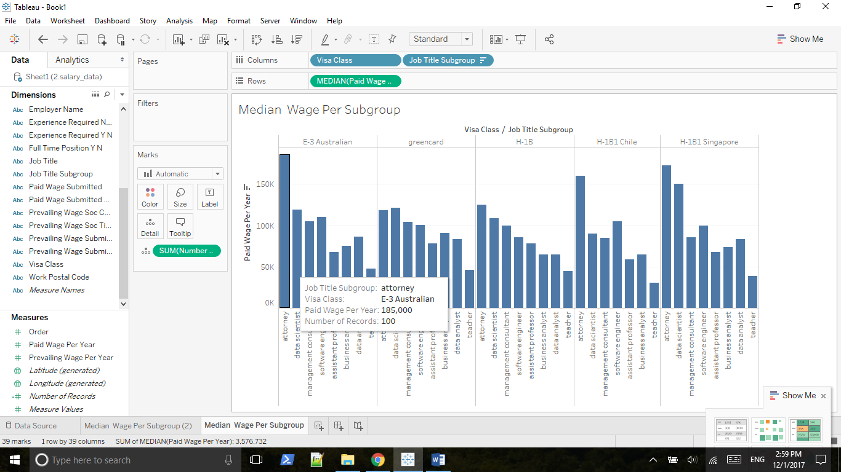

Another way of doing that: drag number of records on Detail button(Marks card)

Std. Dev (Pop) vs Std. Dev

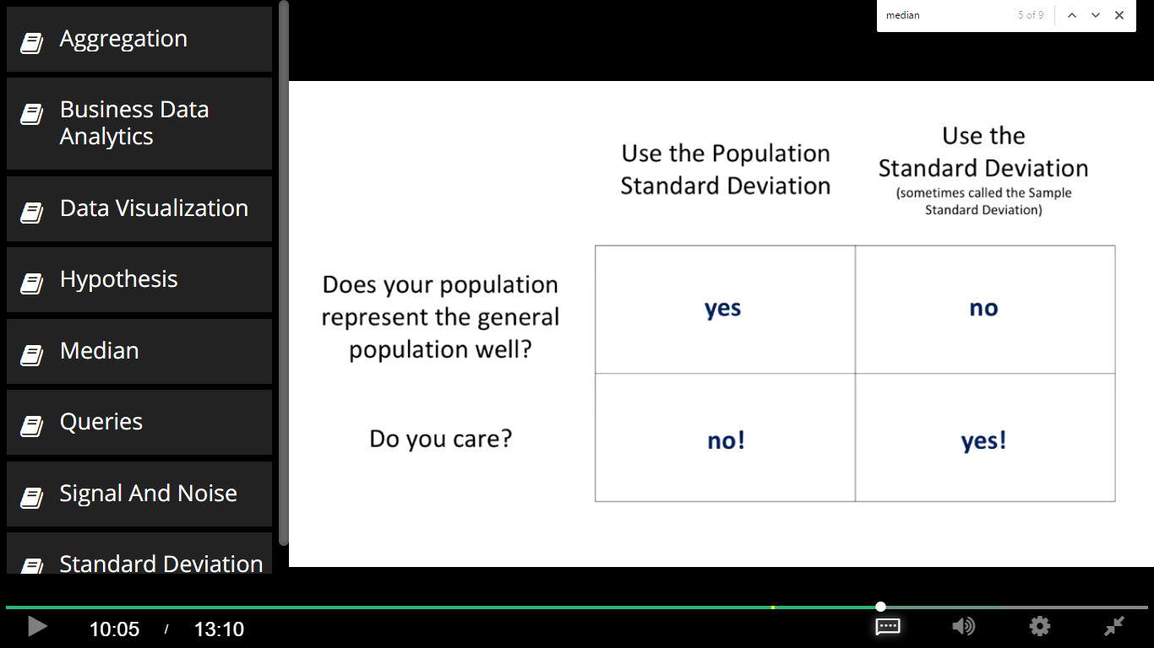

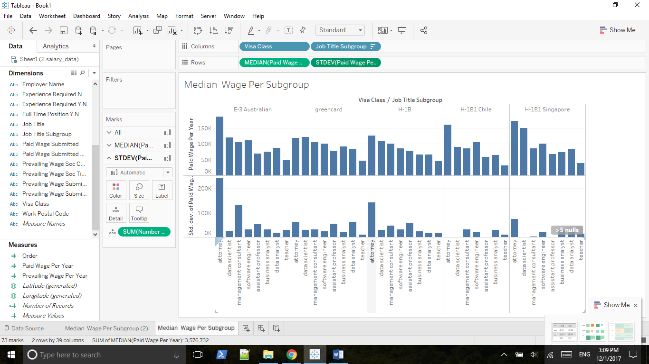

Press Shift key and move STDEV to the detail property.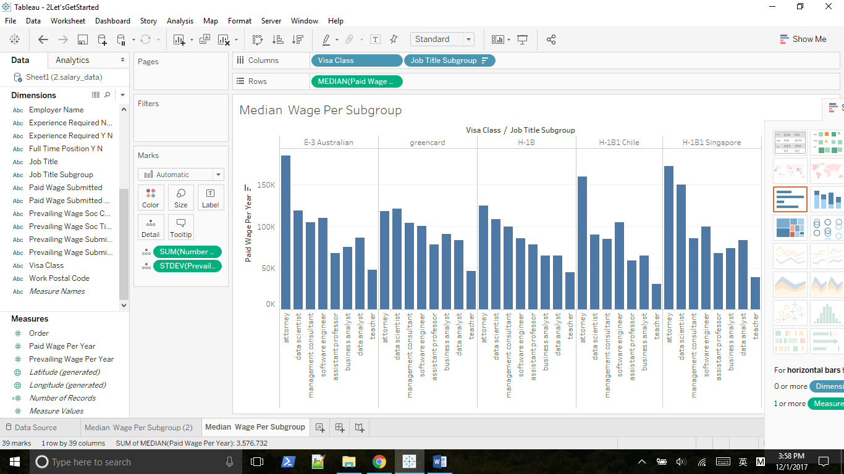

Huge std. dev implies the existence of outliers.

## 2.4 Working with the Marks Card

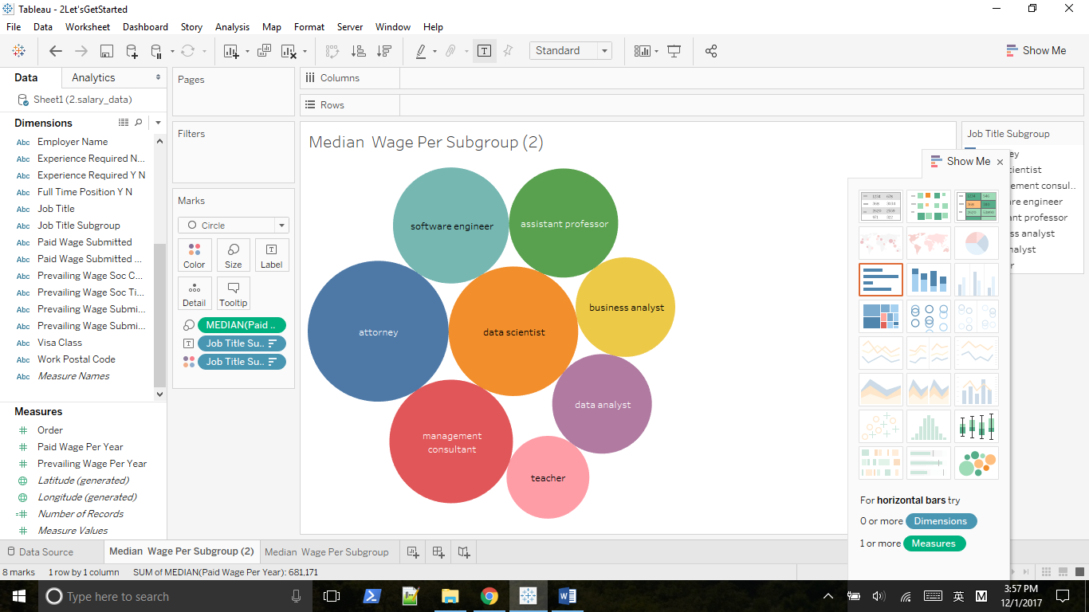

Move median on top of the Size property

Choose median paid wage as Rows, and drag job title subgroup on top of Color property

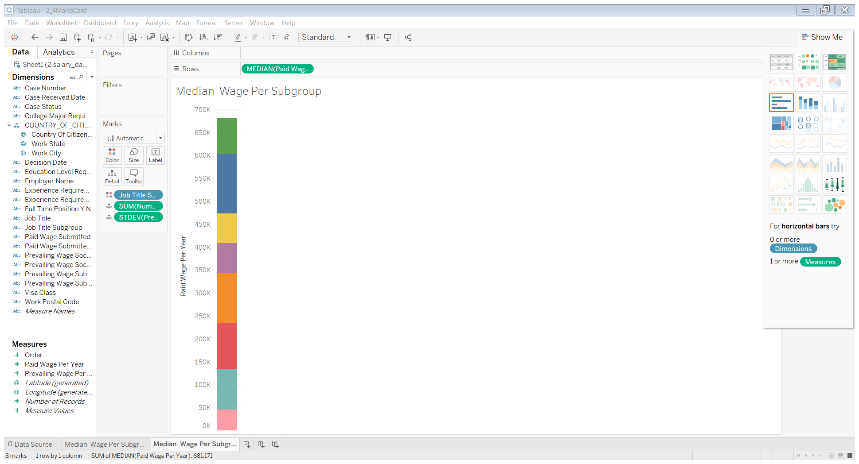

We need code by area, so move median paid wage on top of Size property

Then change Automatic to Circle

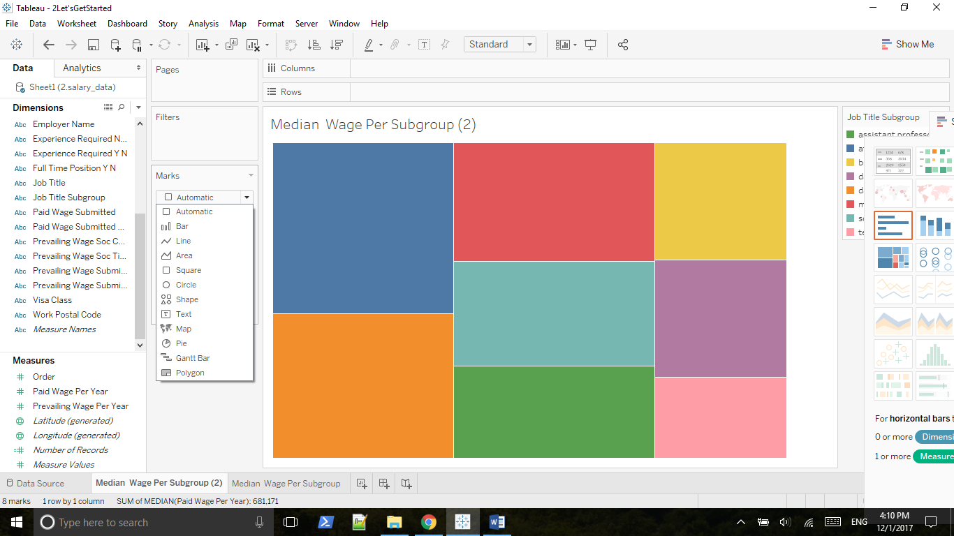

Move job title subgroup to the Label property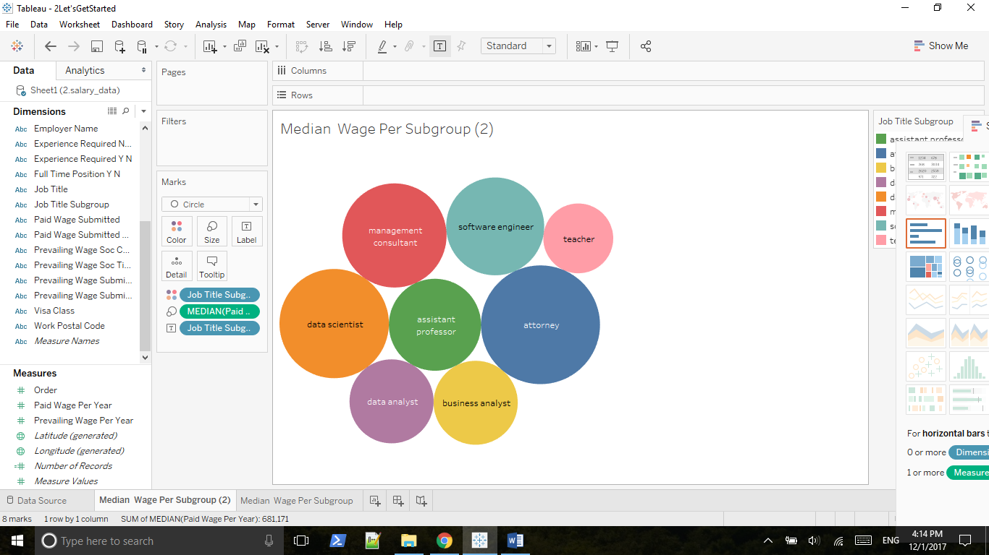

Move Visa Class to Columns

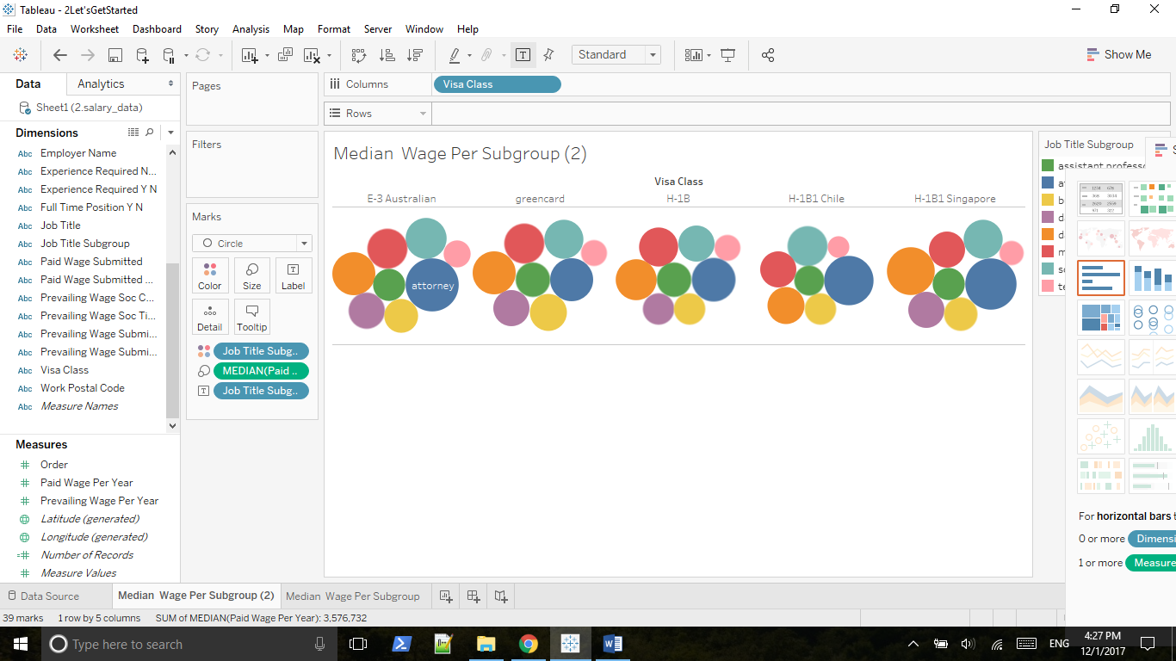

Coding visa class by color, coding the wage per year by size, coding the subgroup by label

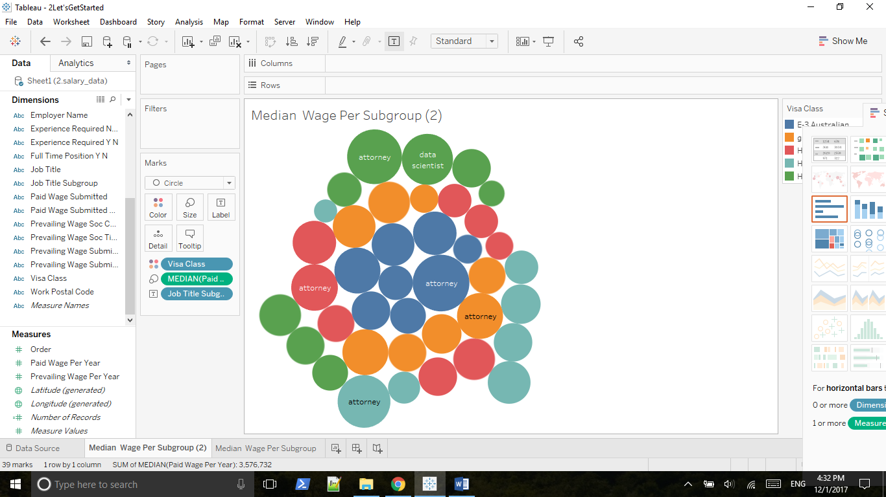

Make label => always show

Press shift together, coding subgroup by color and coding visa class by different shade of the color

Bad interpretation, since shade usually represents a continuous variable

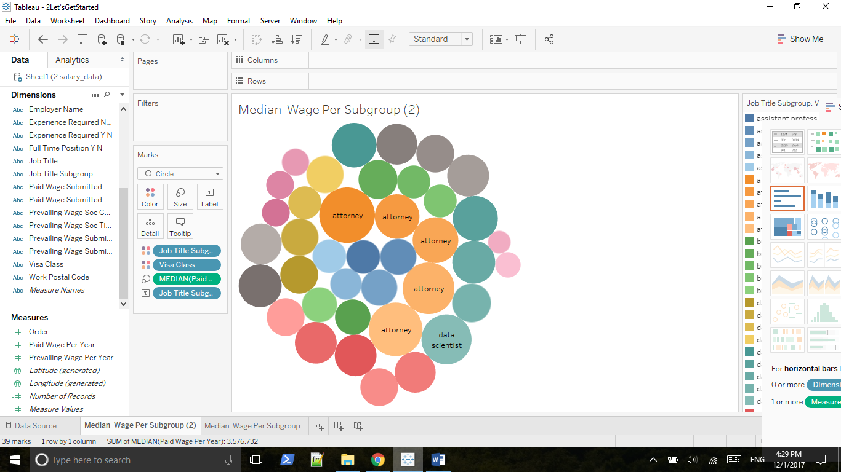

## 2.5 Outliers, Filtering and Groups

### 2.5.1 Removing Outliers Using Scatterplot and Filtering and Groups

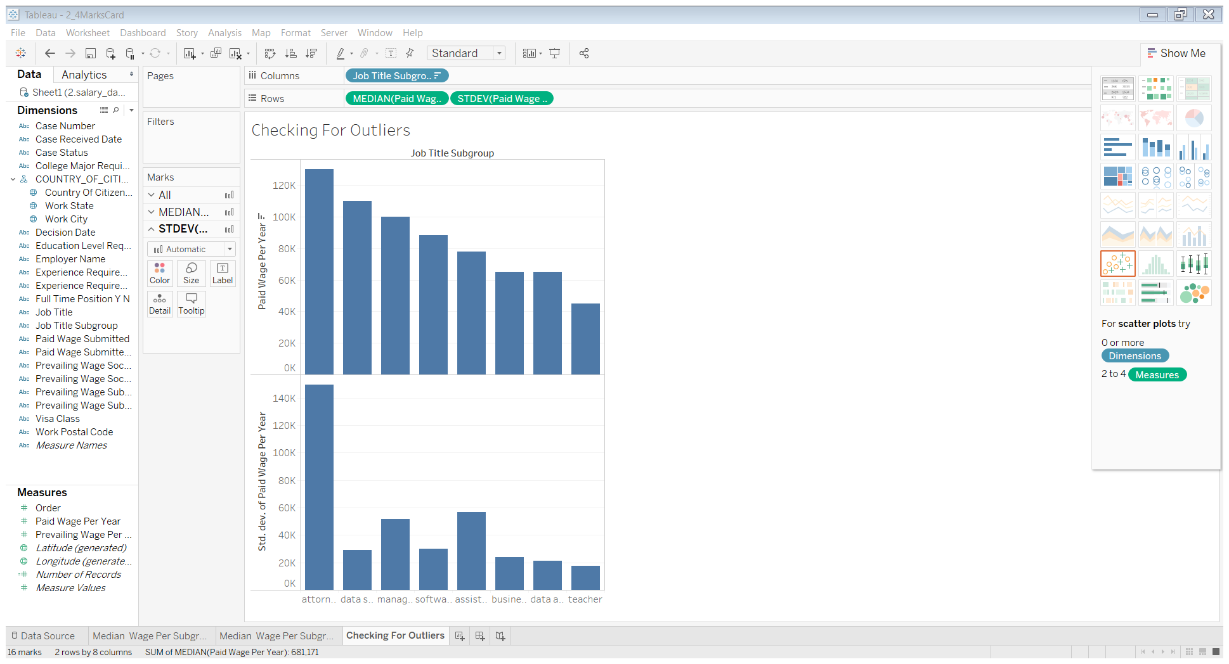

Hypothesis: Attorney group has outliers

Uncheck Analysis => Aggregate measures

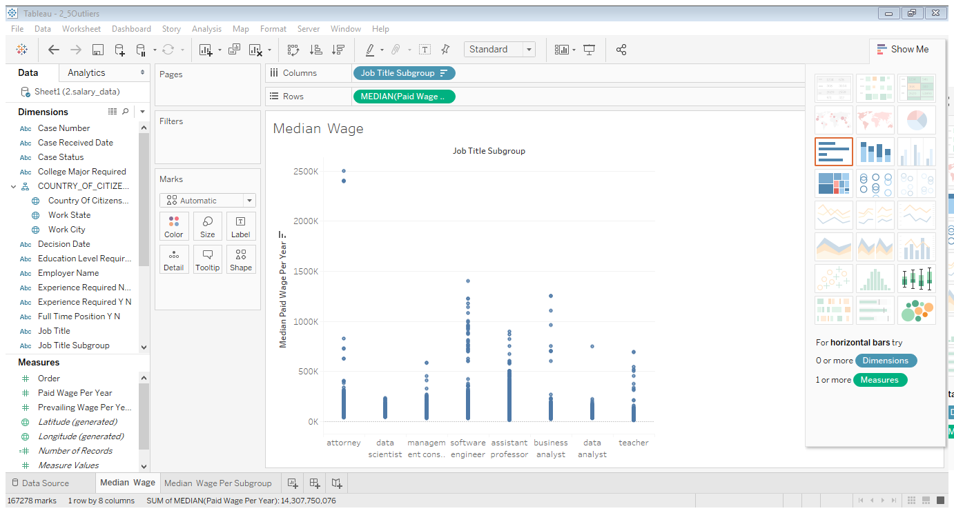

Use a filter, move paid wage per year on filter

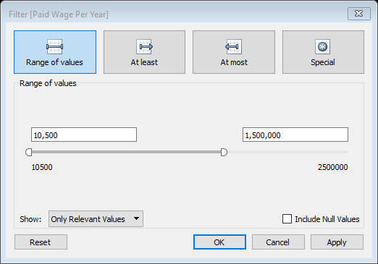

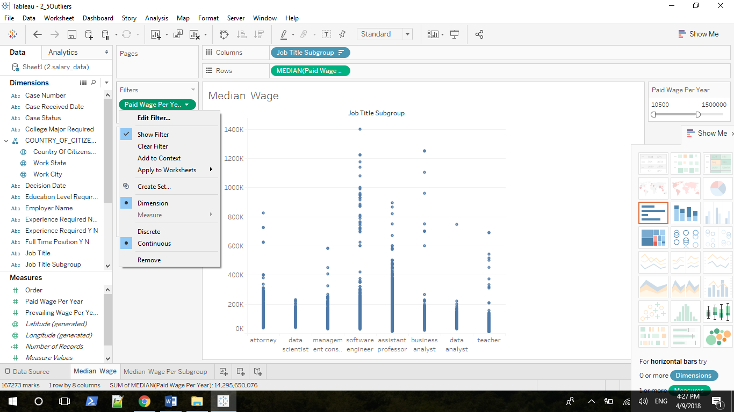

Create a group for outliers: drag case number on top of Detail property

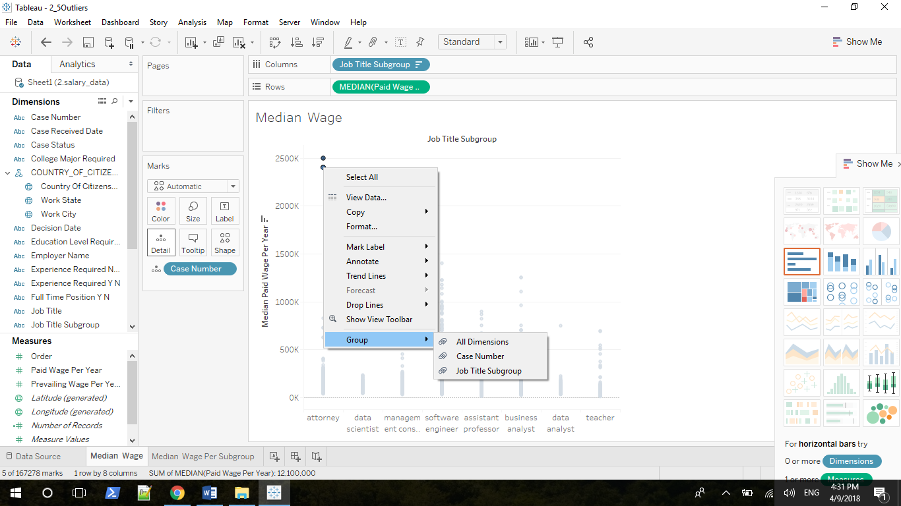

Group by Case Number

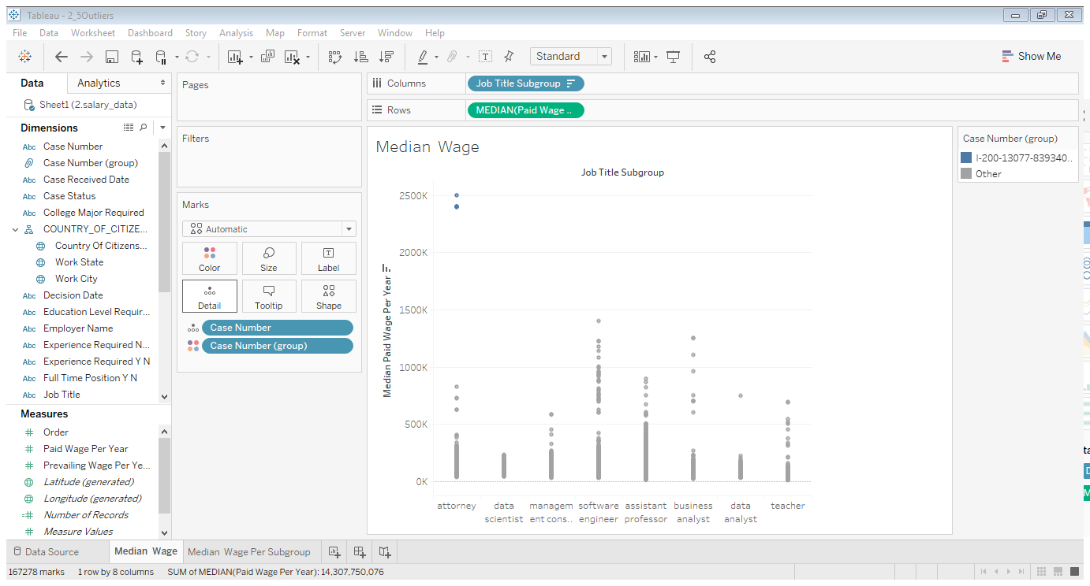

Now we have a Case Number (group), drag it on top of Filters and Show Filter, you can only see Other

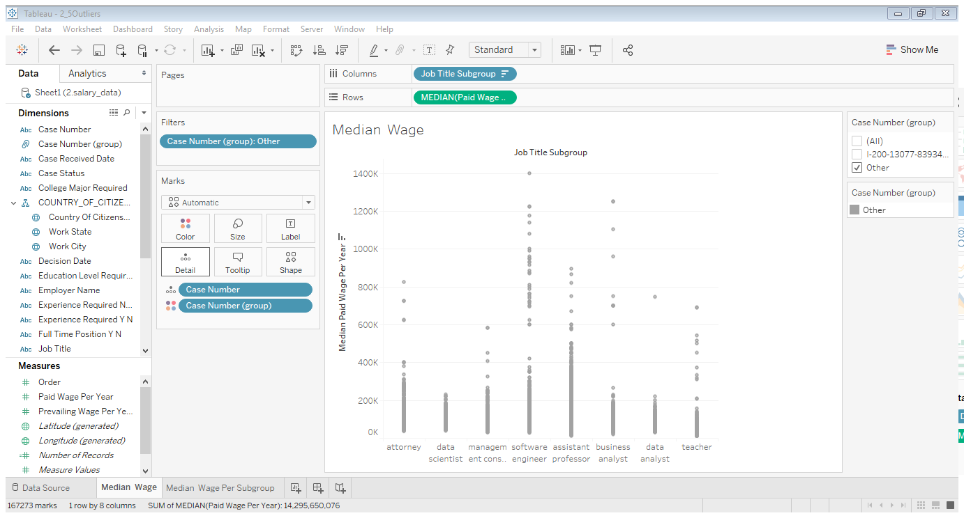

Drag Job Title Subgroup on top of Filters and choose Case Number (group) as Columns

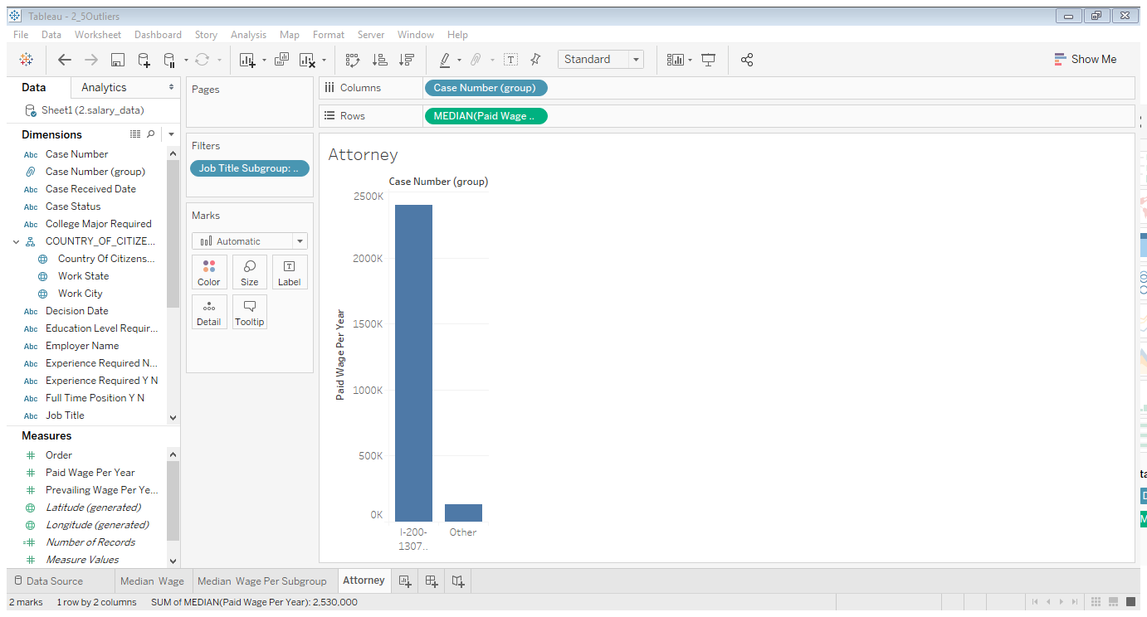

### 2.5.2 Analyzing Data-Related Salaries in Different States Using Filtering and Groups

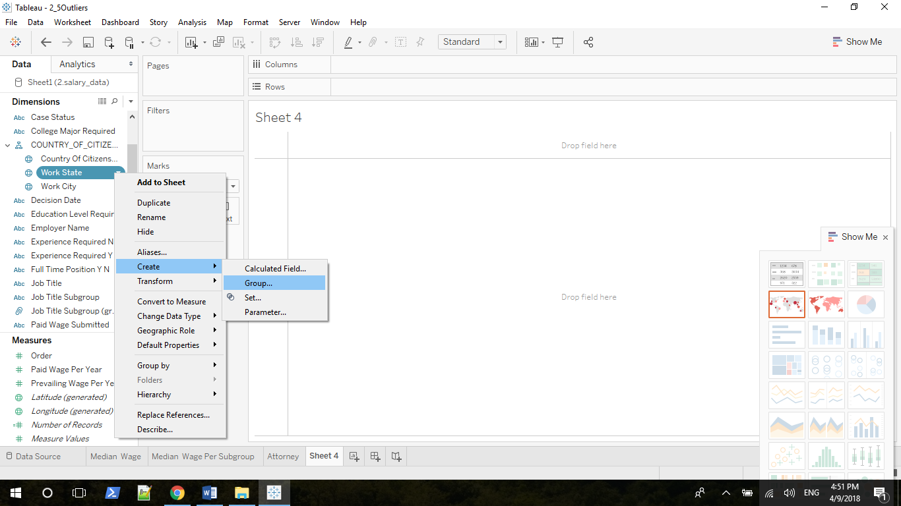

Choose Paid Wage Per Year as Rows, choose Job Title Subgroup and Work State (group) As Columns, and drag Job Title Subgroup on the Color property

You can edit group very easily

## 2.6 Line Graphs and Box Plots

### 2.6.1 When to Use Line Graphs

Line graphs are best for conveying two types of information:

1. How things change over time

2. How two continuous variables relate to one another

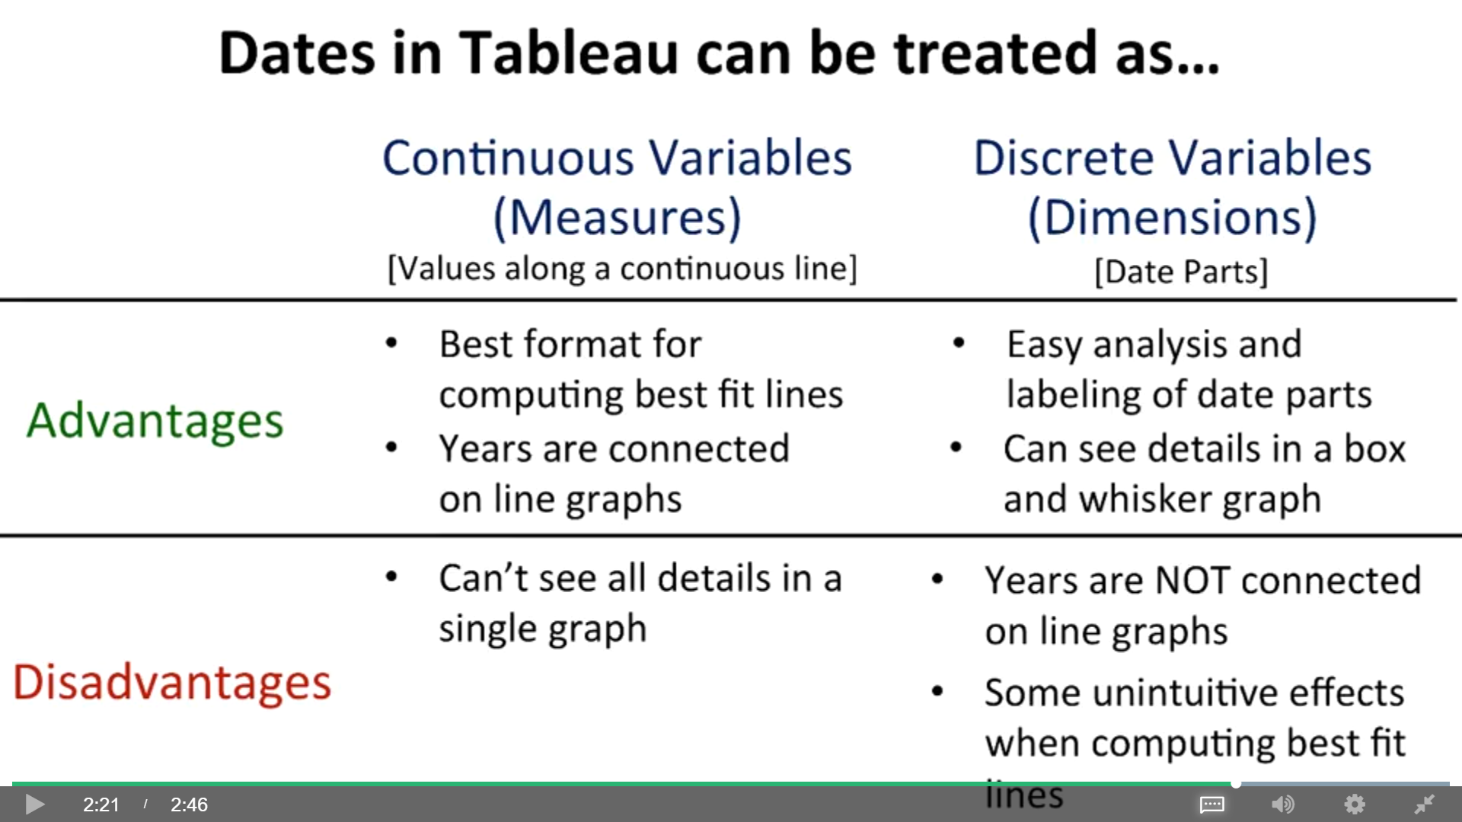

### 2.6.2 Dates as Hierarchical Dimensions or Measures

Treat Case Received Date as Dimensions (categorical variables)

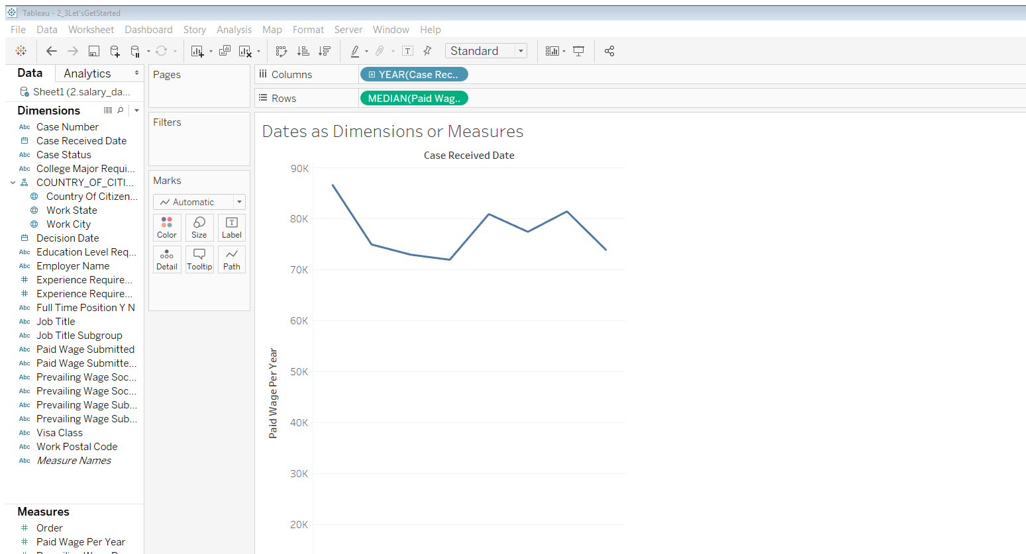

Years vs quarters and months

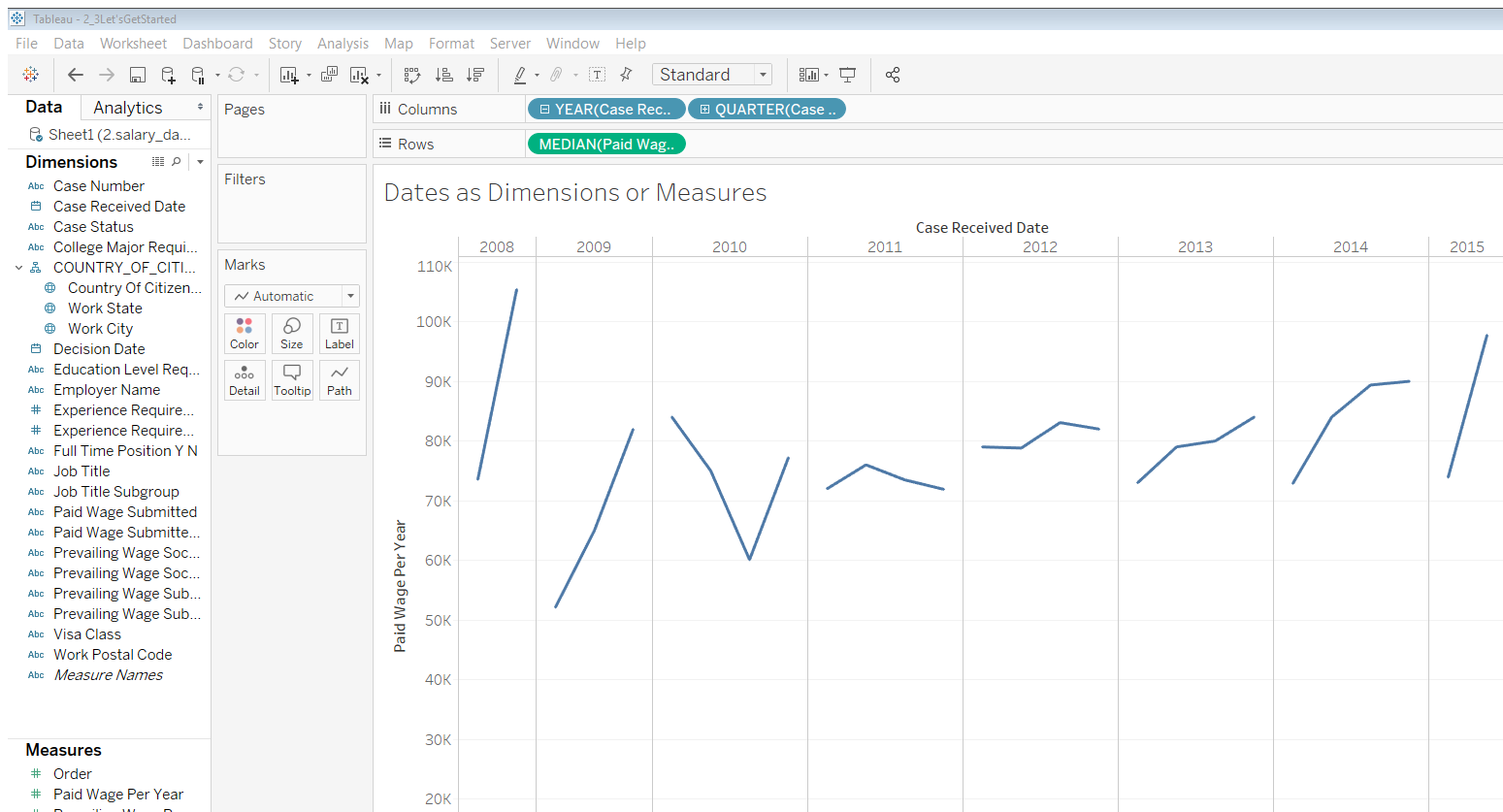

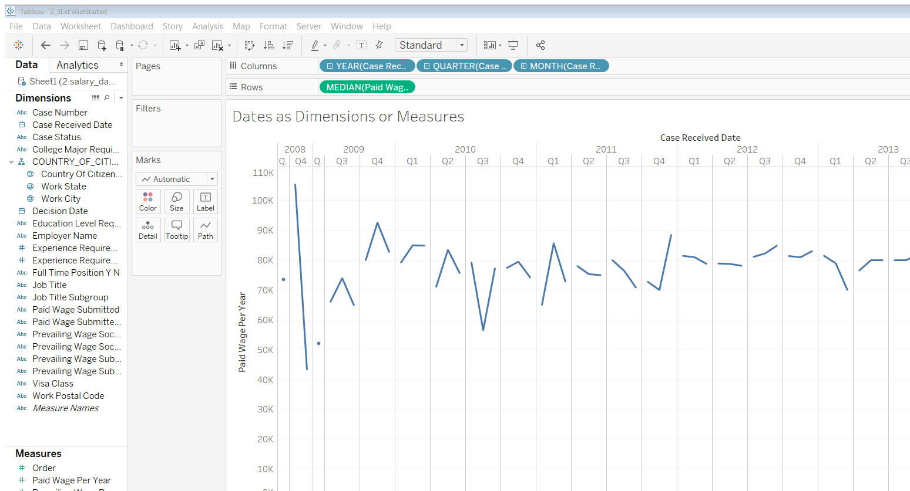

You can create/remove hierarchy

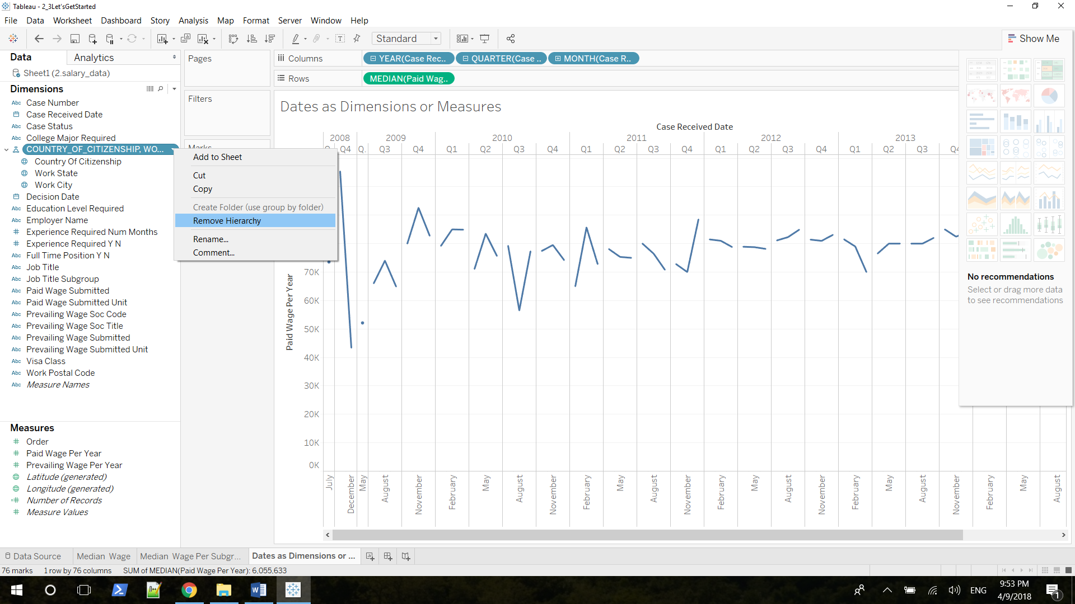

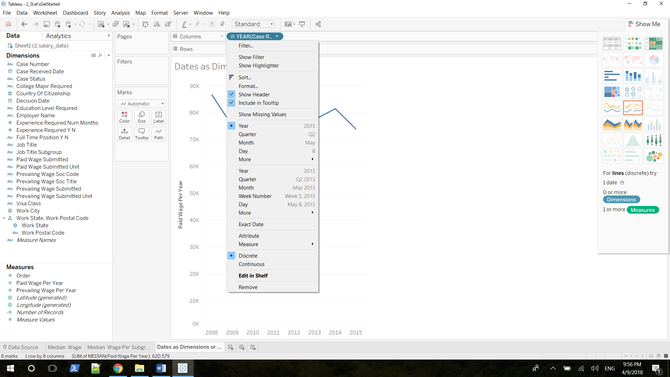

First block refers to all the instances when Tableau treats the data as a dimension, while the second treats date as a measure.

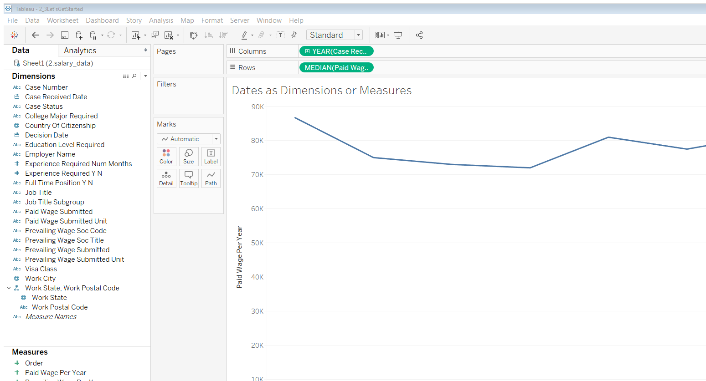

### 2.6.3 Analyzing Data-Related Salaries Over Time Using Date Hierarchies

Filter Case Received Date 1/1/2009

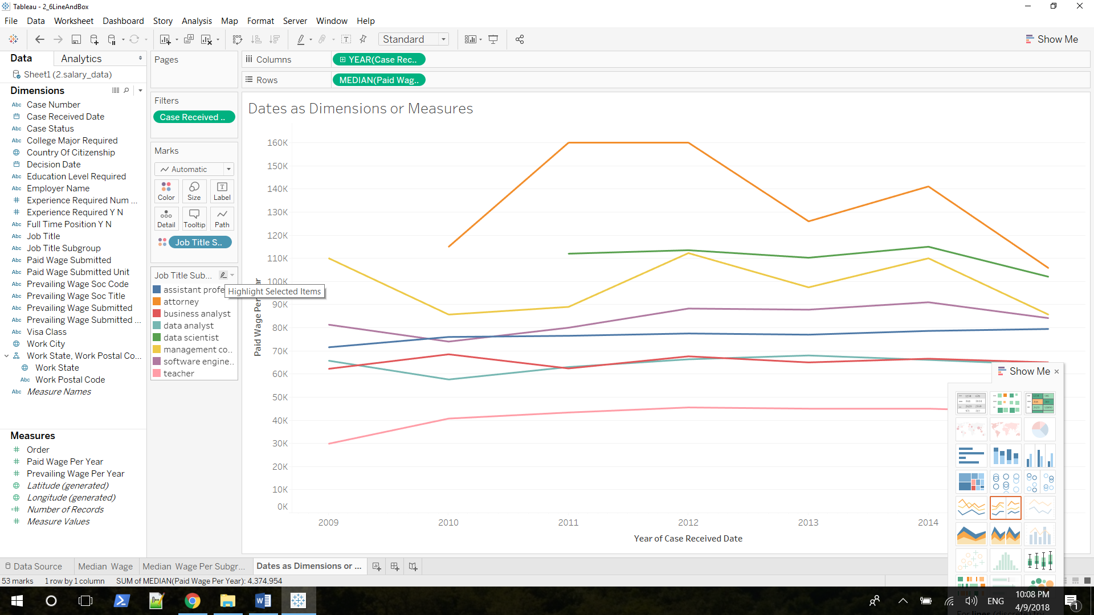

Uncheck Analysis => Aggregate Measures, Change date to measure, and choose Circle View from Show Me card

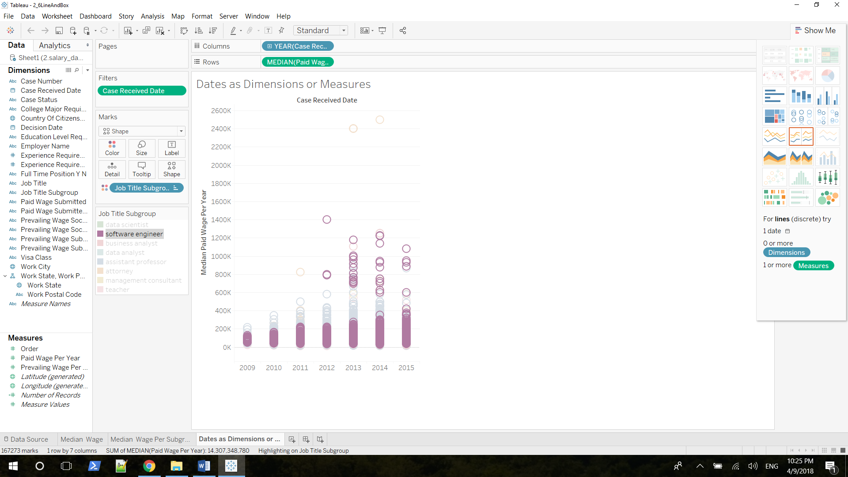

Software engineer looks very different. If you look at the very bottom values of these pink dots, it does look like their going down, but it also looks like the top values of each one of these blobs is going up. It's also obvious that there are a whole lot more outliers over time. So, there are a lot more individual instances of very high salaries for software engineers

Go back to line chart, you can see max goes higher and min goes lower

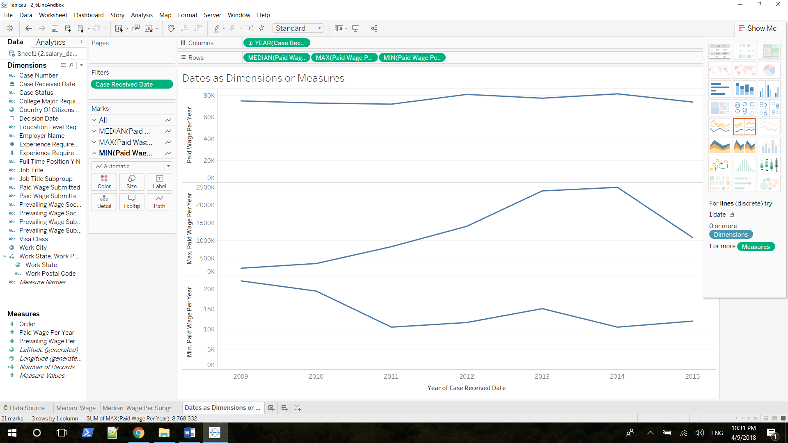

### 2.6.4 Analyzing Data-Related Salaries Over Time Using Trend Lines

Regression, best-fit line/ trend line

p-value should < 0.005 or 0.001

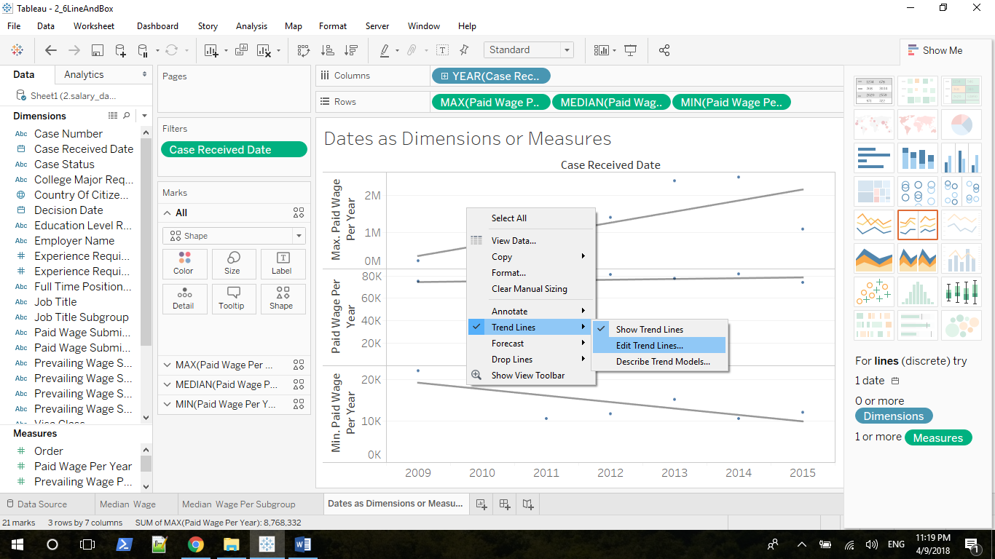

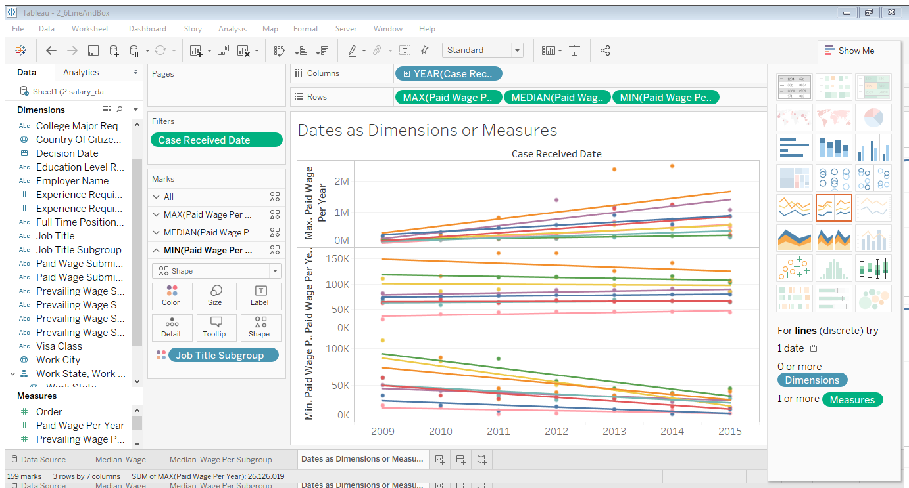

**Just look at the Data Scientist line**

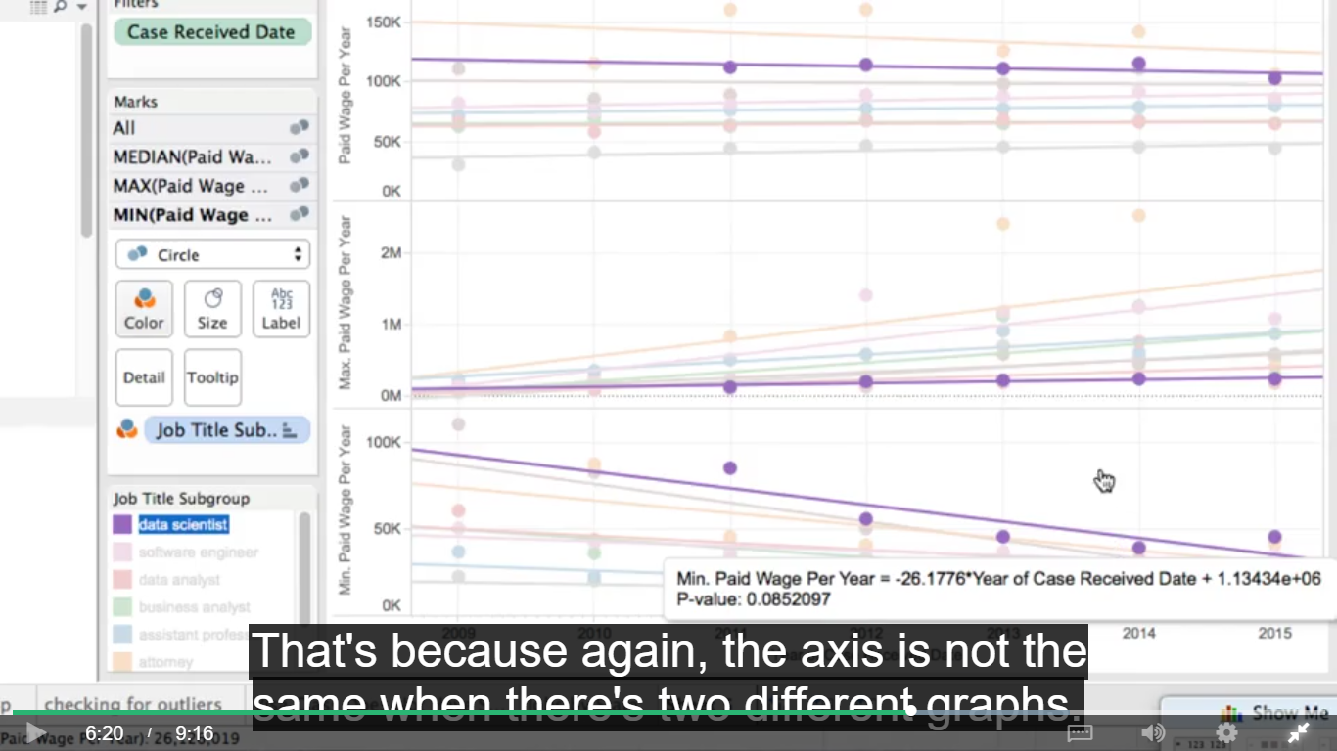

**Uncheck allow trend line per color will give you a trend line for all of the data aggregated together**

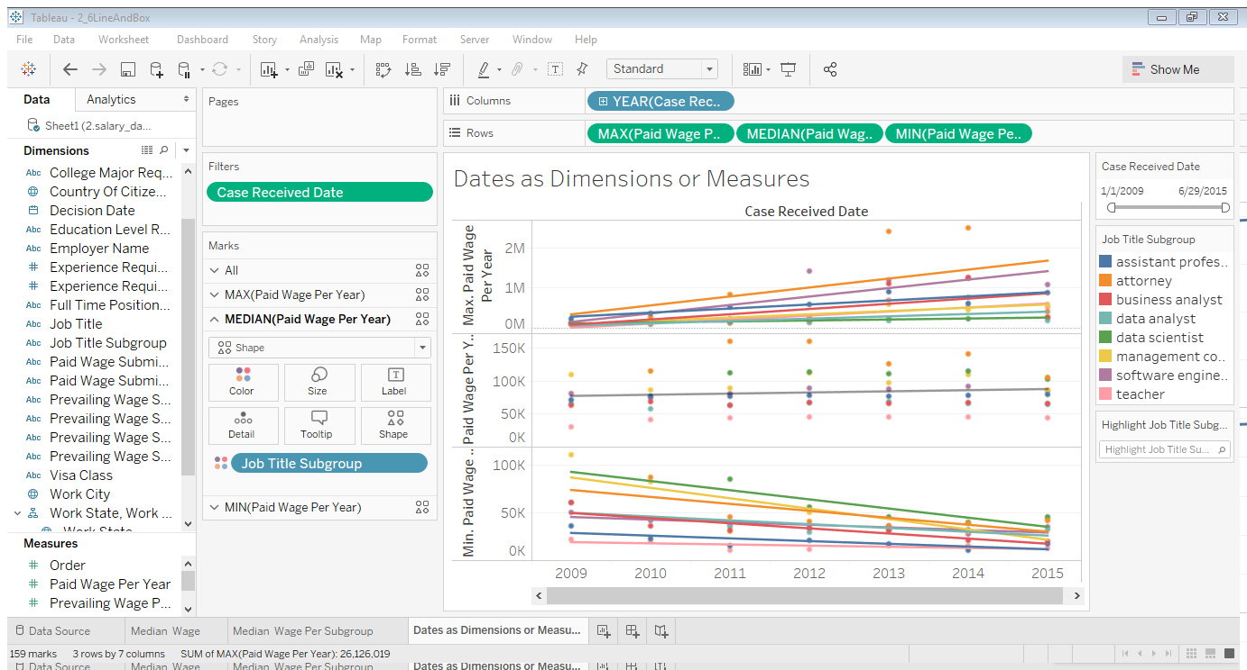

### 2.6.5 Analyzing Data-Related Salaries Over Time Using Box Plots

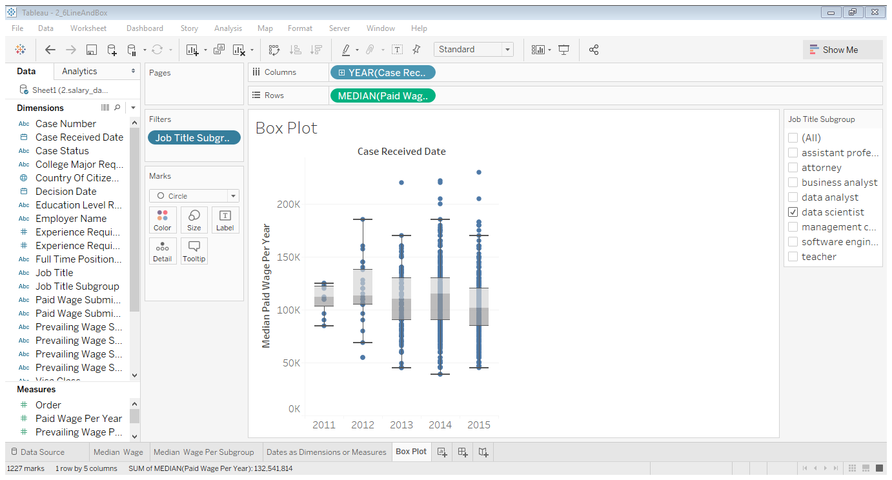  
can’t use color to divide into different boxes, not like trend line

Remember, this box shows you where 50% of your data is. 25% of your data is above this line, and 25% of your data is below this line. And so it's clear here, that over time, there are more and more salaries that have lower and lower values. There are also more and more salaries that have higher values. So this is showing us in an even stronger way than before, that although the median doesn't seem to be changing all that much, again remember, the median is this line here. It seems to be increasingly possible to get both a higher wage, and the lower wage than the median

Edit axis, cut out some outliers but to compare with data scientist more carefully

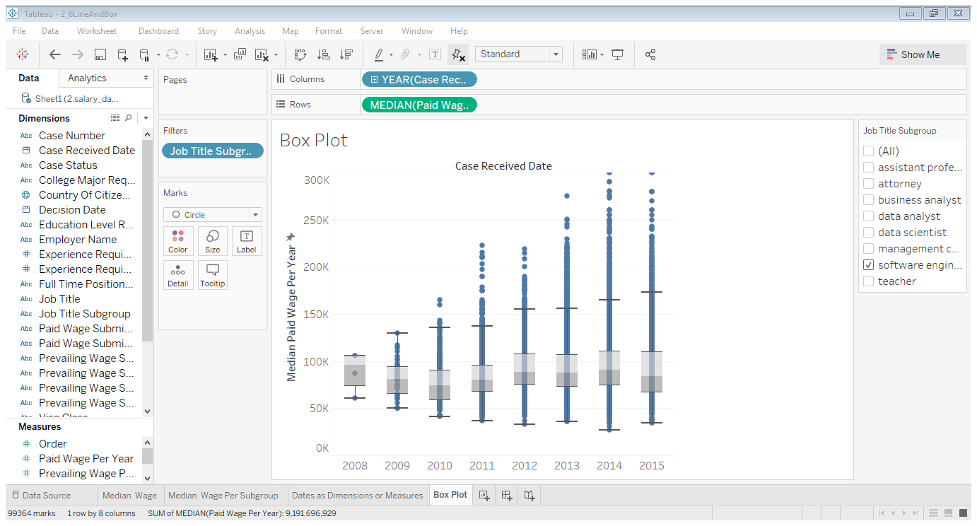

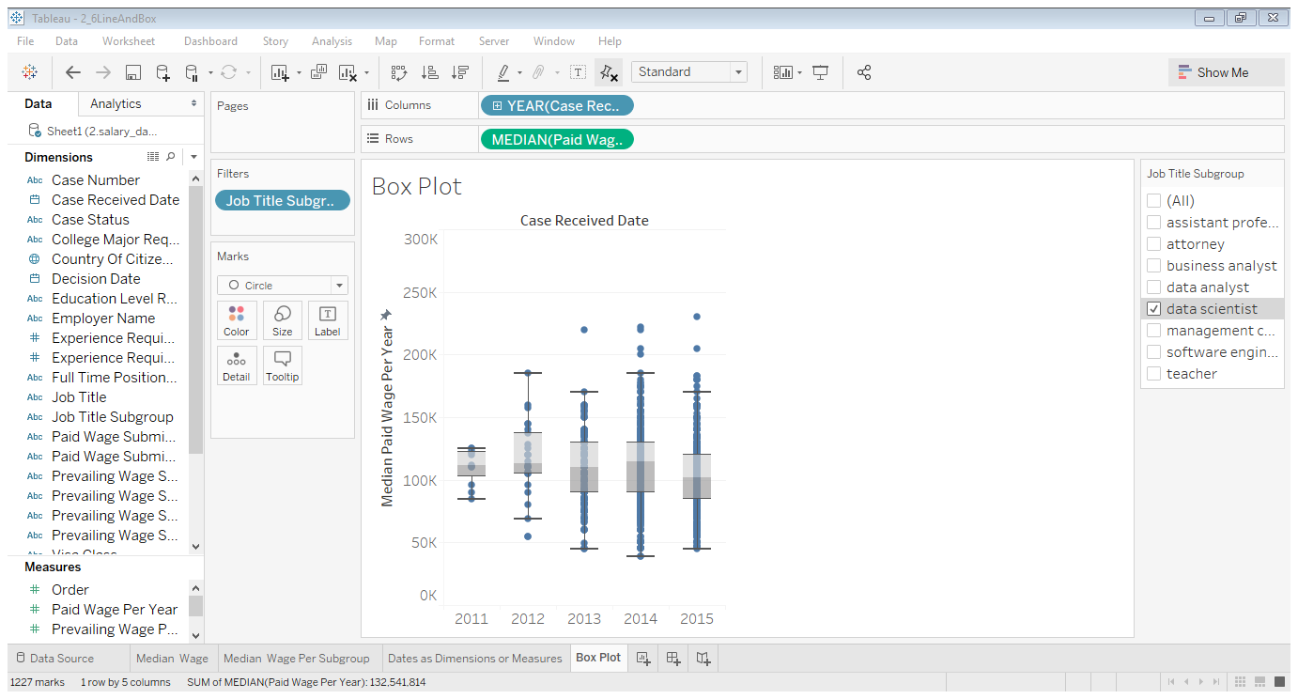

# Week3 Dynamic Data Manipulation and Presentation in Tableau

## 3.1 Row-level Calculations

### 3.1.1 Tableau Calculation Types

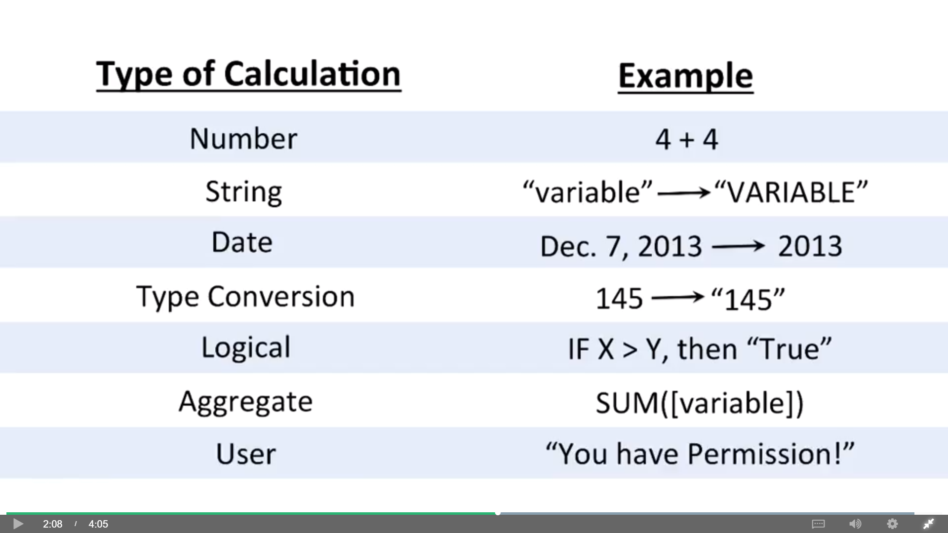

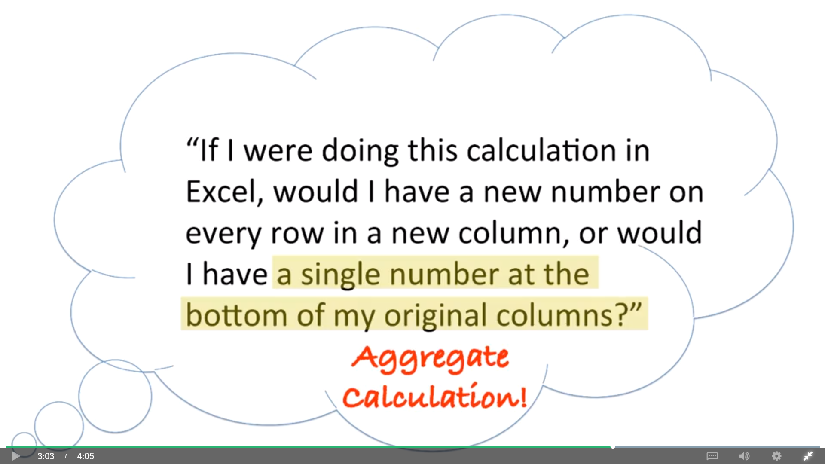

Table calculation: These are calculations you do only in the data you have in your visualization and only as it is organized in your visualization. You can think of these calculations as Tableau doing math in its head. These are extremely powerful, but they can also be some of the toughest parts of Tableau to master.

Click Replaced Data Source and close the old data

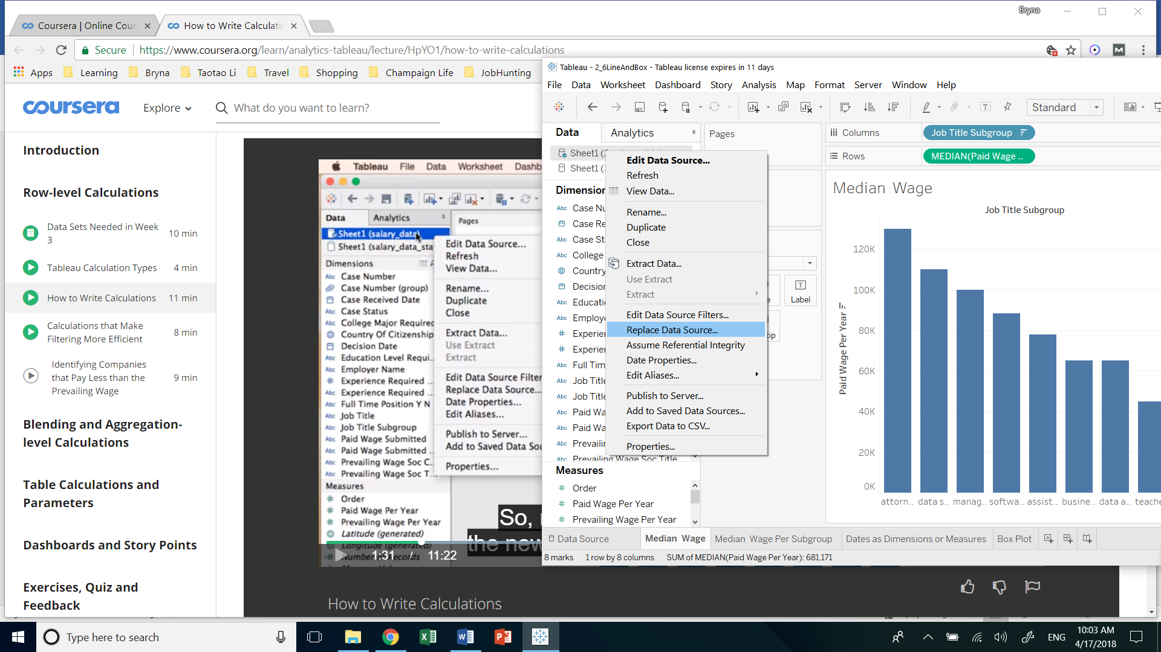

Create calculations( or Analysis => Create Calculation Fields)

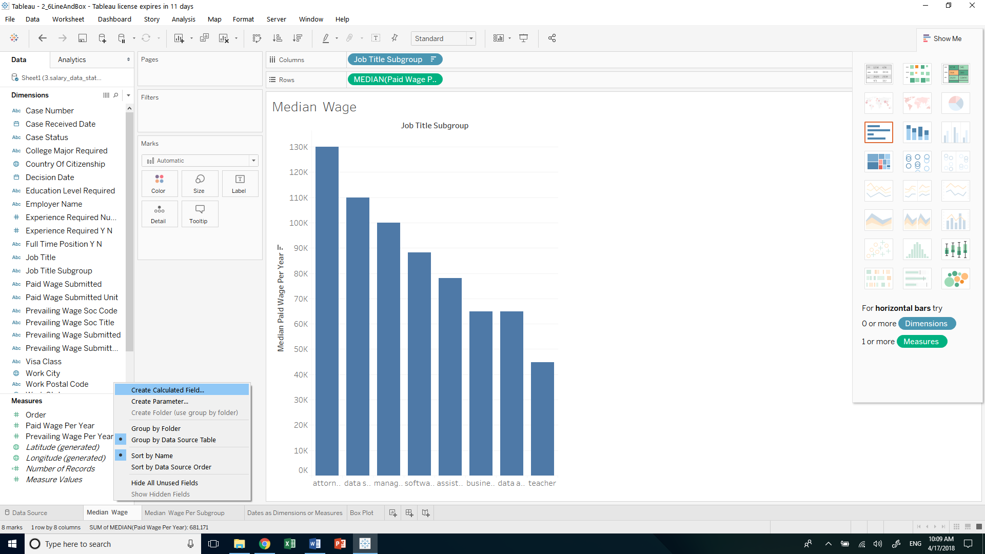

Variable in orage, variable name in [], notice the error message

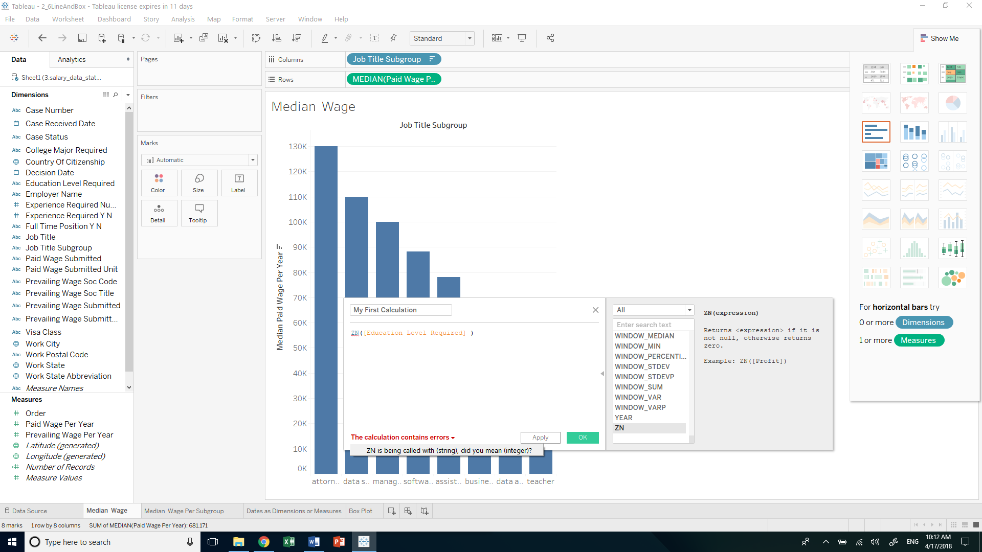

Single quotation or double quotation is fine

Comments start with // (just like Java)

Bold means aggregated results

Little = in front of the measure name means it’s a calculation

### 3.1.2 Calculations that Make Filtering More Efficient

Row calculation: makes a different number for every single row

Another way of filter:

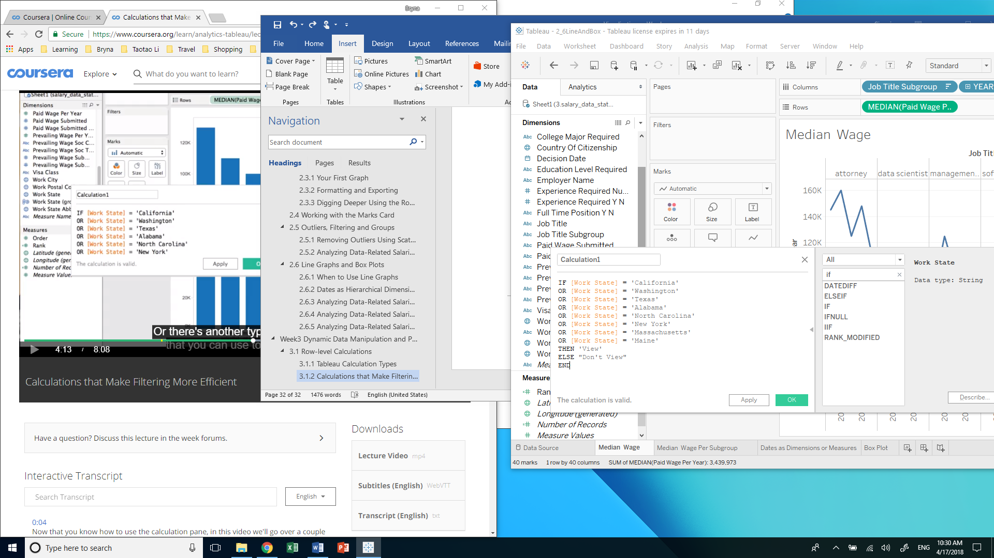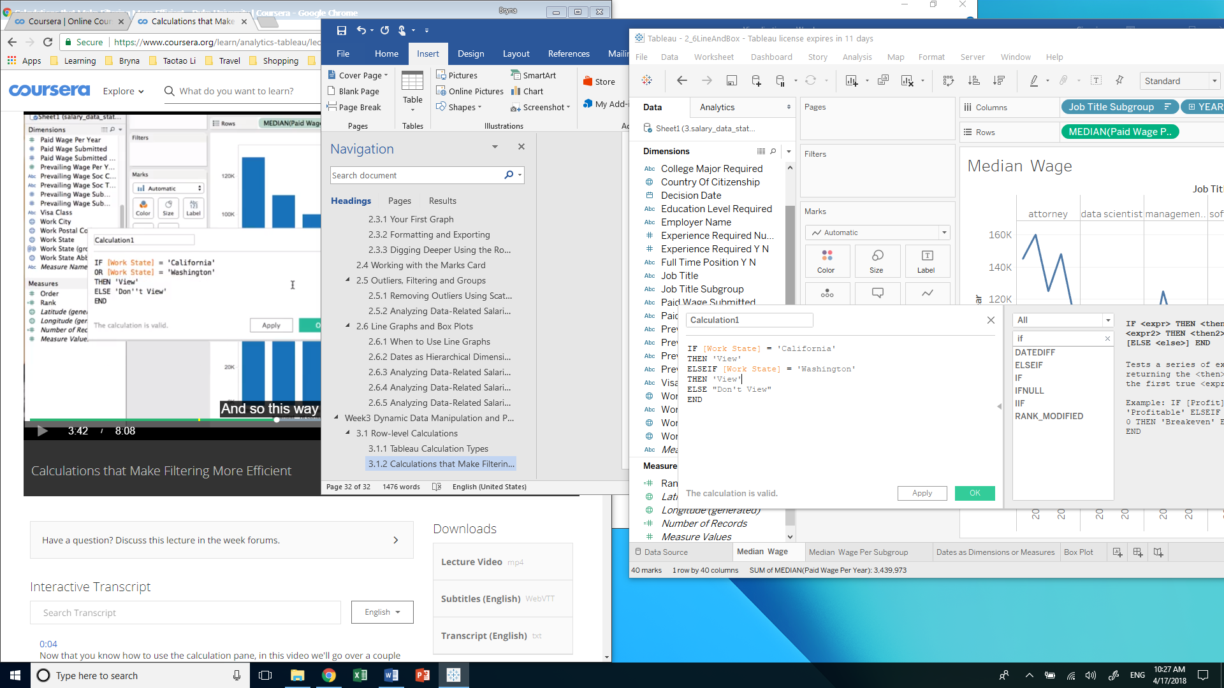

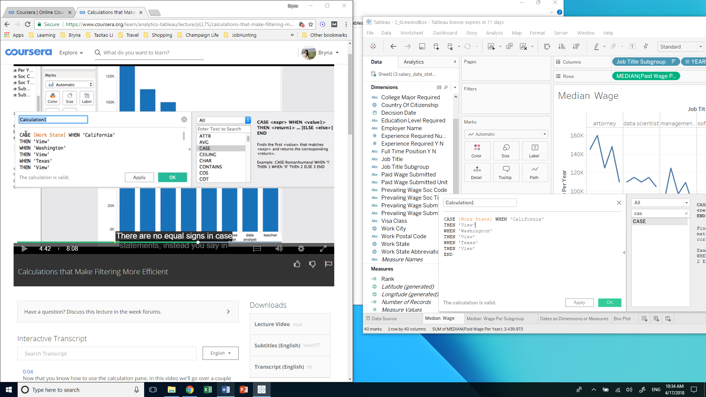

Drag States We are Interested in (our calculation) to Filters and only show View

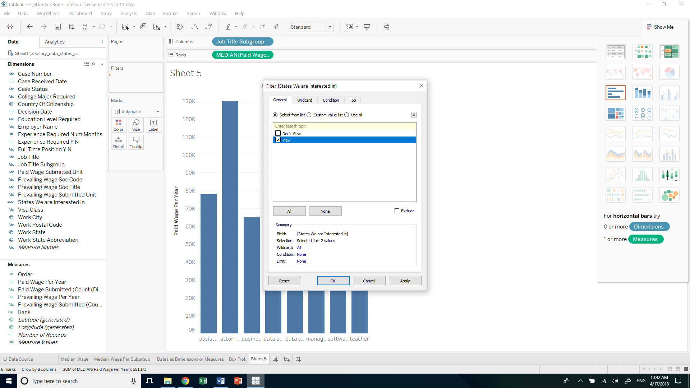

Then drag Work State to Columns and Job Title Subgroup on Color

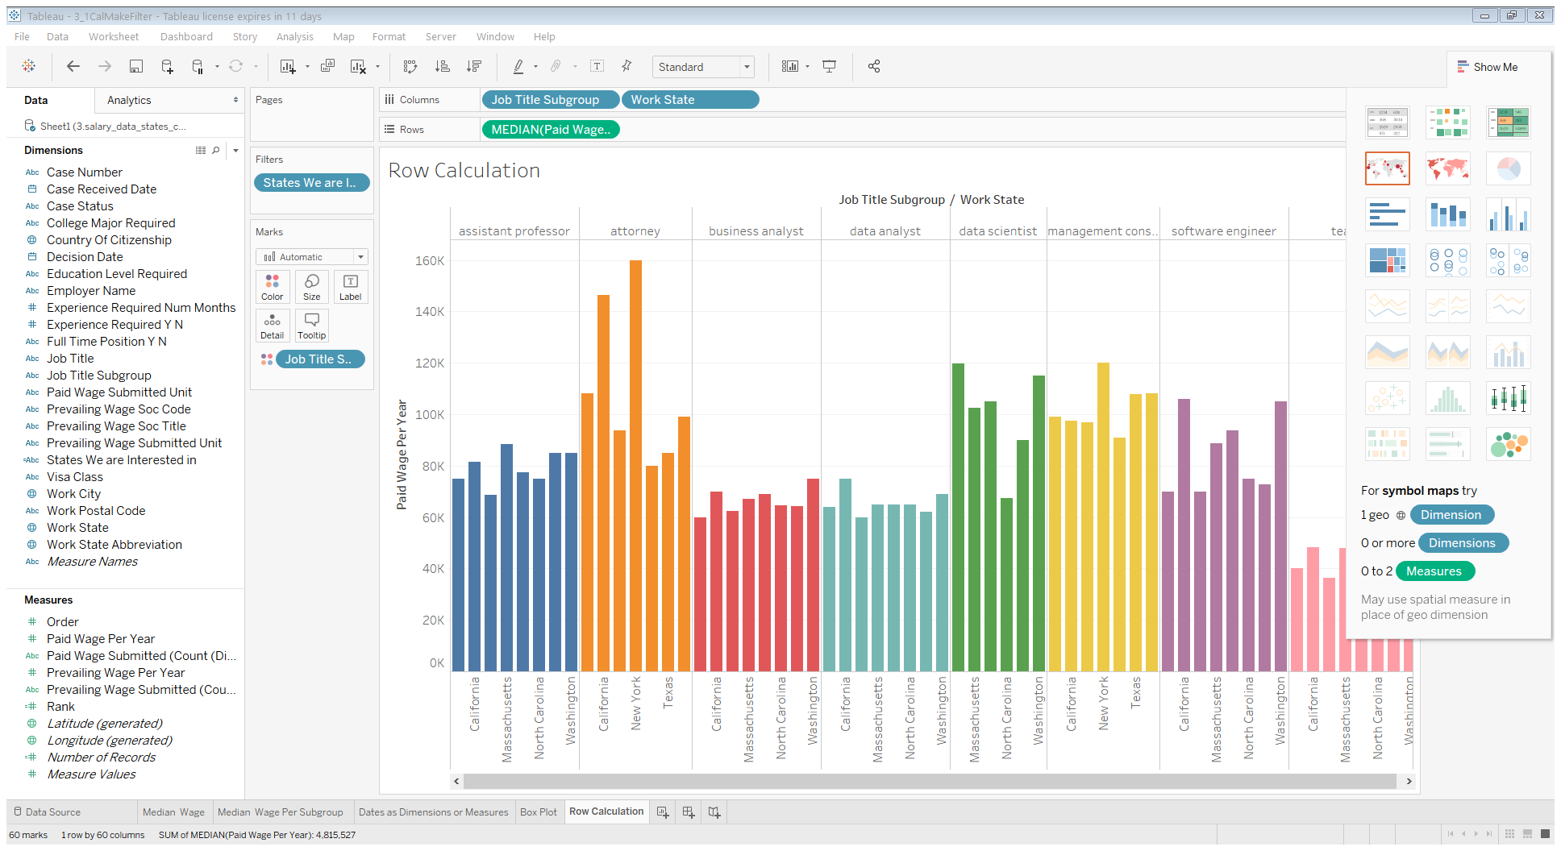

### 3.1.3 Identifying Companies that Pay Less than the Prevailing Wage

Create Difference between Prevailing and Paid Wage

Use it as Rows (change SUM to MEDIAN)

Use Job Title Subgroup as Columns

Analysis => Uncheck Aggregate Measures

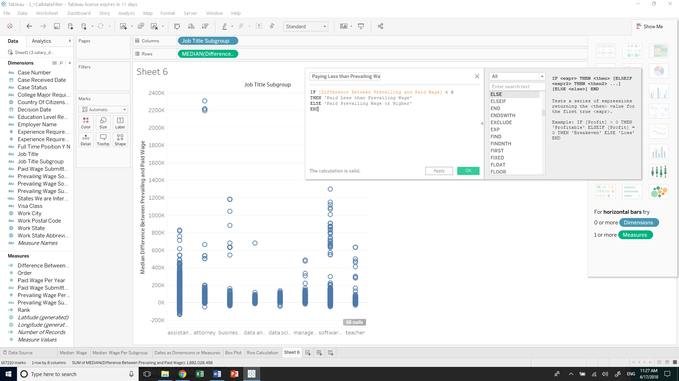

We can make calculation with calculations

Drag Paying Less than Prevailing Wage on Filters and only view Less than

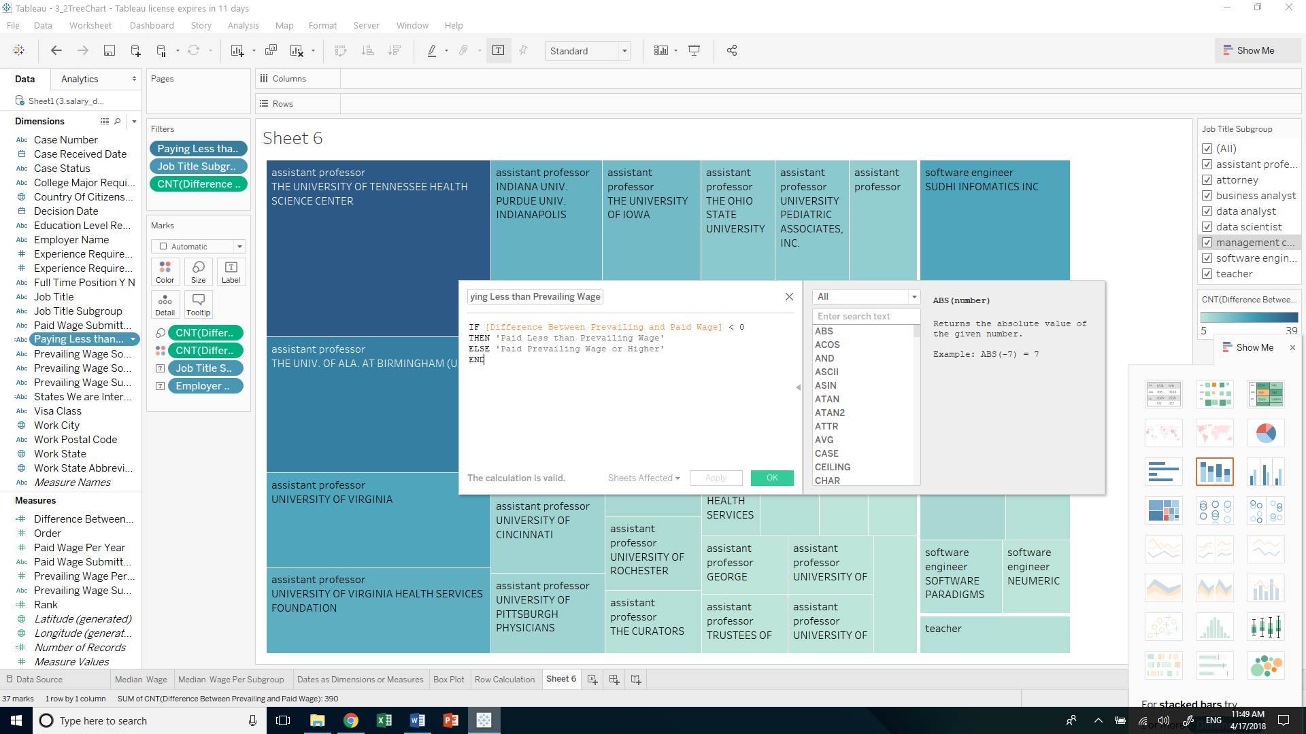

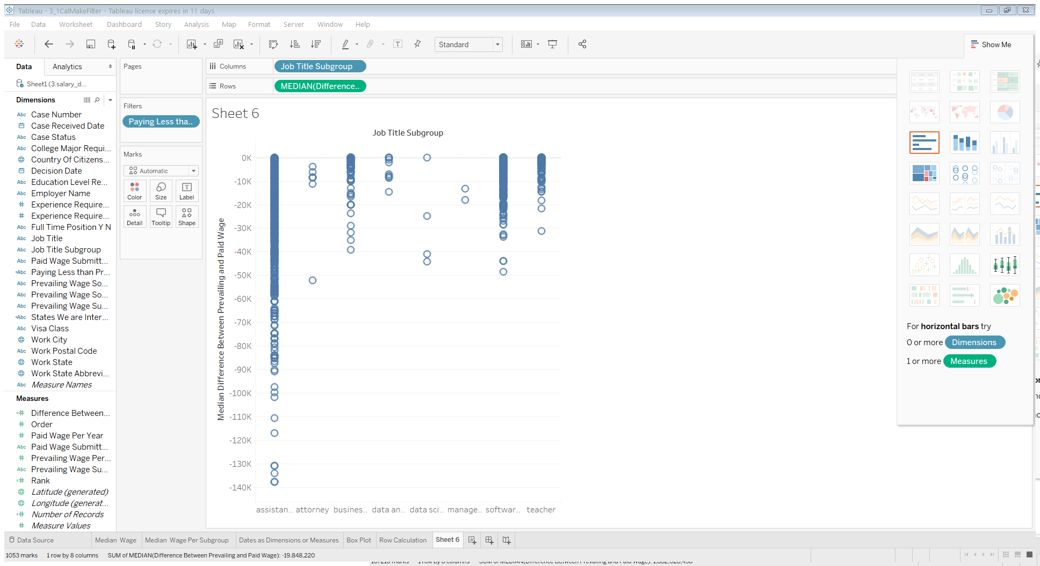

Question:

Are there some companies that are consistently and systematically paying less than the prevailing wage, or are these all just kind of flukes and every company does it once or twice?

Filter Job Title Subgroup and only check data-related jobs

Aggregate measures, change MEDIAN to CNT, change automatic to Circle (Marks card)

Put Employer Name on Size (Marks Card) and make it a Tree Chart

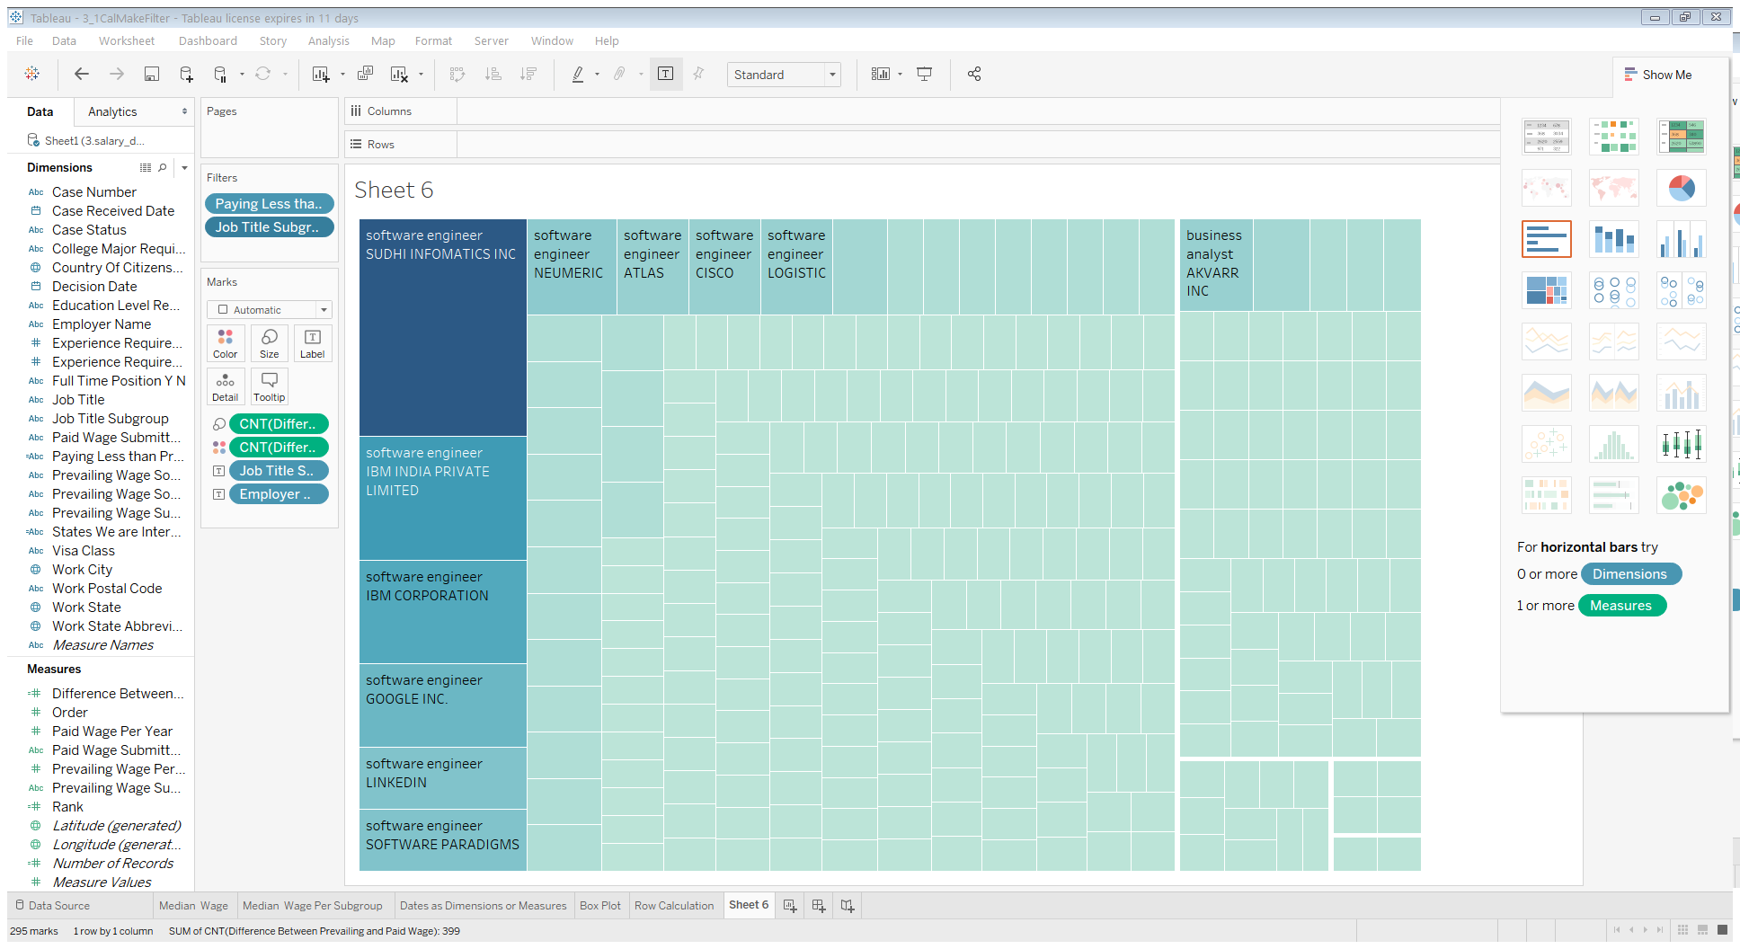

Filter: only look at software engineer

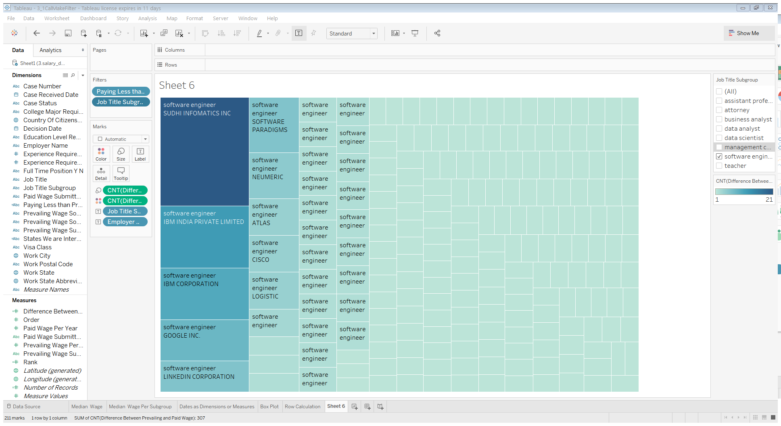

Drag Difference Between to Filter and Count, At Least, 5

means companies have at least five instances where they paid less than the prevailing wage

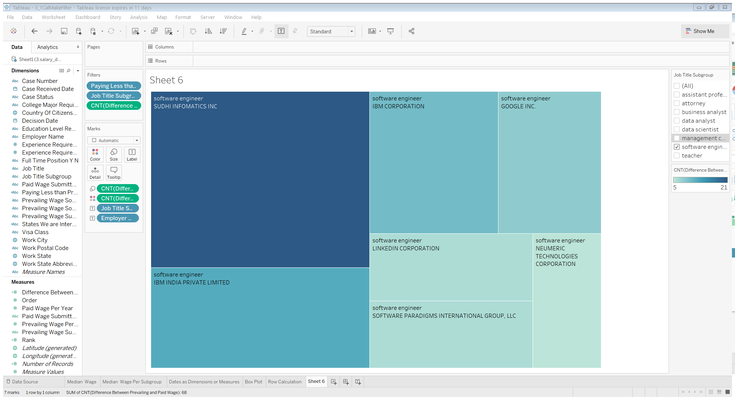

We get an empty chart for business analyst, data analyst, data scientist

## 3.2 Blending and Aggregation-level Calculations

### Blending Price Parity Data with Our Salary Data

Data blending is a way to put two different sources of data together when those two different sources have different levels of aggregation.

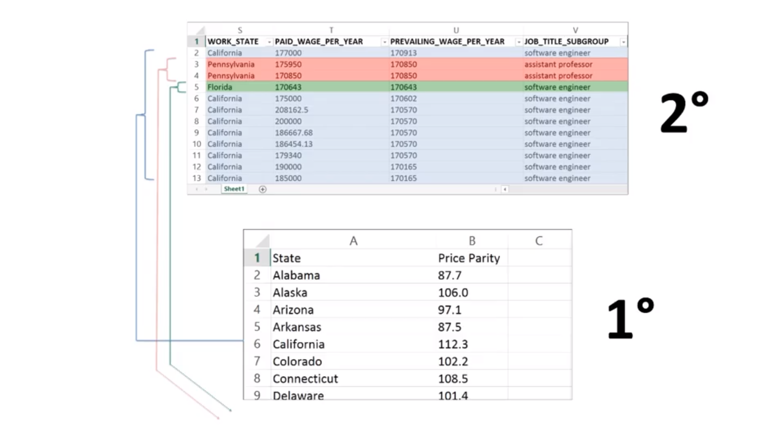

This temporary table it has to store will be much smaller if we aggregate the larger table first, and then link the tables, rather than filling in every single row of the larger table with a repeated copy of the value in the smaller table and then aggregating at the end. In Tableau speak, this means that when you blend, the smaller dataset with the more coarse level of granularity should be the primary data source, and the larger data set with the more detailed level of granularity should be the secondary data source

values that are found in the larger table, but not the smaller table, will not get incorporated into the results. On the flip side, values that are found in the smaller table but not the larger table will be included as null values.

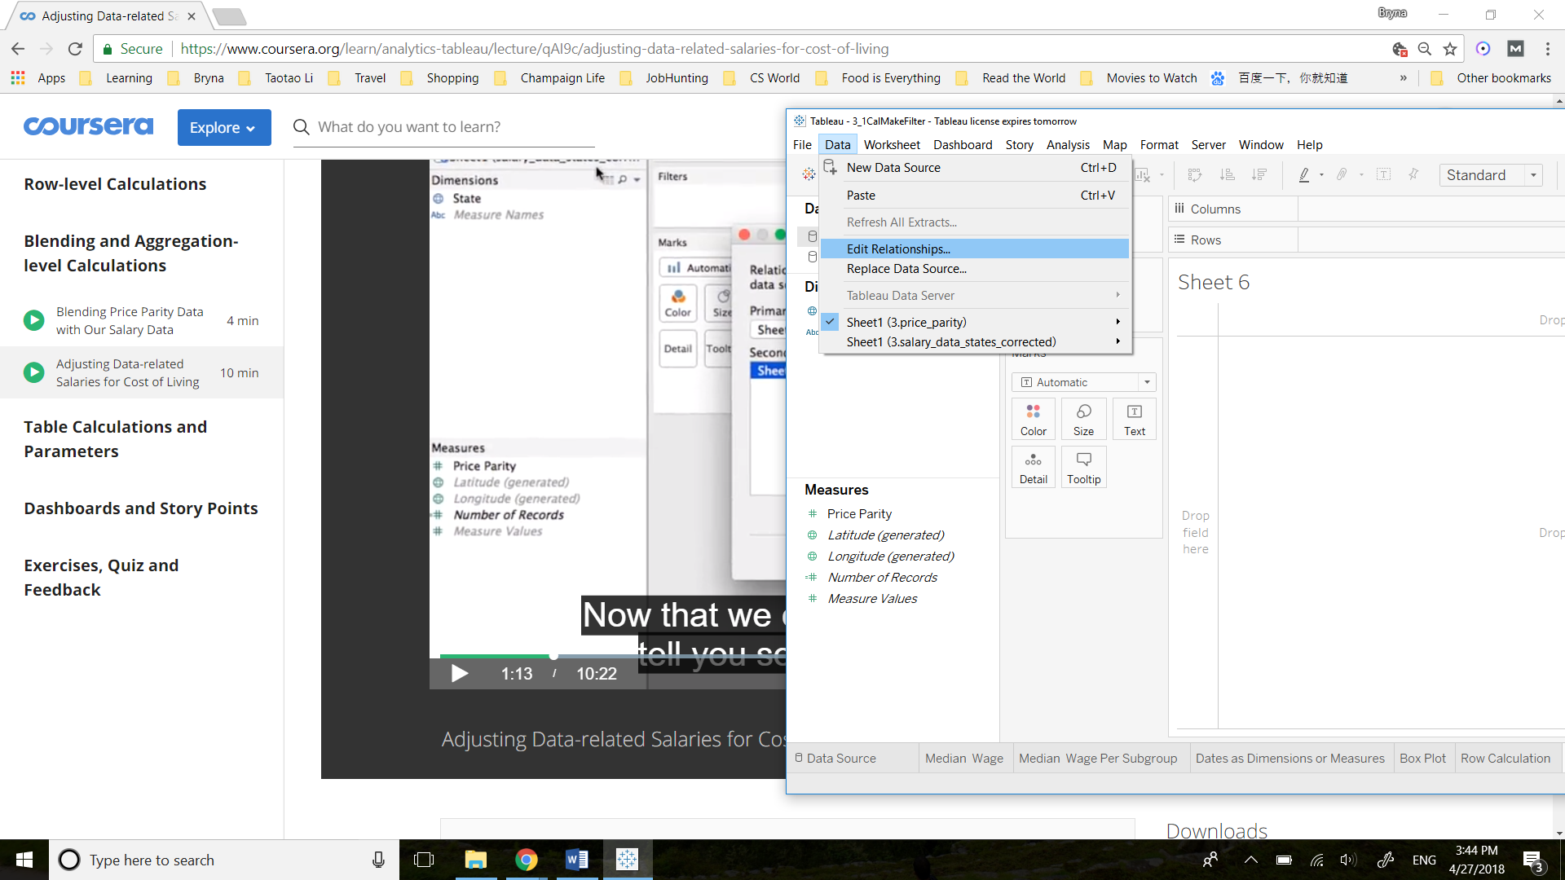

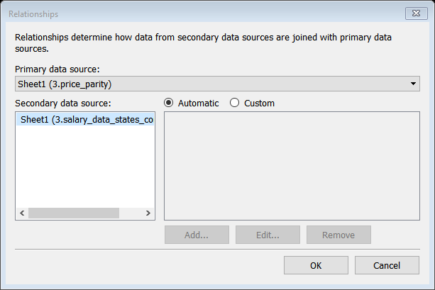

Adjusted Paid Wage = MEDIAN ([Paid Wage Per Year]) / ATTR([Sheet1 (3.price_parity)].[Price Parity]) * 100

Use State as Columns, put Median(Paid Wage Per Year), Adjusted Paid Wage, Price Parity on top of Text Marks, and Filers State We are Interested

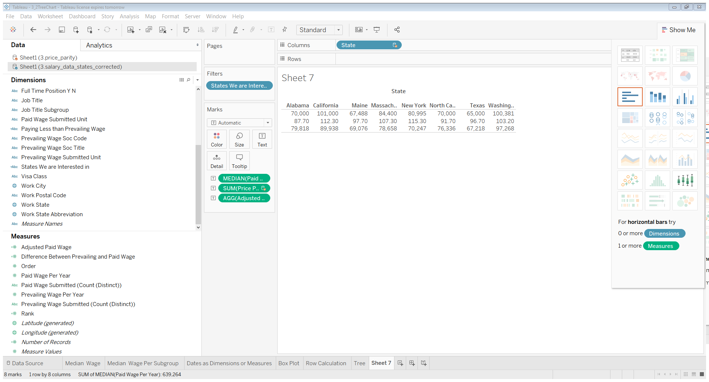

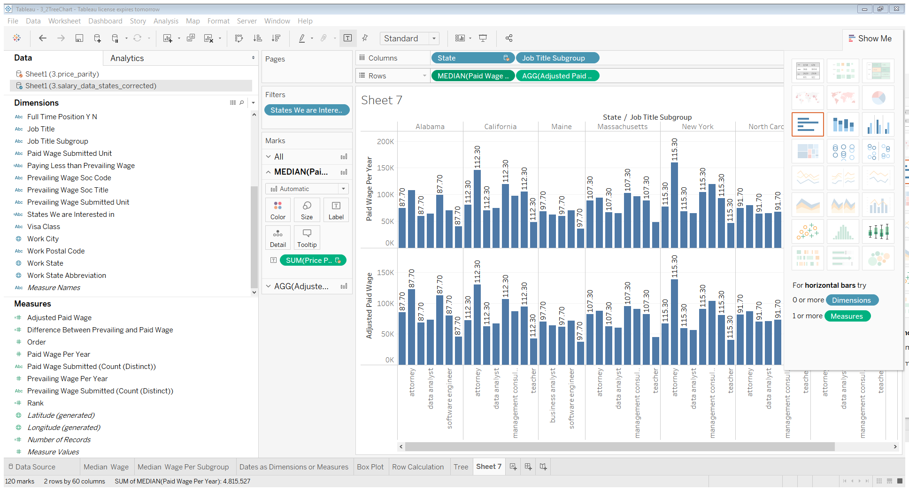

How to compare paid wage per year and adjusted paid wage per year more directly?  
1. Move Adjusted to the Y-axis of Paid

2. Move Measure Names onto Size Marks

3. Ctrl + move Measure Names onto color

Then you will have adjusted overlaid on paid

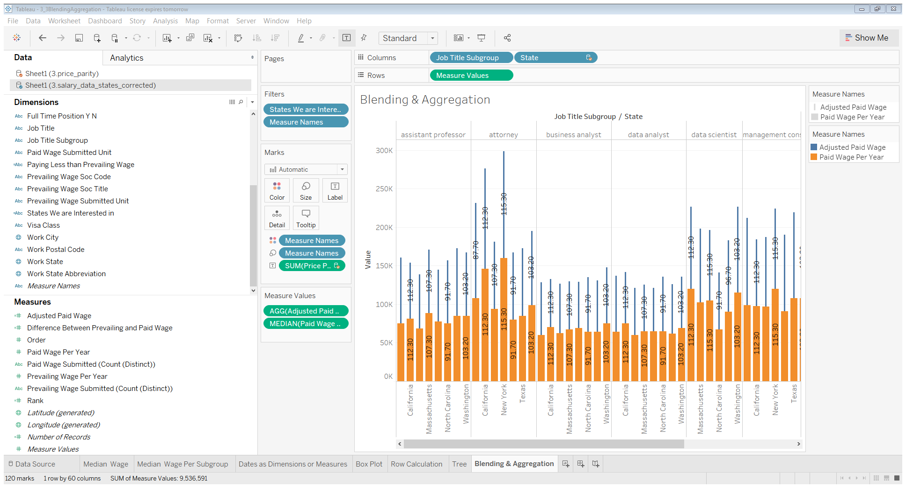

Getting stacked bars instead of overlaid bars:

Go to toolbar -> Analysis -> Stocks Marks -> OFF

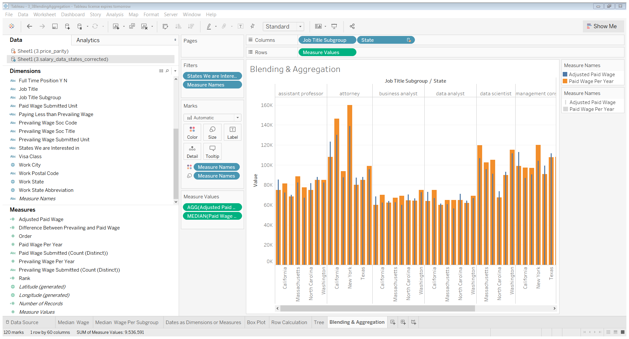

## 3.3 Table Calculations and Parameters

### 3.3.1 Calculating Which States Have the Top Adjusted Salaries within Job Subcategories

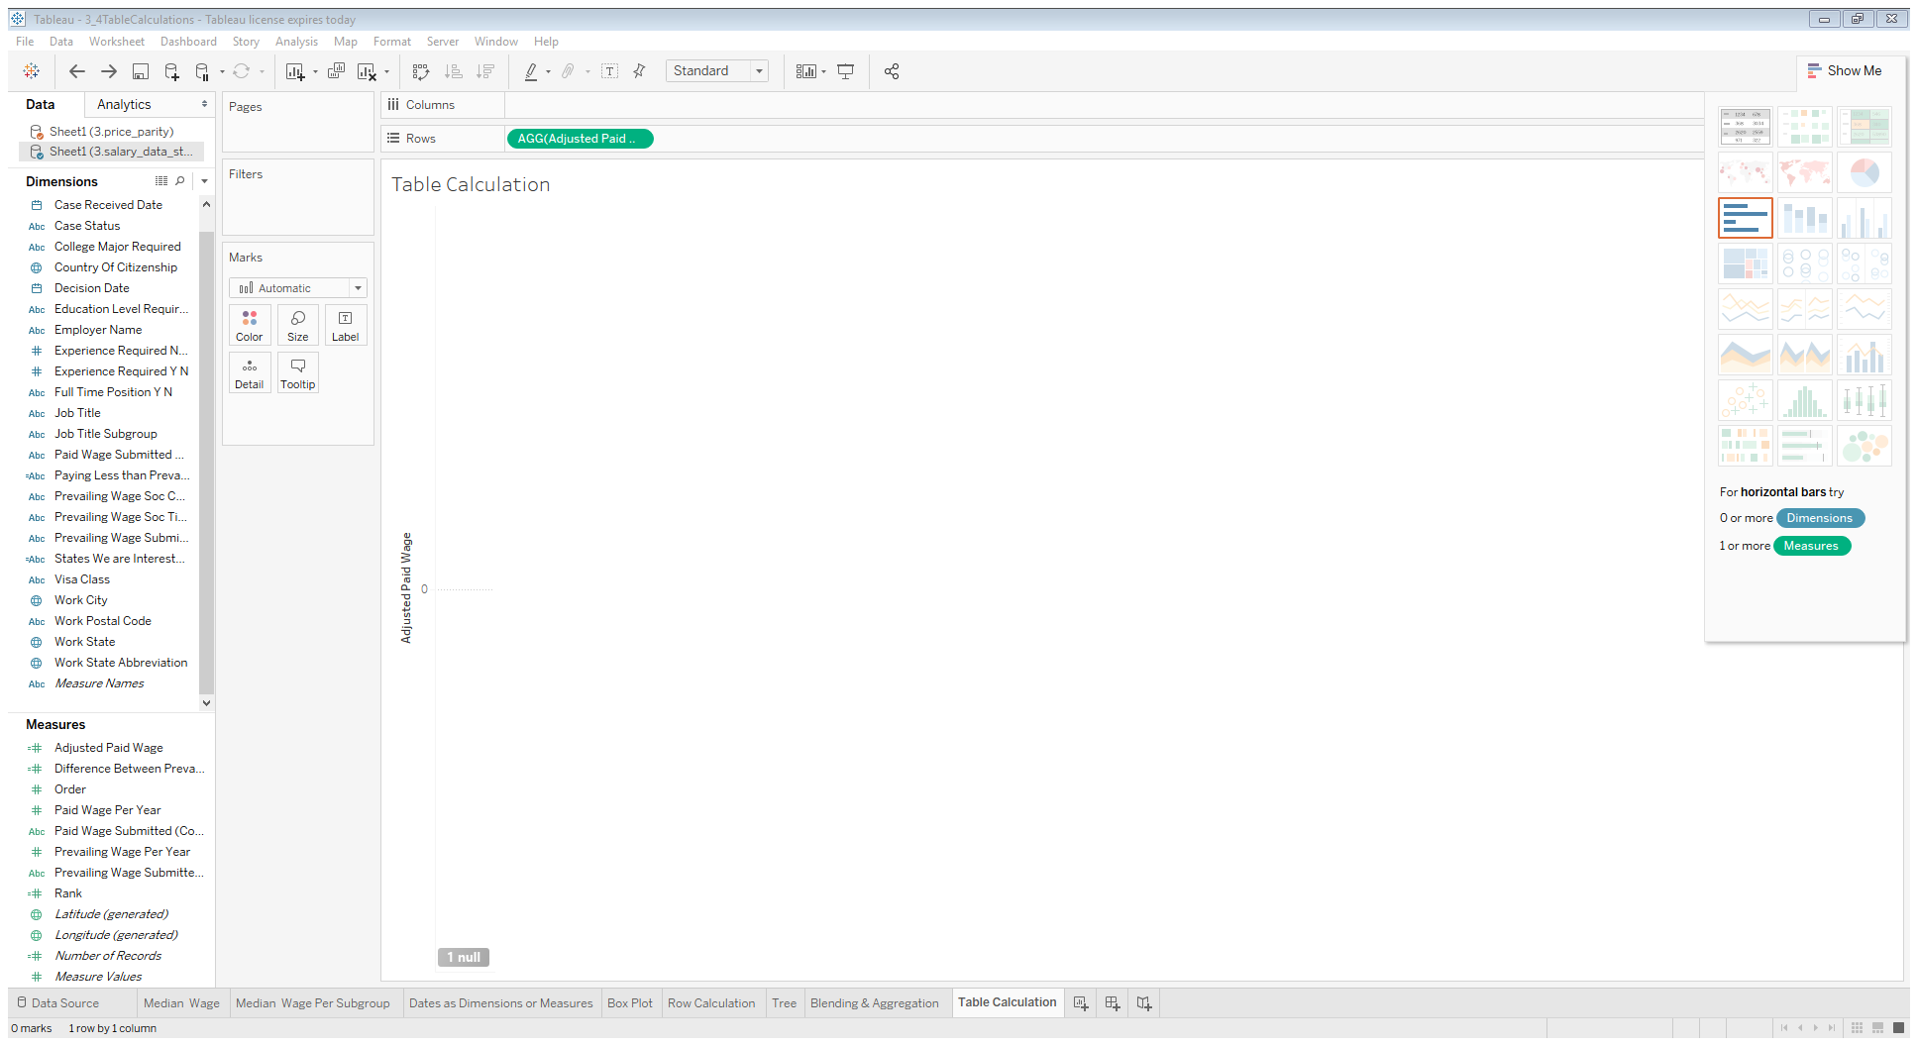

empty because this calculation requires a state level aggregation, and right now there's nothing in the work space to be able to aggregate the raw data that way

There are some null values where are in the primary data source but not in the secondary data source(price parity)

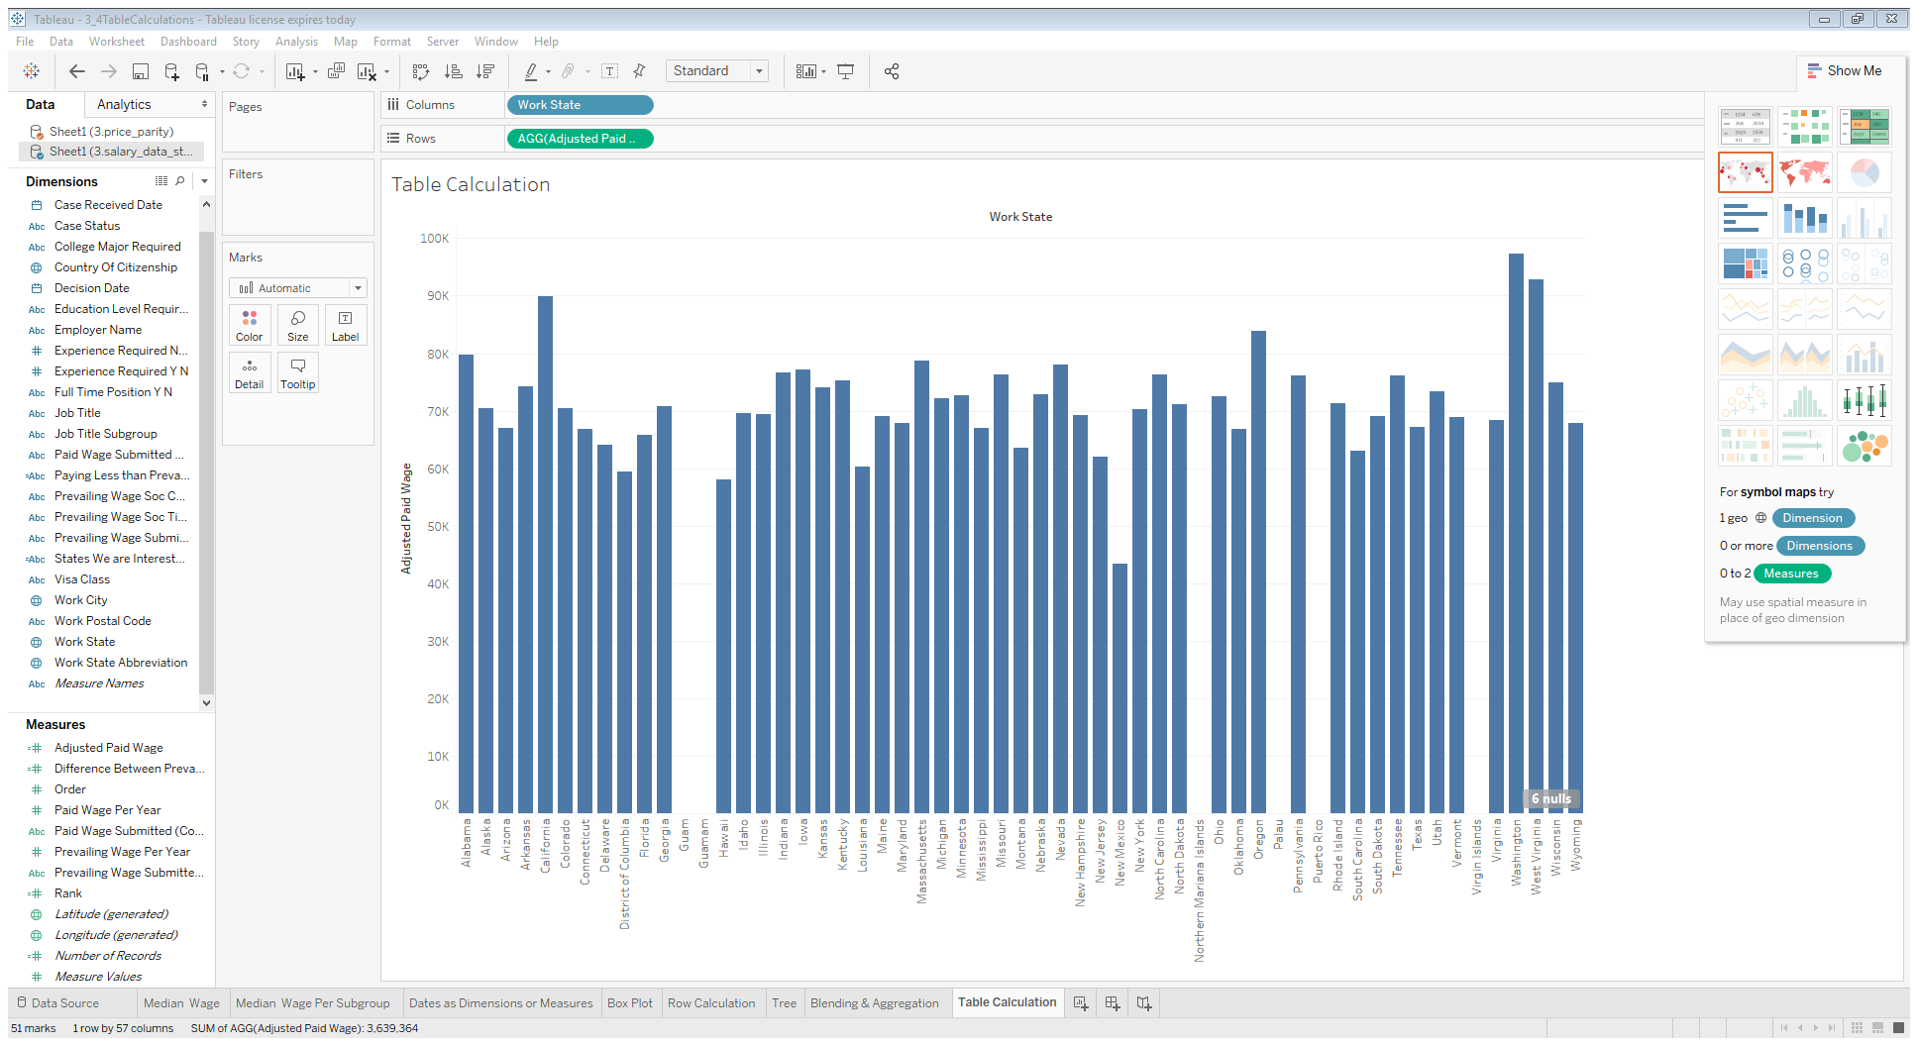

Columns: Job Title Subgroup, Work State

Rows: AGG

Filters: States We are Interested in

Details marks: ctrl + AGG

Right click AGG(Add Table Calculation)

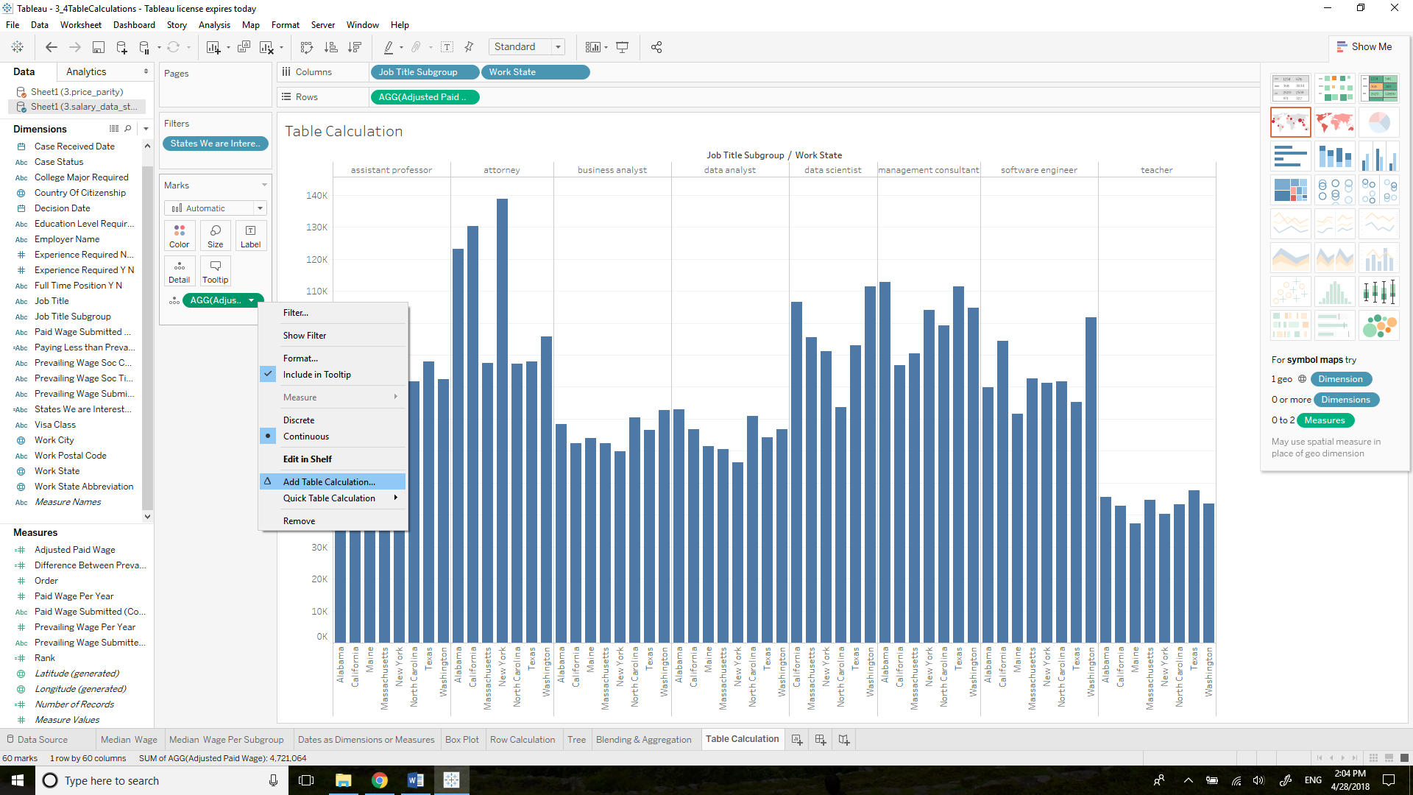

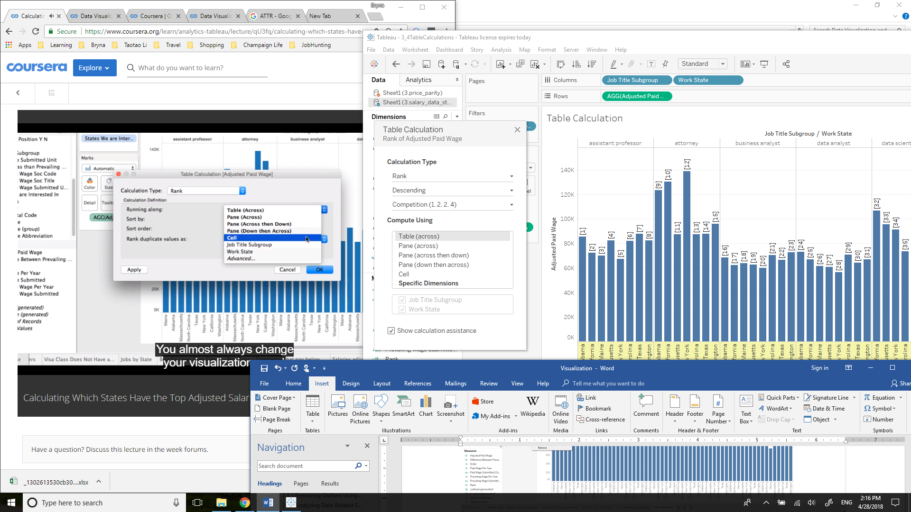

Never use those bold area: hardcode

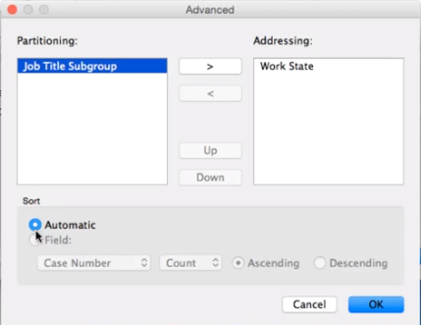

The partition field tells you what you're going to use to group the calculation. The addressing fields are the ones you're going to apply the calculation to. In our case, we want to apply the ranking calculation to Work State. So we're going to put Work State over here and Job Title Subgroup here in Partitioning. Right now you can leave sort as automatic.

In windows, do this:

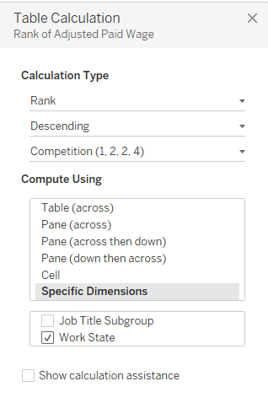

Try to move AGG from Details to Columns, Tableau won’t let you do that, since Columns have to be dimensions. Change it from measures(continuous) to dimensions(discrete), then move it to Columns

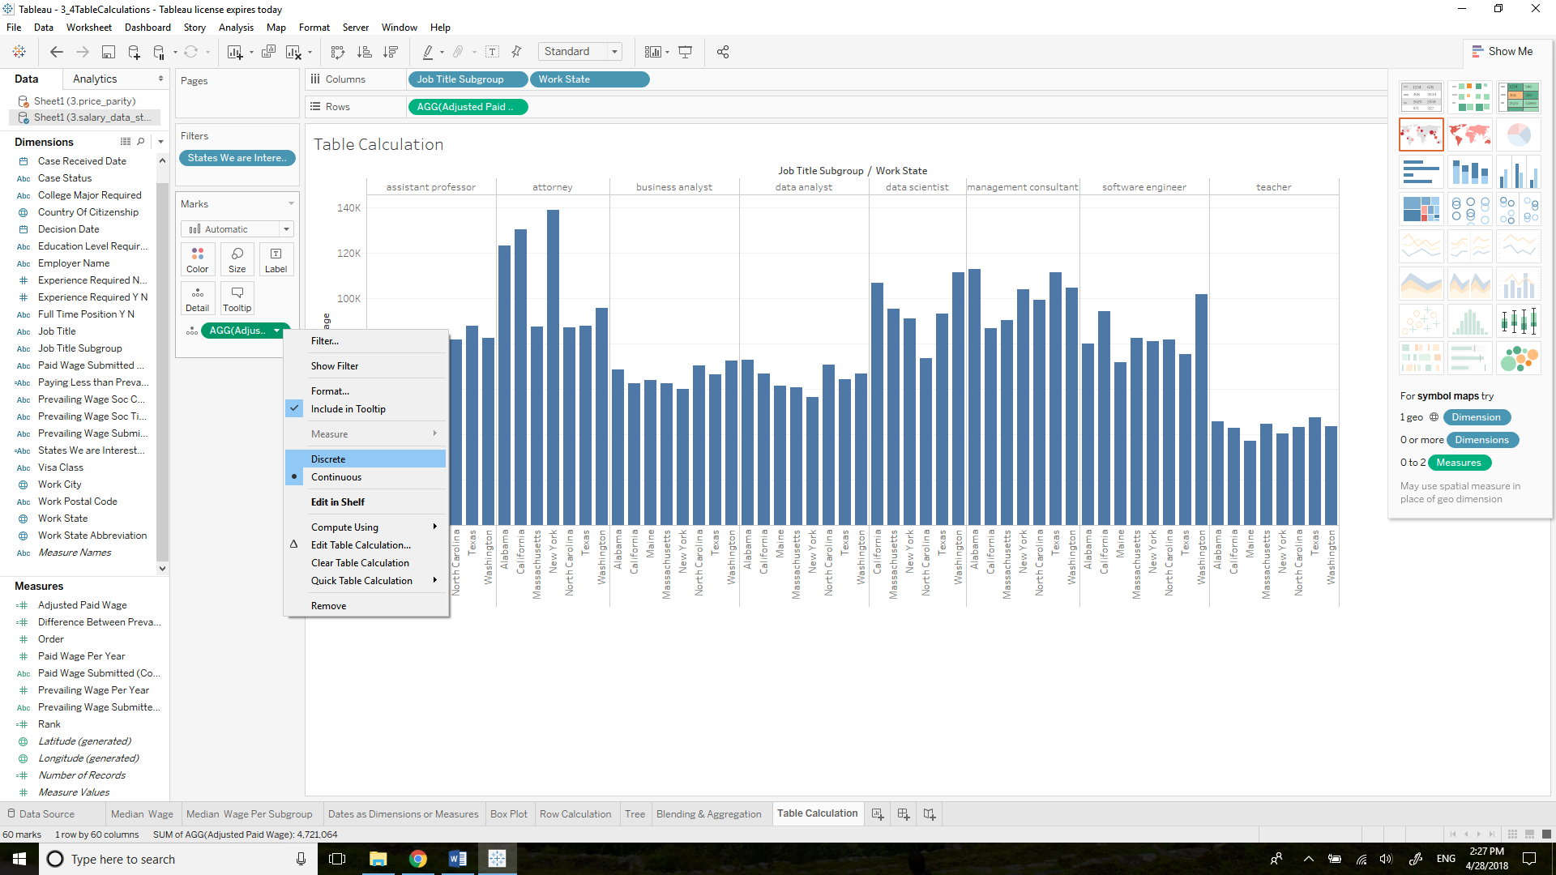

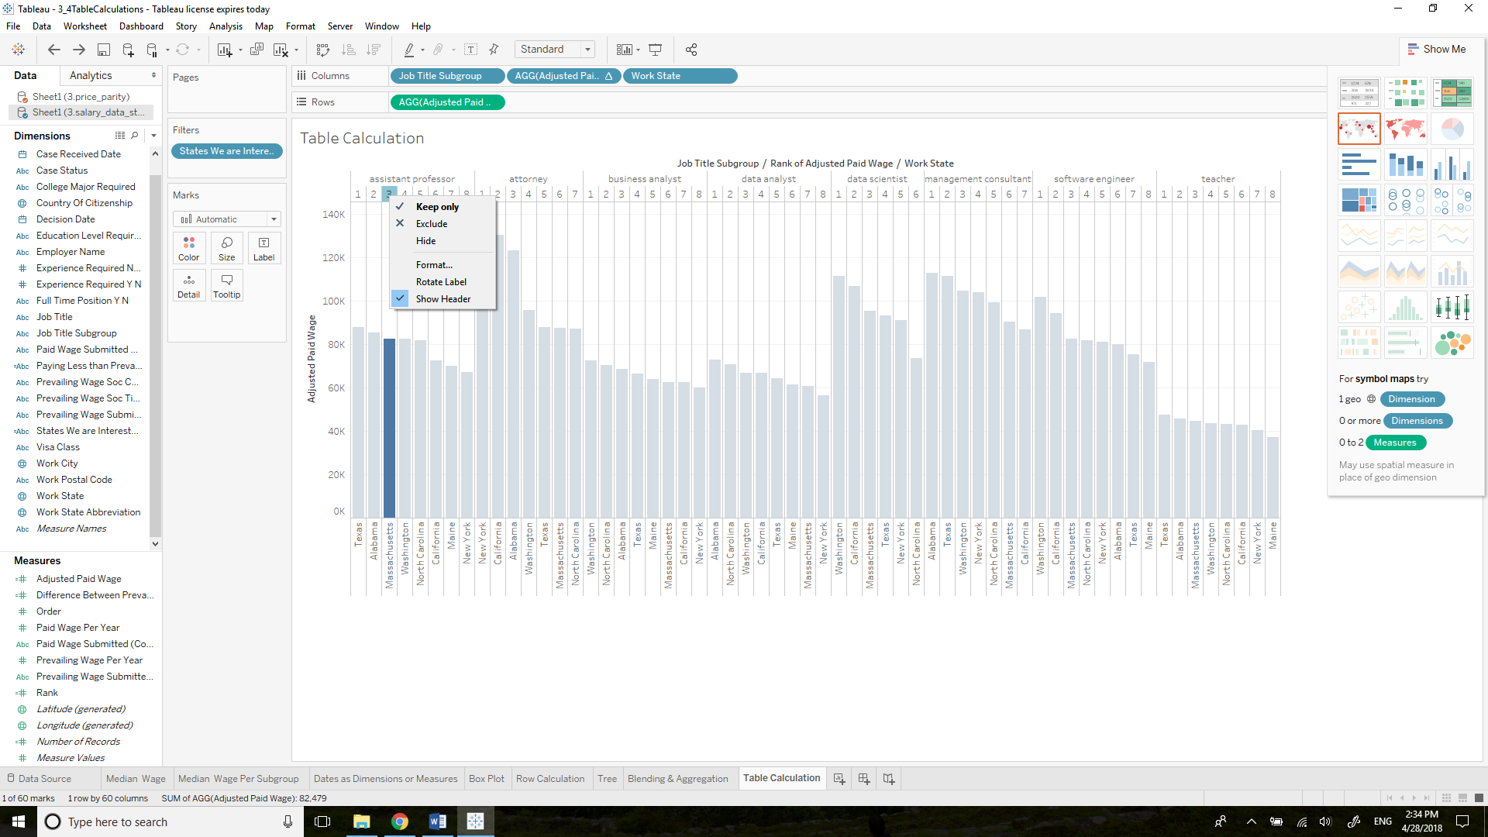 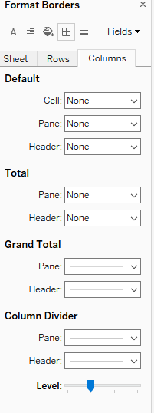

1. Remove Show Header
2. Format: remove Column Divider

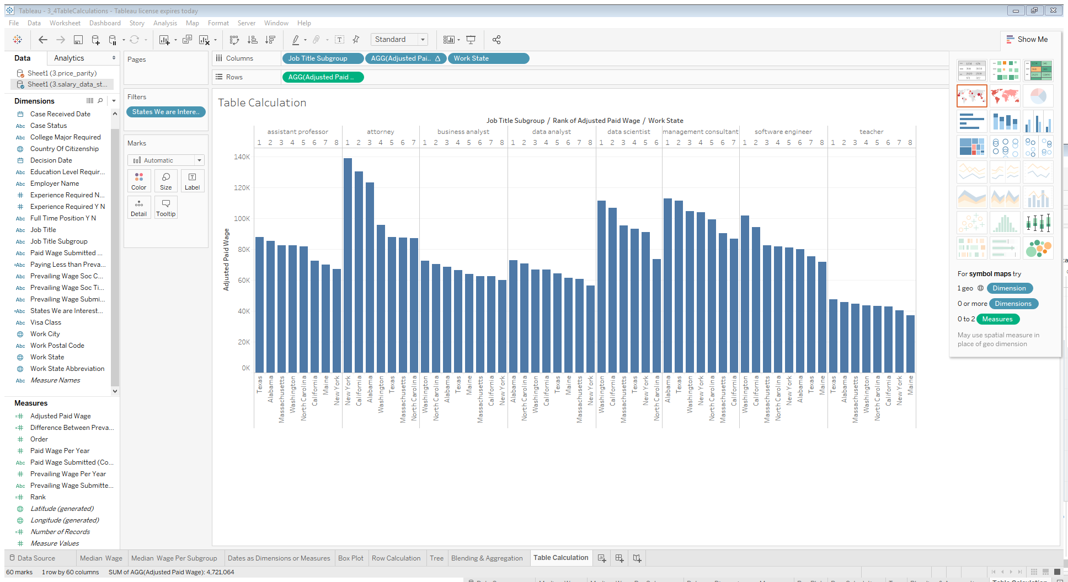

### 3.3.2 Using Parameters to Define Top States

Difference between parameters and filers: parameters are global, and can be used in calculations

Right click: Create Parameter

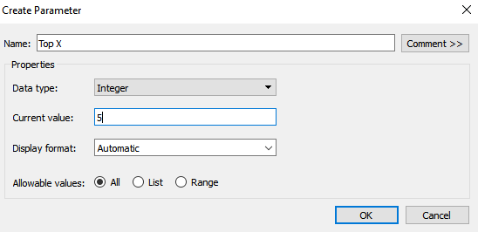

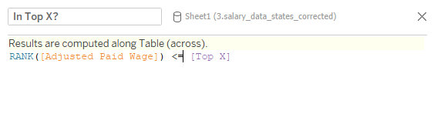

Blue: calculations,

Orange: individual,

Purple: parameters

Columns: Job Title Subgroup, AGG, Work States

Rows: AGG

Filters: States We are Interested in

Marks: Color: Job Title Subgroup

If you just drag In Top X? to the Filters, you will see this:

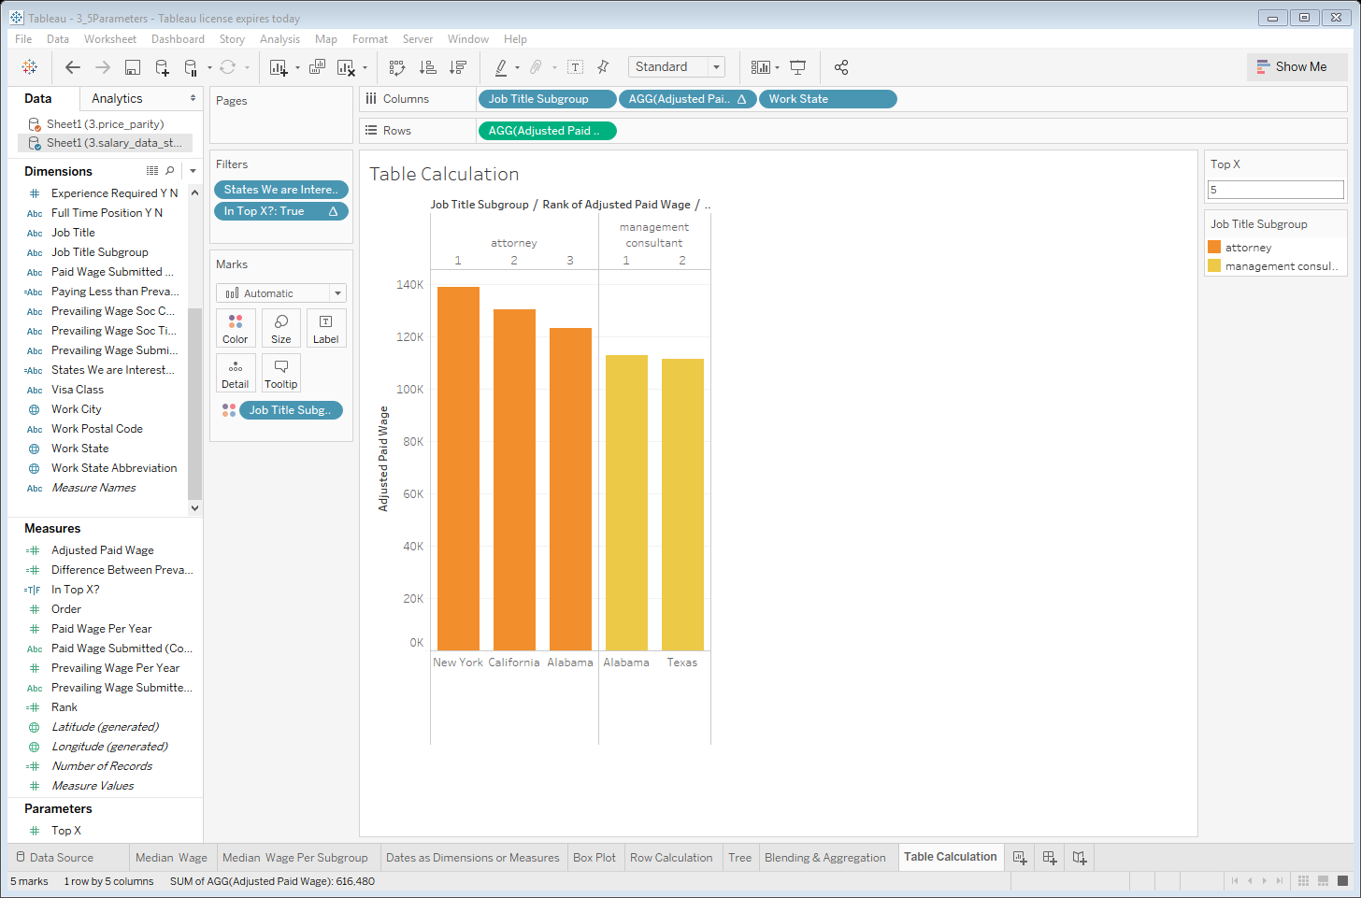

Since forgot to tell how to use the compute. We want top 5 for each work state, not cross table.

Solution: move In Top X? to Details Card and right click change Compute Using to Work State, then move it to Filters.

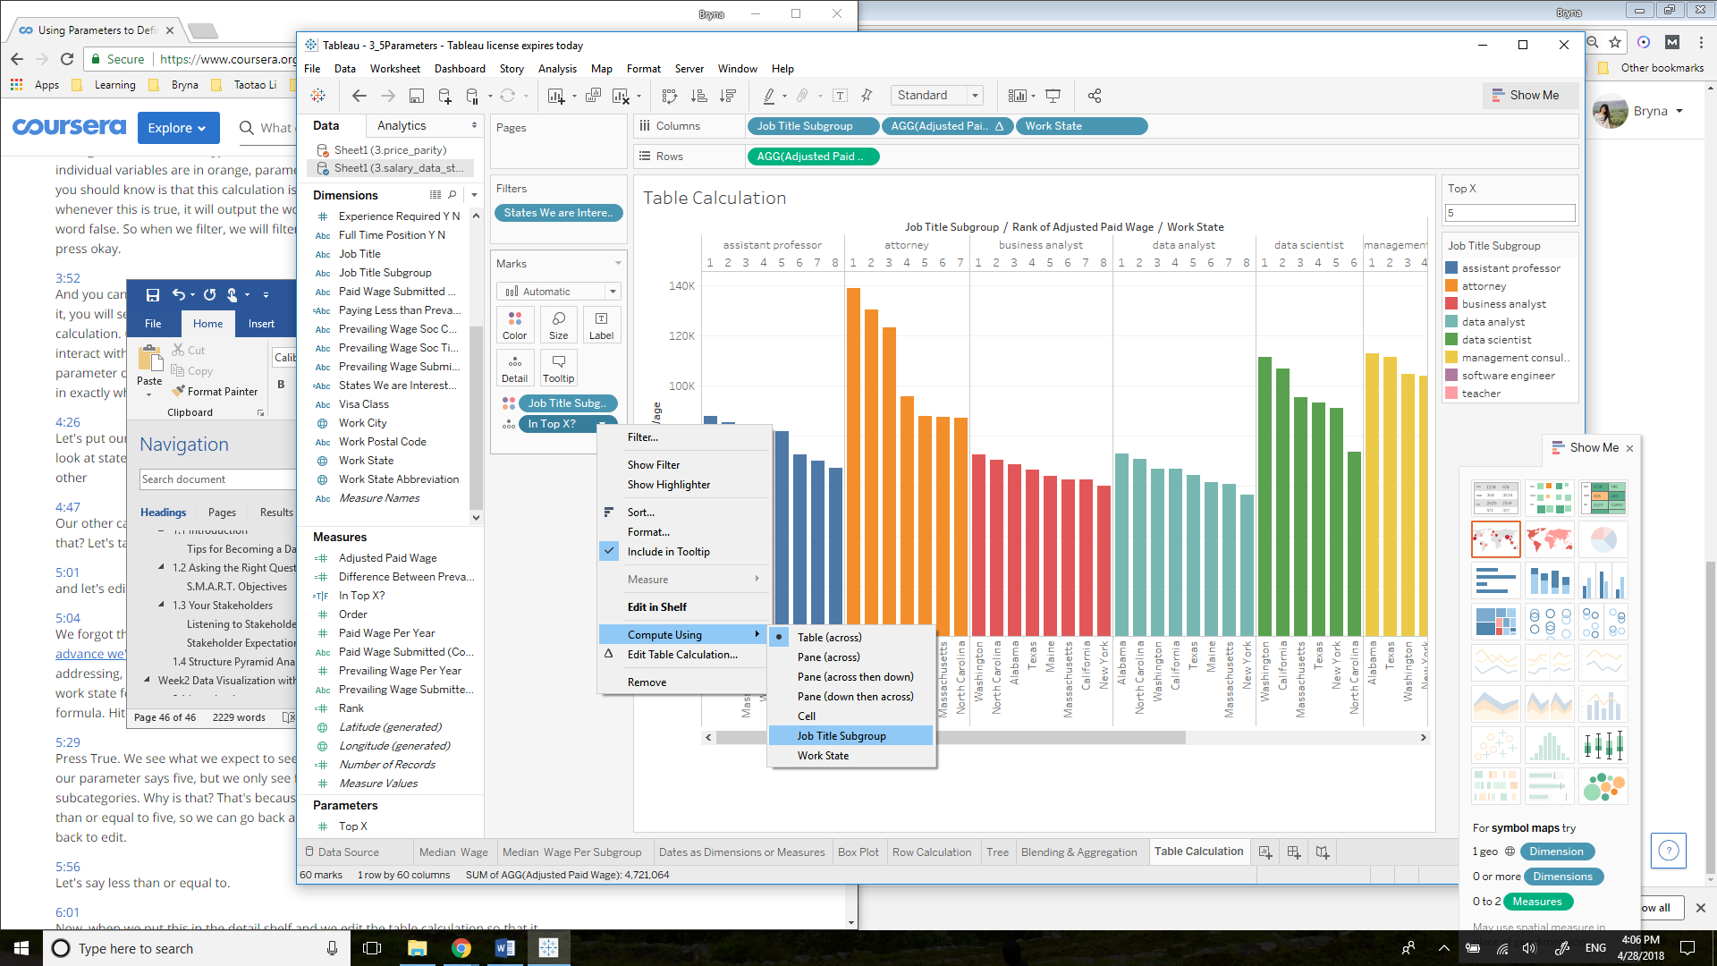

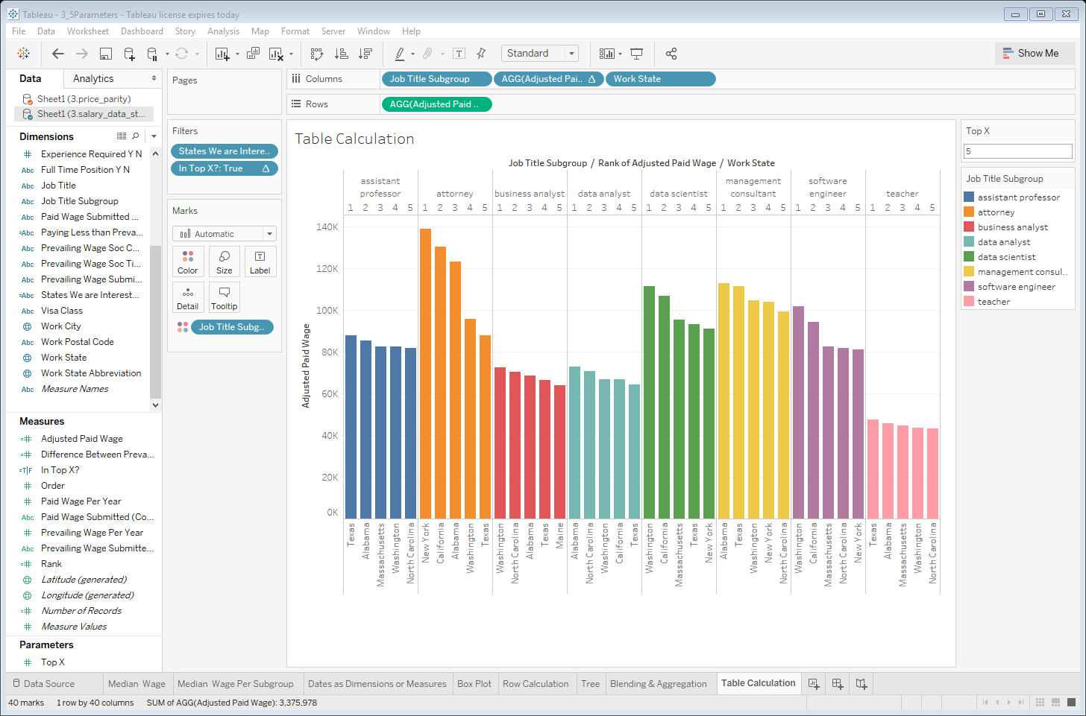

You can always change the parameter Top X to any number you like.

## 3.4 Dashboards and Story Points

### 3.4.1 Calculating Which Companies Have the Top Adjusted Salaries within Job Subcategories

Dashboards:

* You can look at multiple graphs at in once
* Use one of the results of one graph to filter the results of another
* Update your team on notes

Columns: Job Title Subgroup, Work State, Employer Name

Rows: AGG

Filters: States We are Interested in

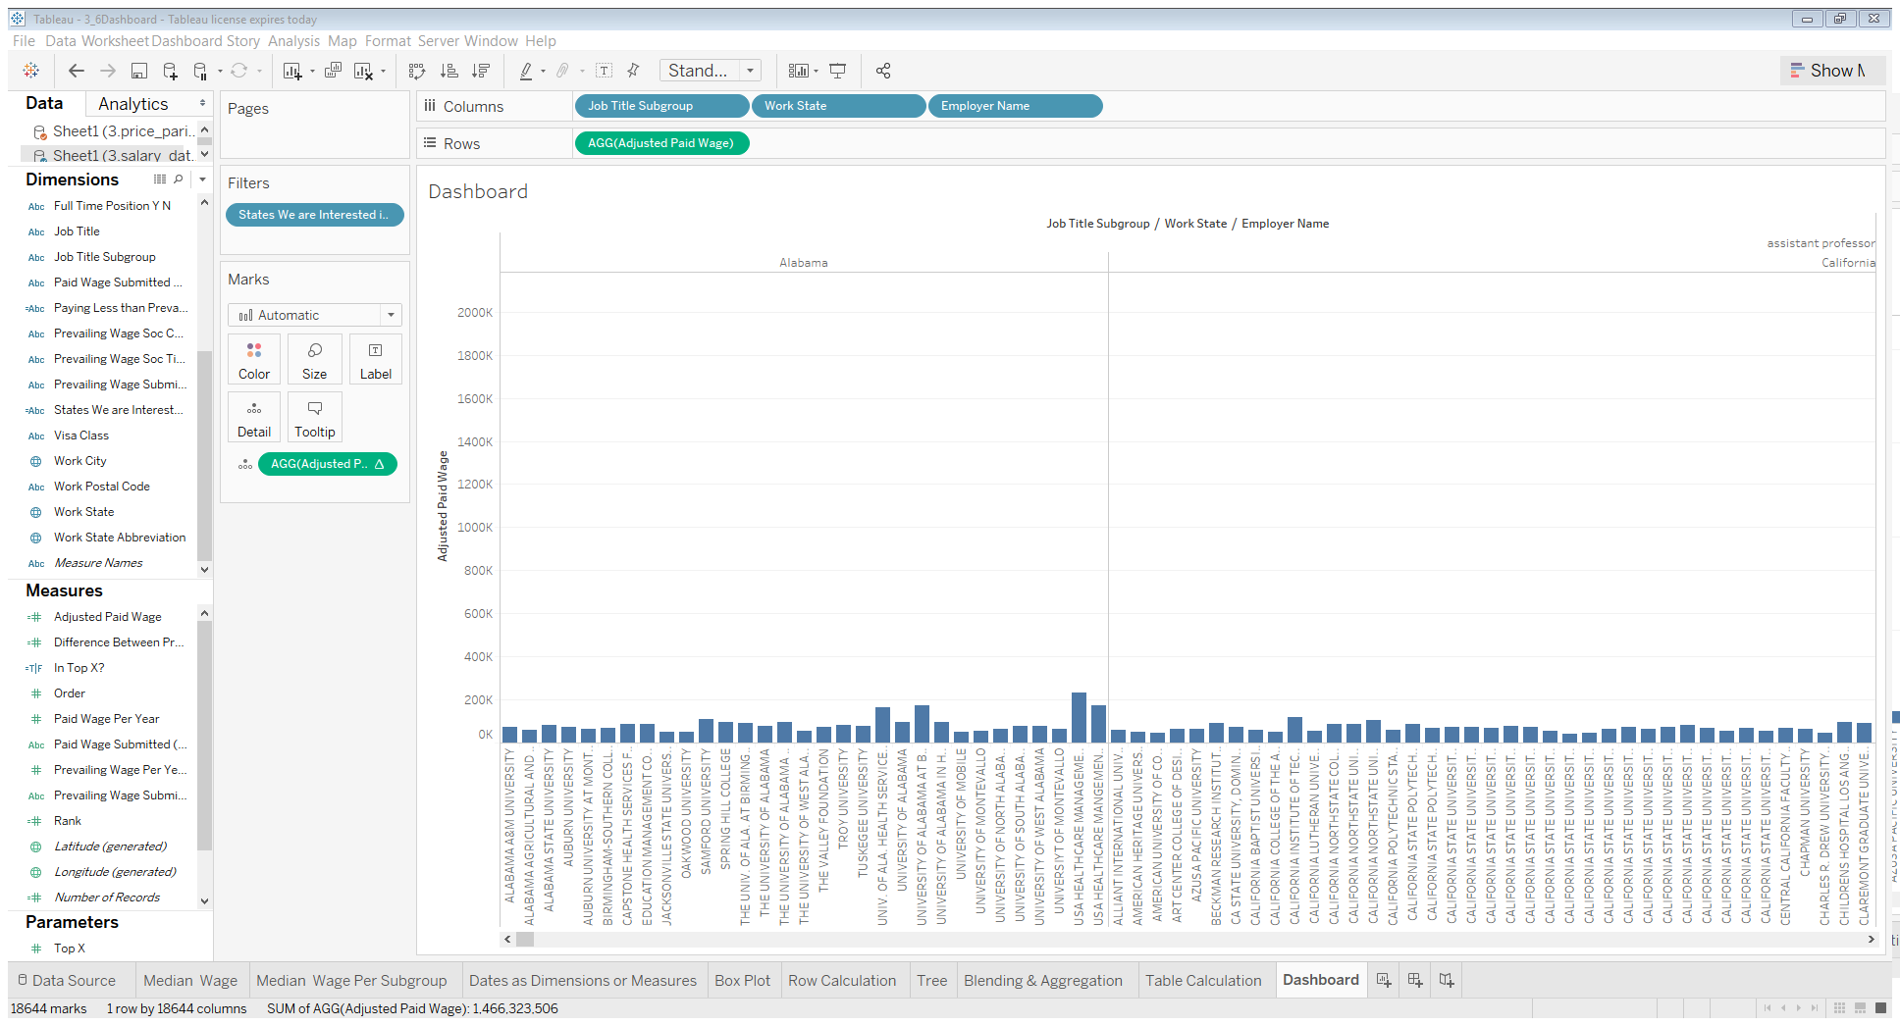

Detail: AGG (Add Table Calculation)

AGG: Discrete, between Work State and Employer Name (Columns)

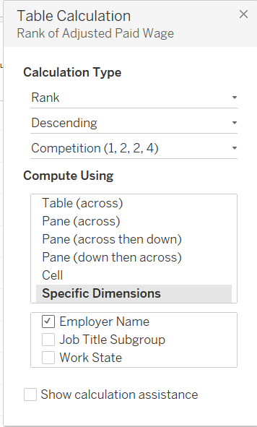

Compute Using Employer Name => move In Top X? to Filters

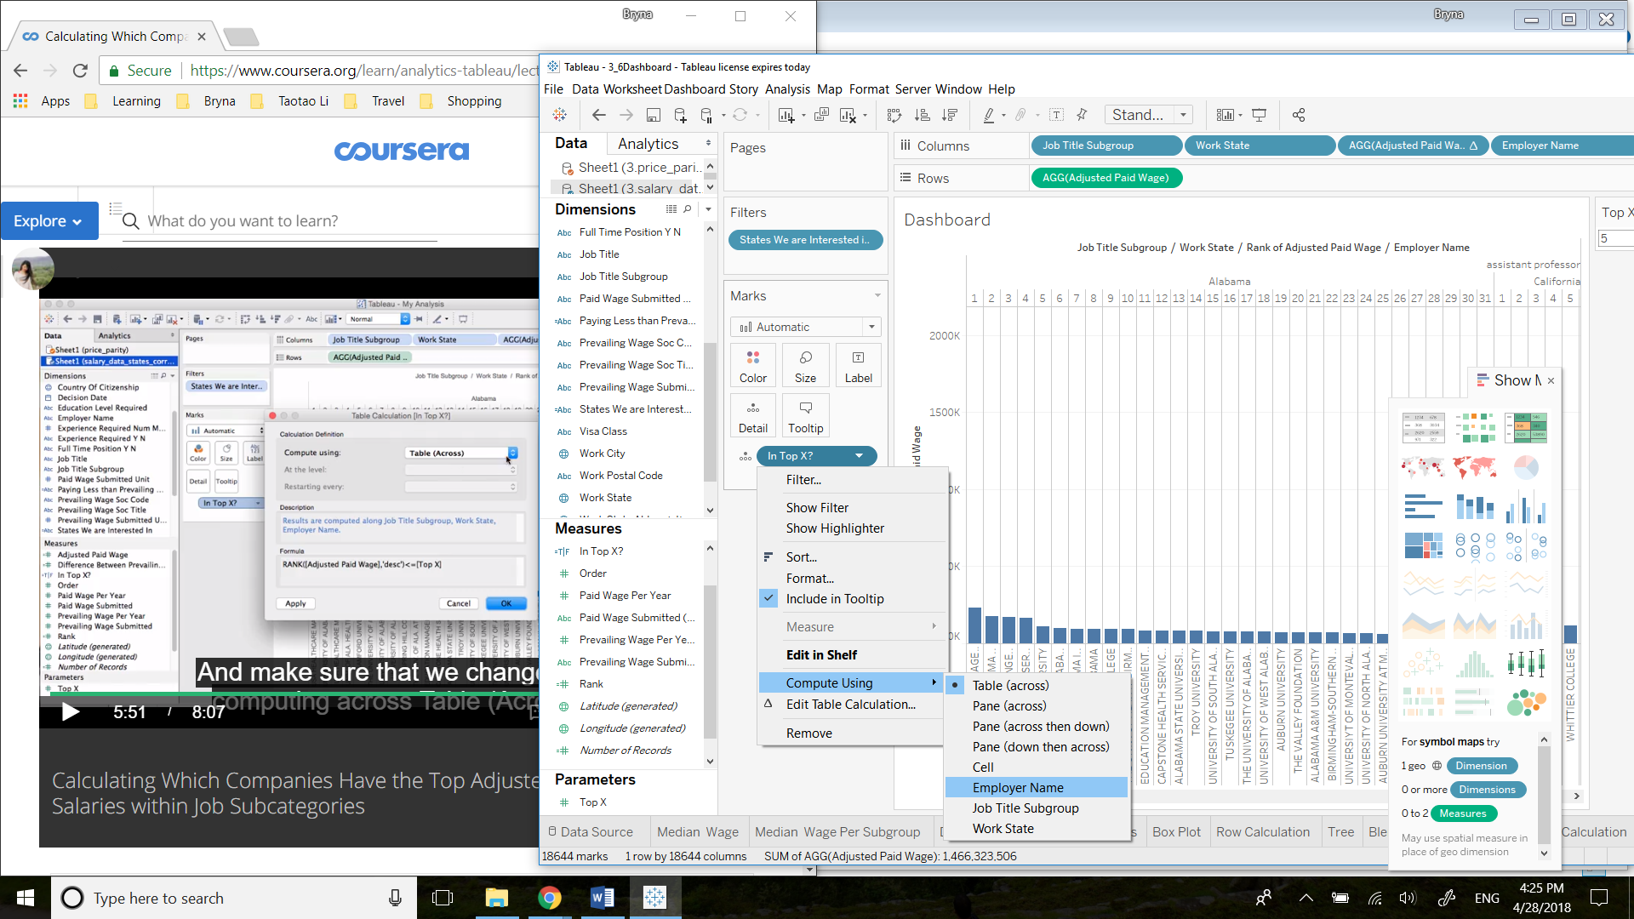

Then get rid of headers and column diveders, and swap rows and colomns

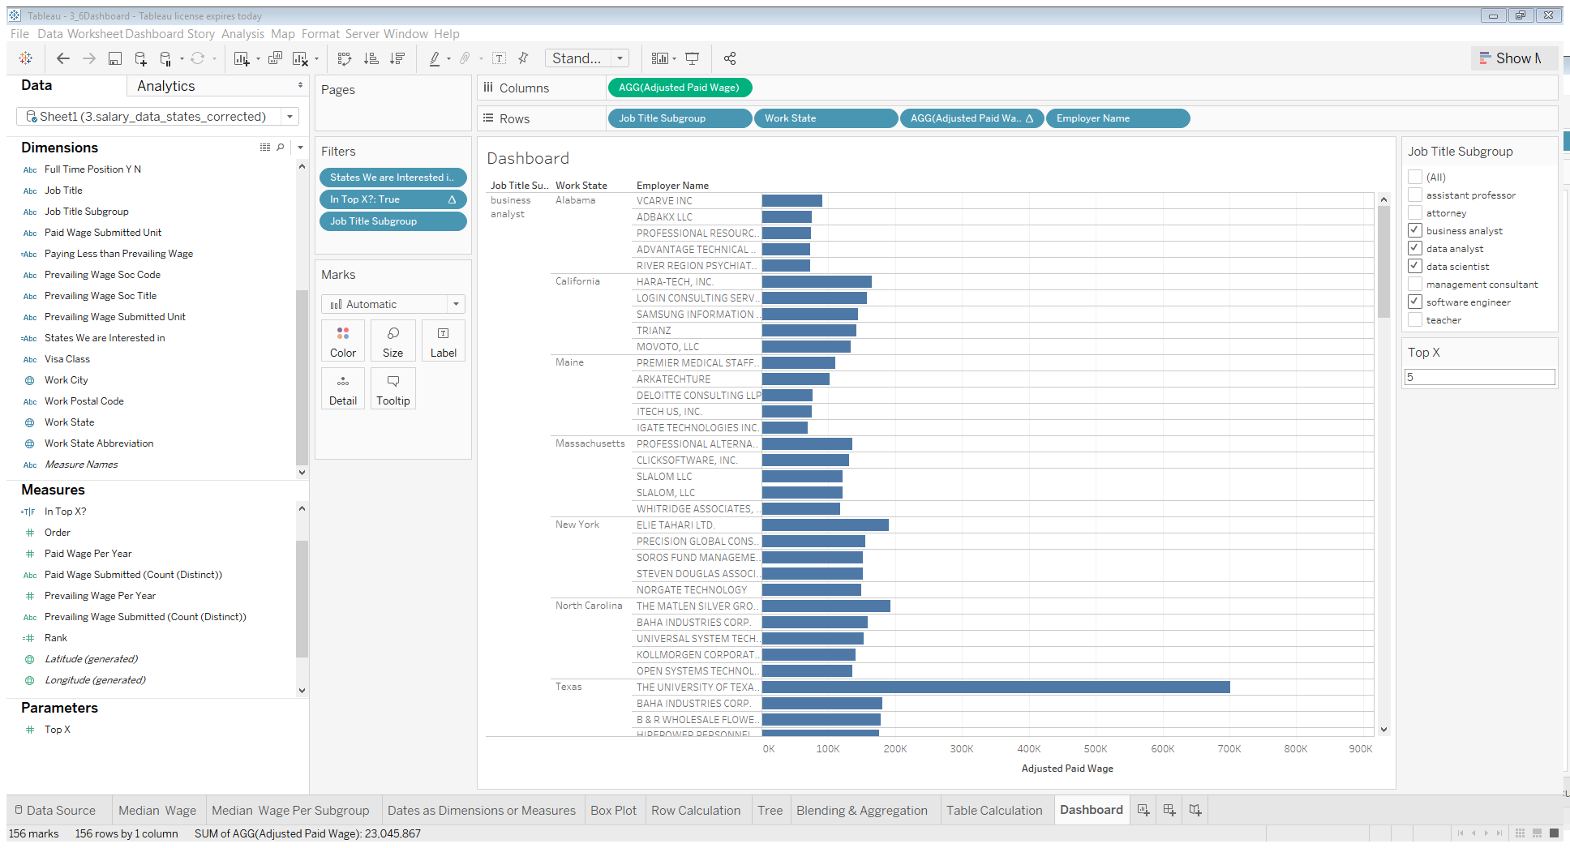

### 3.4.2 Designing a Dashboard to Determine Where You should Apply for Data-related Job



Size: Laptop

Obejcts: Vertical

Sheets: choose from work sheets

Apply filers form one sheet to all sheets: More Options=> Apply Filter to WorkSheets

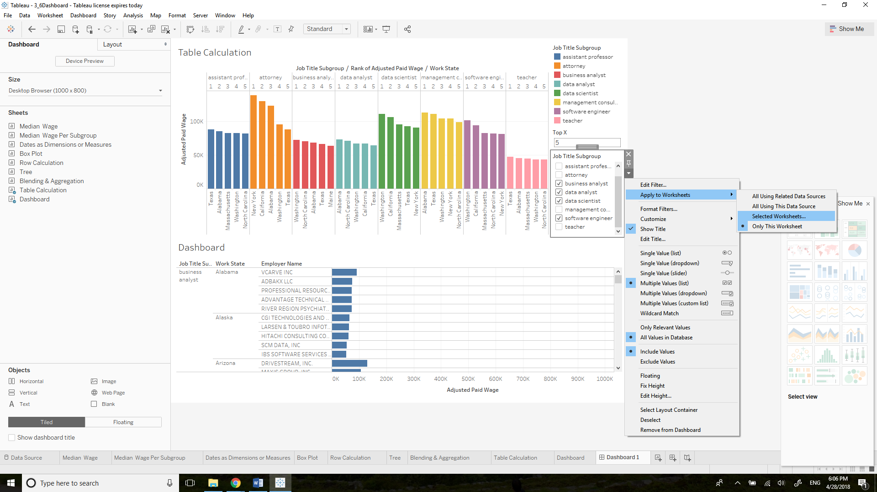

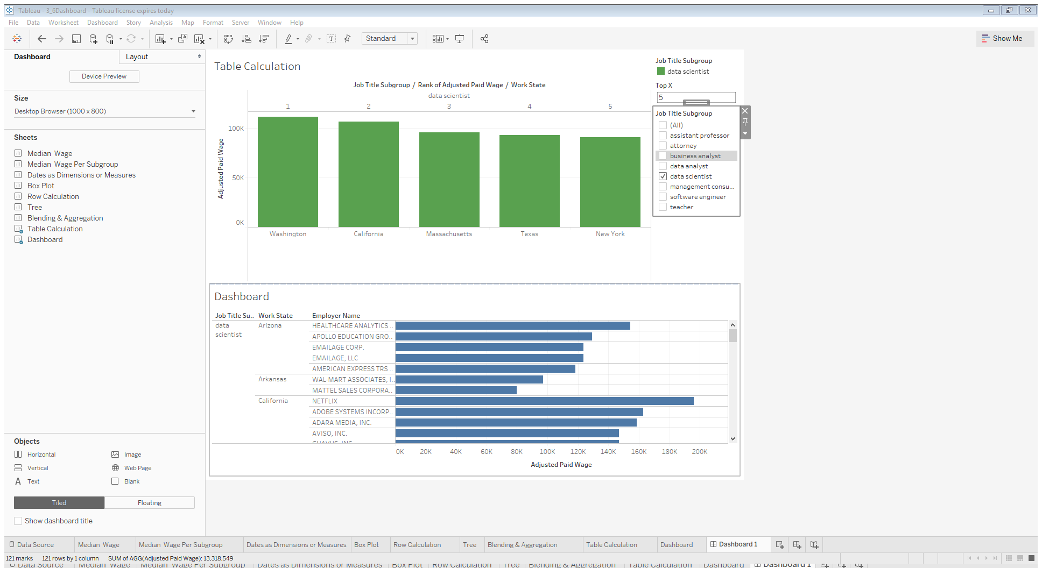

How to get rid of the color legend:

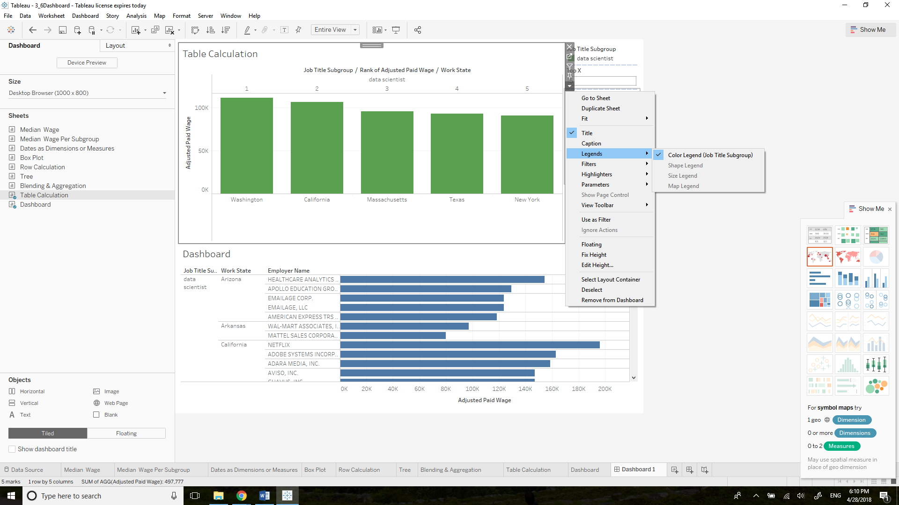

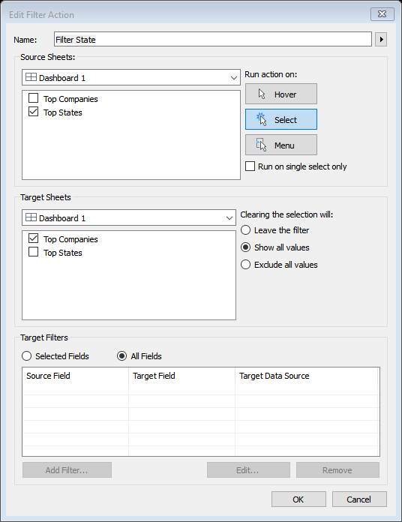Add Filter Actions: if you choose one state from the first worksheet, you will only see the top companies in that state from the second worksheet.

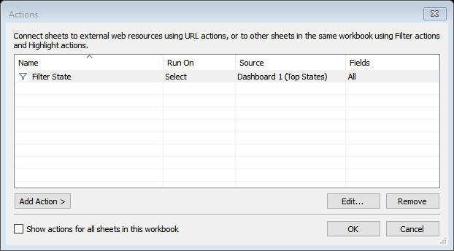

And change Top 5 to Top 8 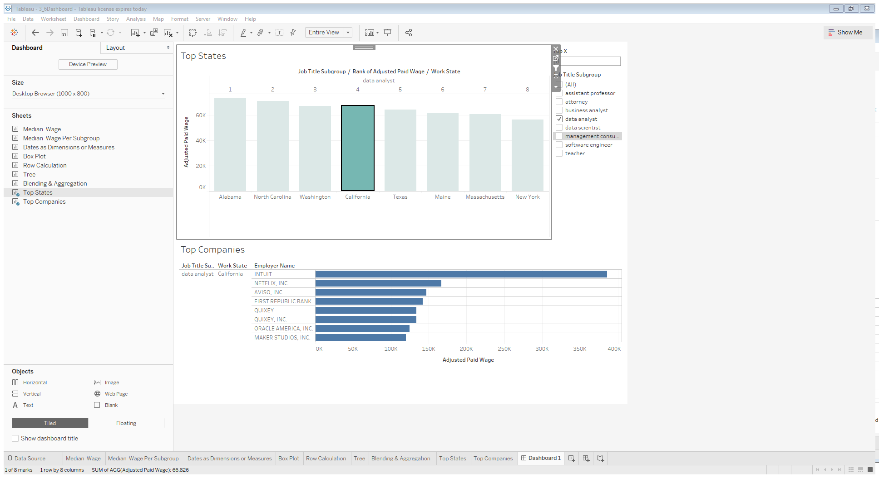

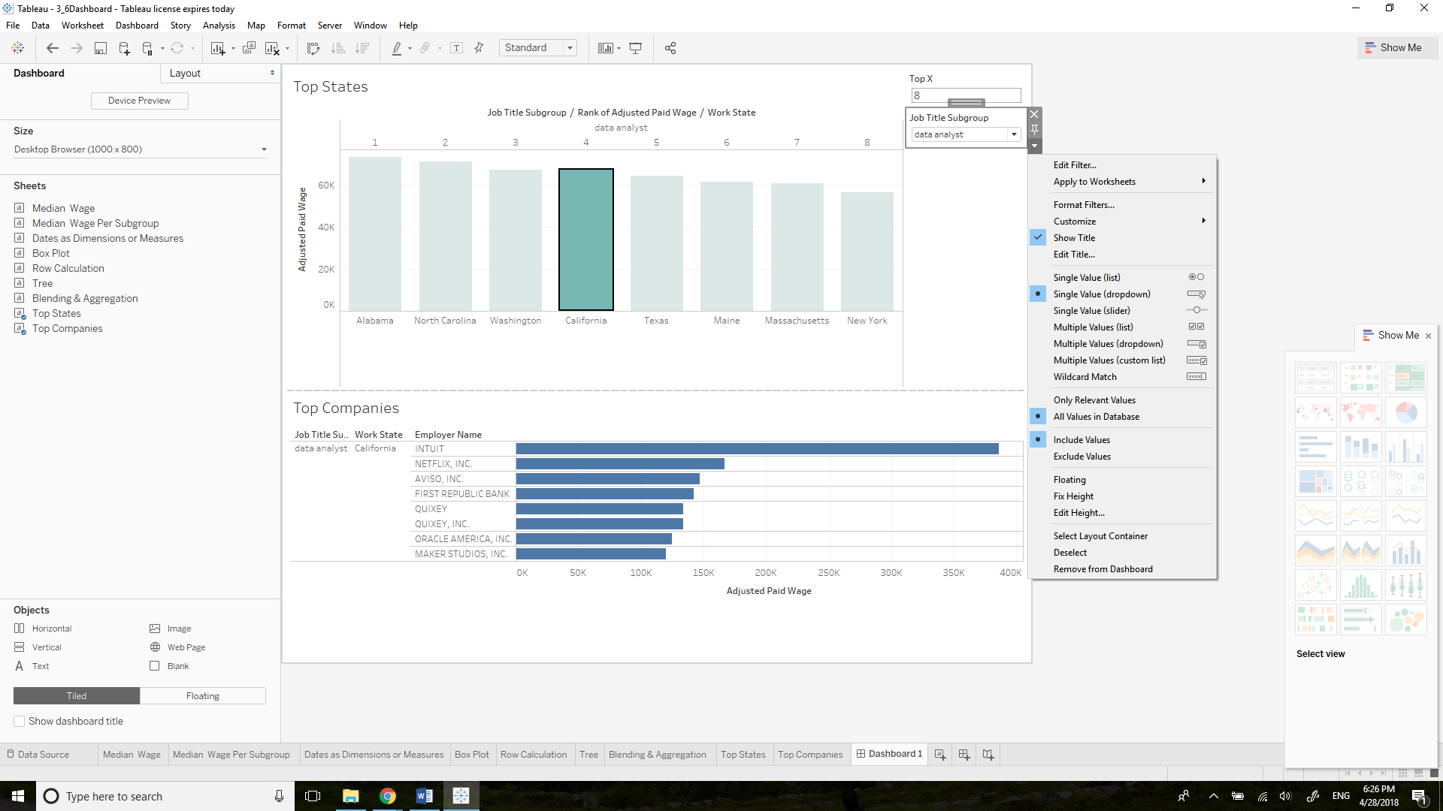 Change Filter to Single Value (dropdown) will save some space

How to see the actual number: go back to the worksheet, move Number of Records to Tooltip and change SUM to CNT

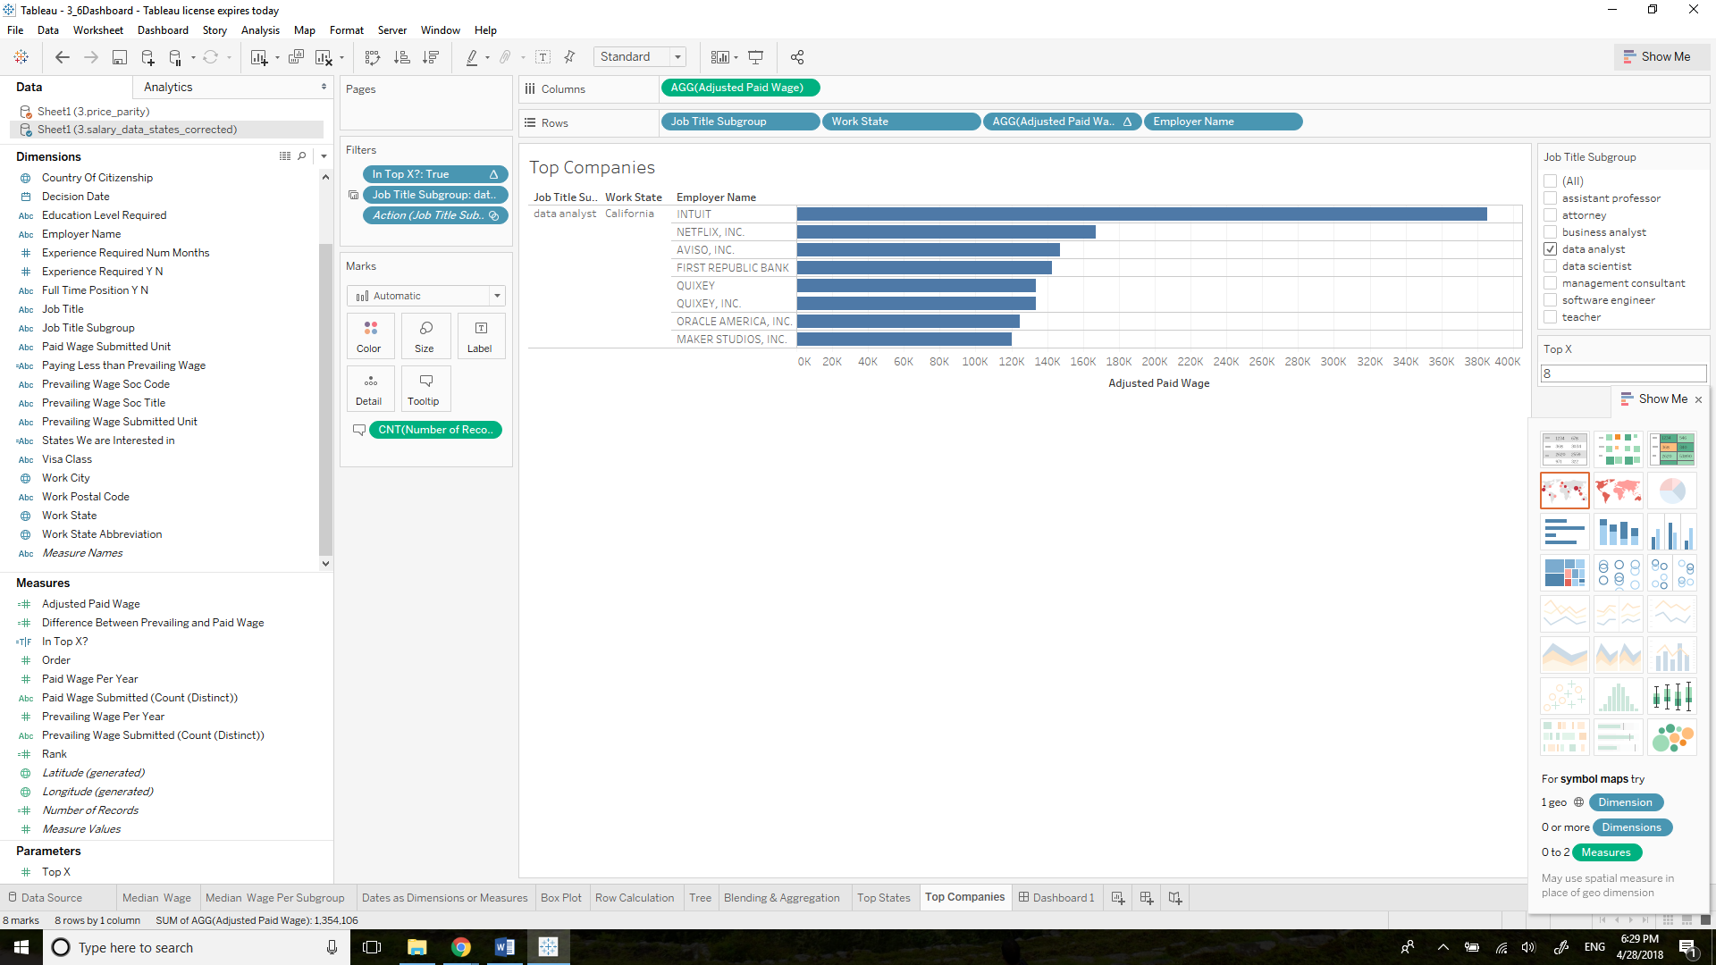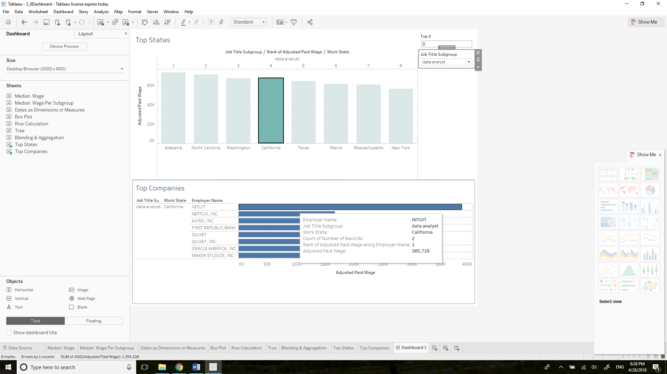

### 3.4.3 Visual Story Points in Tableau



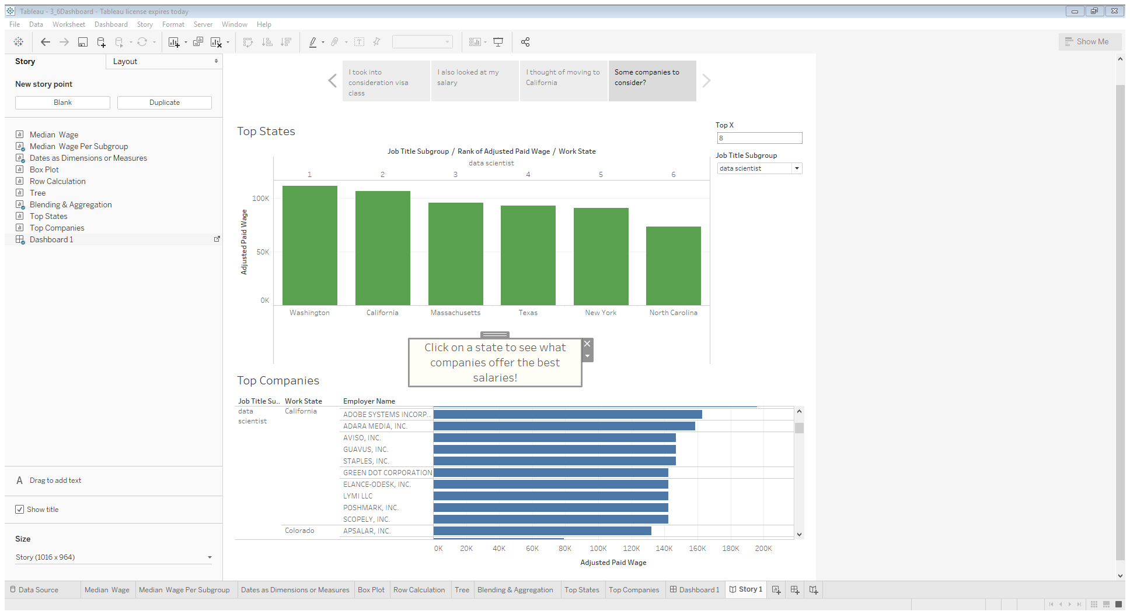

Presentation Mode:

